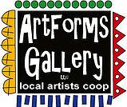**August 2023 Workshops**

**620 N. Broadway, Pittsburg, KS 620-240-0165**

ArtForms Gallery is a co-op of artists offering monthly workshops ranging from acrylic painting, watercolor, oil pastels, glass fusing, pottery, metalsmithing, jewelry, textiles, kids’ art and more! All workshops are held at the Gallery unless otherwise noted. Please call Artforms Gallery to register for any artist’s workshop. **620-240-0165**

**Refunds/Cancellations—Decisions regarding refunds and cancellations are determined by the artist leading the workshop.** You can find individual contact information for each artist on the “Artists” page of our website, or just call the Gallery and we’ll get you in touch. Facebook:[ArtFormsGallery620/](https://www.facebook.com/ArtFormsGallery620/)

**Art Explorations!**

Are you looking for camaraderie while exploring your artistic side? Join Gallery artists Pat Glick **every** Tuesday afternoon for a fun time working on your own project or art! Bring your materials and create with us for free!

Every Tuesday

August 1, 8, 15, 22, 29

12:30 – 2:30 p.m.

FREE~FREE~FREE!!!

**Give the Gift of Art**

* Original Art
* Local Artists
* Gift Cards

Gift cards may be purchased in any amount and do not expire. They may be redeemed for workshops or for original art!

To check the balance of your Gift Card online:

[https://squareup.com/gift/46K96BF2TK6W7/check-balance](https://squareup.com/gift/46K96BF2TK6W7/check-balance?fbclid=IwAR1iEqUd4ASMldq6Fm8eoysfMKfOYcFHXH1Rb1SFKIGHspD2yyCQCQInoJ8)

Website:[www.artforms-gallery.com](http://www.artforms-gallery.com)

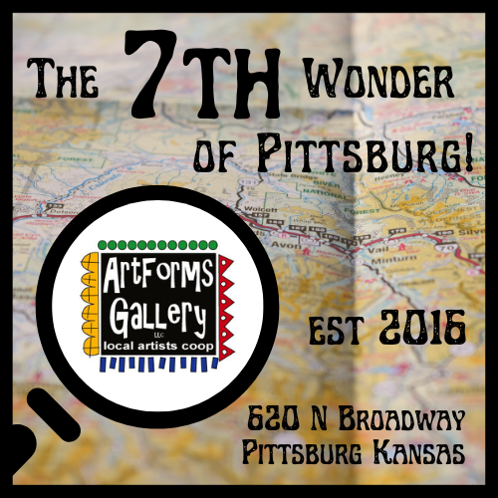

In honor of its 7th anniversary, ArtForms Gallery is declaring itself the 7th wonder of Pittsburg! Join us in a scavenger hunt for six more “wonderful” community artworks in the surrounding area for chances to win special anniversary artworks created by ArtForms artists.

A display of the anniversary artworks, scavenger hunt maps, and giveaway guidelines will be available at the Gallery. Artists will be doing demonstrations there throughout the day on Saturday, September 2, from 9:00 a.m. to 6:00 p.m. The drawing to win one of the 7th anniversary artworks will be held at 6:00 p.m. that evening.

**Intuitive Fluid Art** **Artist: Debbie Southard**

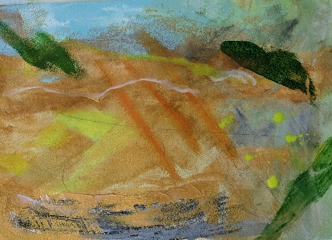Work with very fluid paints, placing line, shape, and texture on paper.  You will come out with something completely individualized and express yourself with a very loose fun painting.

* Saturday, August 12 | 2:00 p.m. – 4:00 p.m.
* Fee: $35, due at time of registration
* Class size: 10
* Ages: 14 years and older

**Water Marbling   Artist:  Mona Jurshak**

Create one-of-a-kind marbled paper. Mesmerizing paint floats on the water surface before being transferred to paper in this surface design technique.  Beginner friendly! There are many traditional techniques used in water marbling. You can choose to start with one of these techniques or experiment and find your own style. All materials are provided.

* Date:           Sunday, August 13     |    1:00 - 3:00 p.m.
* Ages:          12+
* Fee:            $35, due at time of registration
* Class Limit: 12 people

**Sunprints -Cyanotype     Artist:  Mona Jurshak**

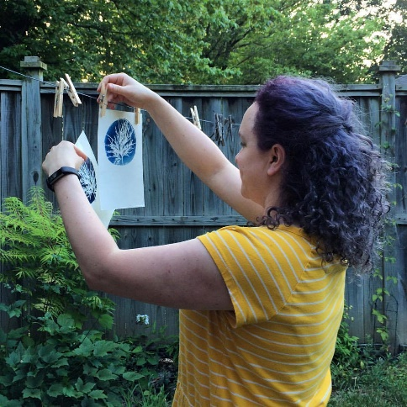Summer blues? Let's print them away with this photography technique from the 1800s!

Sunlight exposes the paper coated with the cyanotype chemistry before washing the blues away!

If you have never experienced a dark room, come to this workshop to experience the earlier process of exposing the print right out of the sunshine!

* Date:           Sunday, August 20     |    1:00 - 3:30 p.m.
* Ages:          18+
* Fee:            $40, due at time of registration
* Class Limit: 10 people

ArtForms artists also offer pop-up workshops during the month. Follow the Gallery on our Facebook page and/or our website!

Facebook: [ArtFormsGallery620/](https://www.facebook.com/ArtFormsGallery620/)

Website: [www.artforms-gallery.com](http://www.artforms-gallery.com)

Do you have a birthday or special occasion to celebrate? Contact the Gallery to book a private party with an ArtForms Gallery artist!

Possibilities include:

|  |  |
| --- | --- |
| * Sip and Paint * Painting * Jewelry * Textiles * Pour Painting | * Fused Glass/Stained Glass * Pottery (ceramic birdhouse, windchime, pitchers) * Fiber * Glass and Resin |
| **Have a workshop suggestion or special request for us?**  **Don’t hesitate to give us a call!**  See the source image  **Become a**  **Gallery Patron**  Save 10% on **every** workshop you take in a 12-month period!  Only $40.00 | |

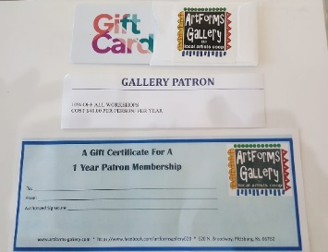  
An ArtForms Gallery gift card makes the perfect gift for any occasion! Our gift cards may be purchased in any amount and they never expire.