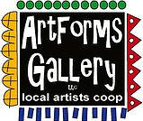

**May 2022 Workshops**

**620 N. Broadway, Pittsburg, KS 620-240-0165**

**Give the Gift of Art**

**Mother’s Day is May 8!**

* Original Art
* Local Artists
* Gift Cards

Gift cards may be purchased in any amount and do not expire. They may be redeemed for workshops or for original art!

To check the balance of your Gift Card online:

[https://squareup.com/gift/46K96BF2TK6W7/check-balance](https://squareup.com/gift/46K96BF2TK6W7/check-balance?fbclid=IwAR1iEqUd4ASMldq6Fm8eoysfMKfOYcFHXH1Rb1SFKIGHspD2yyCQCQInoJ8)

Give Give the Gift of Art!

the Gift of Art!

ArtForms Gallery is a co-op of artists offering monthly workshops ranging from acrylic painting, watercolor, glass fusing, pottery, metalsmithing, jewelry, textiles, kids’ art and more! All workshops are held at the Gallery unless otherwise noted. Please call Artforms Gallery to register for any artist’s workshop. **620-240-0165**

Refunds/Cancellations—Decisions regarding refunds and cancellations are determined by the artist leading the workshop. You can find individual contact information for each artist on the “Artists” page of our website, or just call the Gallery and we’ll get you in touch.

Website: [www.artforms-gallery.com](http://www.artforms-gallery.com)

Facebook: [ArtFormsGallery620/](https://www.facebook.com/ArtFormsGallery620/)

The Big Kansas Roadtrip!

May 5-8

Visit ArtForms Gallery to see our new art in the window commemorating the State of Kansas!

* 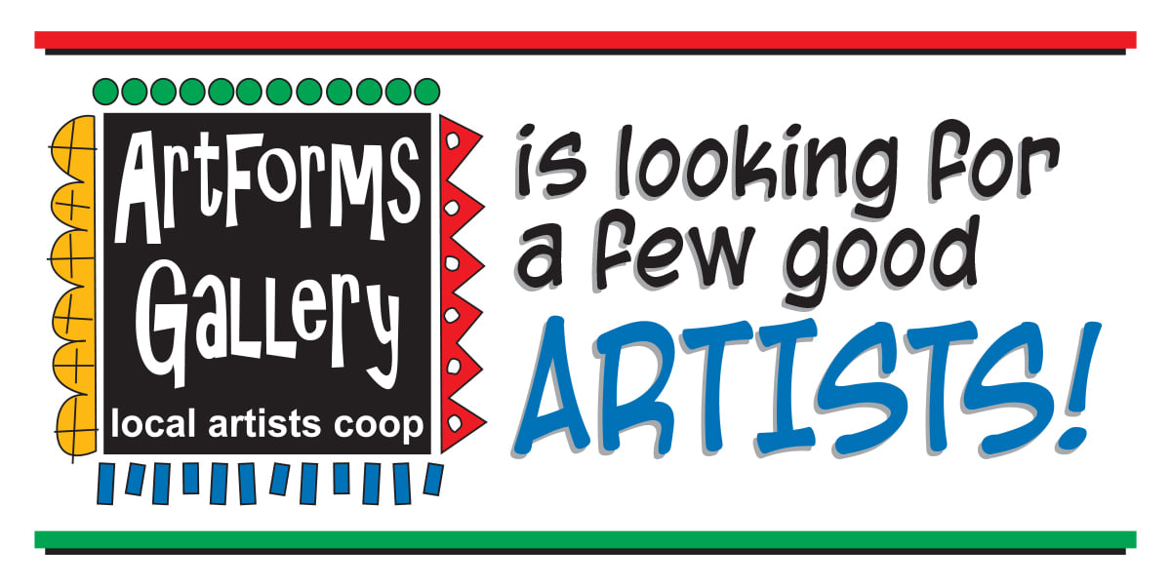Constant exposure in the community with minimal time and financial investment.
* Opportunity to be featured in special events and on the ArtForms Gallery website and Facebook page.
* Participate in ArtForms Gallery group shows.
* Be a member of a supportive community of artists.
* Maximize sales with minimal effort. NO commission on sales through the gallery.
* Offer workshops to increase income potential through the gallery.
* Attend monthly meeting to discuss and offer input in gallery operations.
* IT’S FUN!

**Email info@ArtForms-Gallery.com For more information**

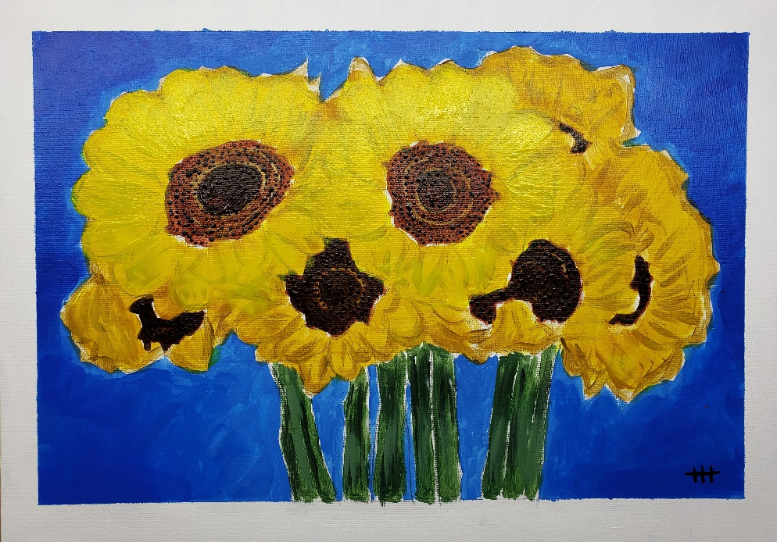

**Stand Together!**

**Artists: Nicole Meyer-Foresman and Michael Cessna**

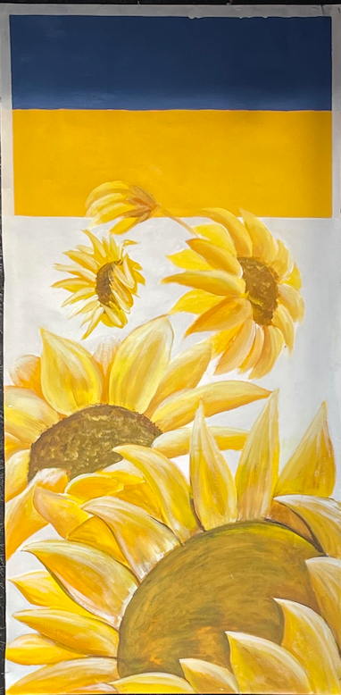Please join us in both creating a beautiful piece of art and in supporting the children of Ukraine! Each workshop participant will be given a 12” x 18” blank burlap garden flag on which an image supporting the children of Ukraine will be painted. We'll provide at least two examples. Note: A flag pole isn't included. The theme will reflect the colors of the Ukraine flag (i.e. yellow and blue) and the national flower of Ukraine (i.e. sunflower). One hundred percent of the proceeds will be donated to UNICEF USA for the children of Ukraine. This is a beautiful opportunity to support a great cause!

Sunday, May 1 | Time: 1:00 p.m. - 5:00 p.m.

Drop by anytime between 1:00 and 5:00 p.m. and we will accommodate you!

Fee: $40 **Note: One hundred percent of**

**the proceeds will be donated**

**to UNICEF USA and will be designated for the children of Ukraine.**

Age: Appropriate for all ages  
Class size: 12

**Art Exploration and Weekly Beginning Painting Instruction**

**Artists: Pat Glick and Laura Wright**

Are you looking for camaraderie while exploring your artistic side? Join Gallery artists Pat Glick and Laura Wright **every** Tuesday afternoon for a fun time working on your own project or art! Bring your materials and create with us for free!

Tuesdays, May 3, 10, 17, 24, 31 | 12:30 – 3:30 p.m.

* Art Exploration Workshop Fee: FREE~FREE~FREE!!!
* Beginning Painting Workshop Fee: $15 per session, payable at time of registration each week to reserve a spot
* Ages: 11 and older

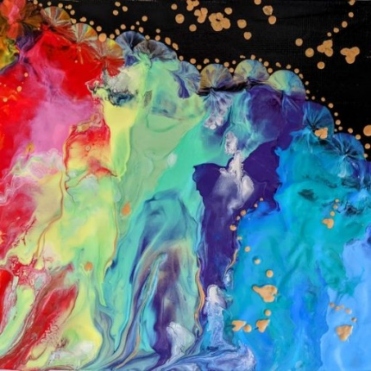**Acrylic Pour Painting** **Artist: Debbie Southard**

We will be doing a gradient technique with negative space on canvas. This class is for those who are inexperienced and experienced with fluid art.

Once varnished it is very touchable and can be wiped off with a damp cloth to clean.

* Saturday, May 7 | 2:00 p.m. – 4:00 p.m.
* Fee: $35
* Class limit: 10
* Age: 14 years and older

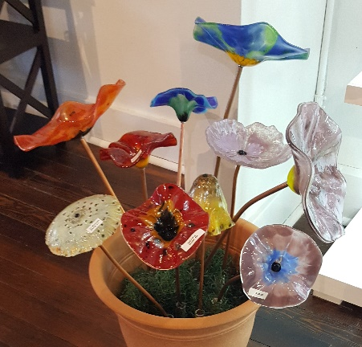**Fused Glass Flowers Artist: Dianne Miller**

Using glass powders and water, participants will create a slurry in a variety of colors and design a glass flower to be fused on a ceramic mold. After drilling a hole, a copper tube will be inserted to make a free-standing flower for your home or flower bed. Since you will be working with glass powders, please bring a mask (**N95 recommended**) and wear close-toed shoes.

* Saturday, May 14 | 1:00 p.m. – 3:00 p.m.
* Fee: $30 for one slurry flower; $55 for two slurry flowers
  + $40 for one large slurry flower, payable at time of registration
* Class limit: 10
* Age: All ages; however, children under 12 require adult supervision

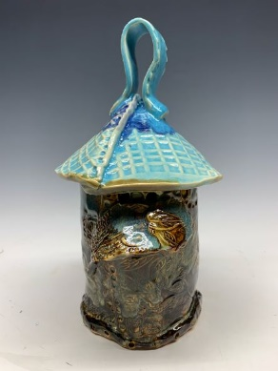**Ceramic Bird Houses Artist: Daria Claiborne** Using a slab of clay, participants will create ceramic birdhouses using stencils, stamps, and other tools. Patterns will be included, but you are not limited to only that design. Bring your creativity!! All supplies are provided. Get muddy in the clay with Daria!

* Sunday, May 15 | 1:00 – 4:00 p.m.
* Fee: $45, payable at time of registration
* Ages: 12 and older
* Class size: 8

**Composition Notebook Journal Artist: Brenda Hayes**

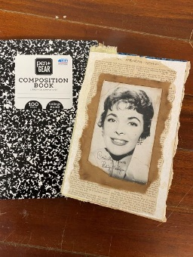

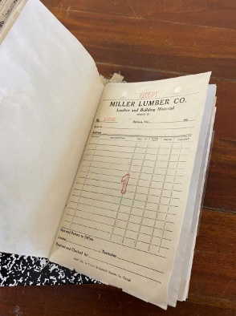**First time offered!** In this fiber workshop, you will take a basic composition notebook and turn it into a journal to gift someone or record your thoughts! Coffee-dyed paper, stamps, inks, vintage ephemera, acrylic and watercolor paints, vintage lace, fabrics, and junk mail are materials you will work with to create your own unique journal. All supplies are provided. Bring your creativity!!!

* 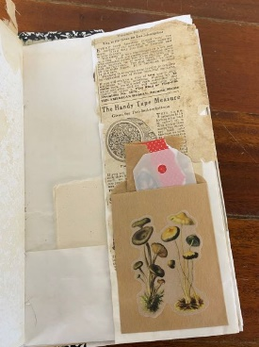Saturday, May 28 | 1:00 - 4:00 p.m.
* Workshop fee: $35
* Ages: 14 years and older
* Class size: 6

**“It’s a Scream!”**

**6th Annual Young Artist Camp 2022!**

**Presented by the Dynamic Duo Nicole Meyer-Foresman and Kristin Girard!**

**Fun while creating!**

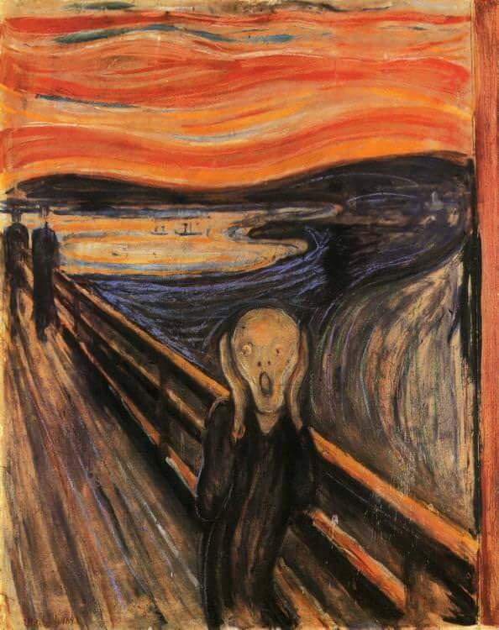

* **Thurs May 26**
* **Fri May 27**
* **Tues May 31**
* **Wed June**
* **Thurs June 2**

|  |  |
| --- | --- |
| **Ages** | **Time** |
| **6-9** | **9:00 – 10:00 a.m.** |
| **10-12** | **11:00 – 12:30 p.m.** |
| **13-18** | **1:30 – 3:00 p.m.** |

**Workshop fee: $60 per student Class size: 12**

**"2 Hot"**

A Jewelry workshop, using torches!

Presented by Kristin Girard and Nicole Girard Meyer-Foresman

Looking for fresh ideas to energize your curriculum?  This mini-Art Ed boot-camp is designed to share jewelry-making projects with instructors who may not have a loaded metal smithing studio.  Projects include: soldered earrings, cuttlebone casting, and rivet pendant.  Techniques include: designing, sawing, piercing, riveting, soldering, and casting.

**Not a teacher?  No problem!**  Anyone who is interested in these jewelry-making techniques may join our adventure!

**This is not "Too Hot" for you!**

* Tuesday—Thursday, May 31, June 1 and 2 | 4:00 - 6:30 p.m.
* Workshop fee: $90 per participant
* Age: 18 years and older
* Class size: 8

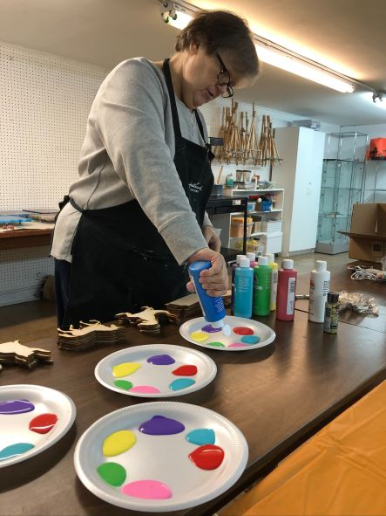

ArtForms Gallery artist Ruth Miller preps trays of bright colors for a kids’ private party workshop!

Have a special event coming up in your family or circle of friends? Schedule a private party with a Gallery artist in painting, jewelry-making, journal-making, fused glass, clay-building, and more!

Call ArtForms Galllery to discuss your ideas!

620-240-0165

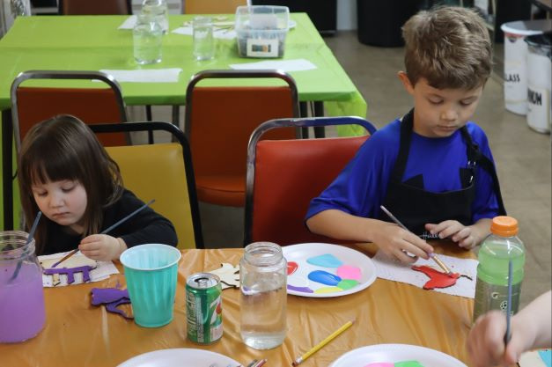

Check out these pictures from a private birthday party workshop! You too can book a private party for any age group with one of our artists!

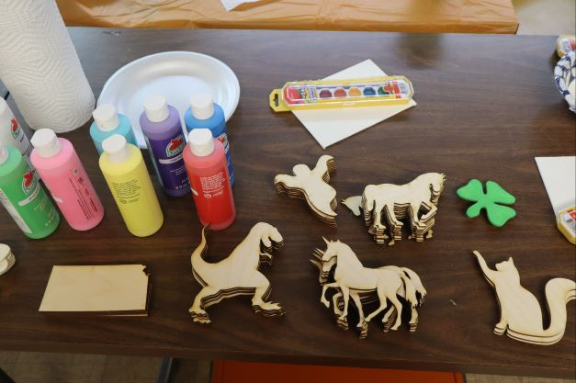

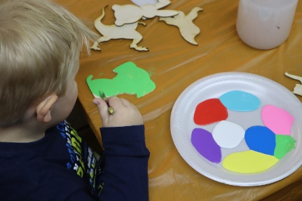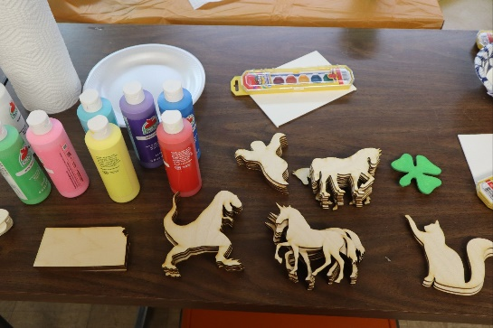

**Check our Facebook page during the month as artists may offer “popup” workshops!**

ArtForms artists also offer pop-up workshops during the month. Follow the Gallery on its Facebook page and/or its website!

* Facebook: [ArtFormsGallery620/](https://www.facebook.com/ArtFormsGallery620/)
* Website: [www.artforms-gallery.com](http://www.artforms-gallery.com)

Do you have a birthday or special occasion to celebrate? Contact the Gallery to book a private party with an ArtForms Gallery artist!

Possibilities include:

|  |  |
| --- | --- |
| * Sip and Paint * Painting * Jewelry * Textiles | * Fused Glass/Stained Glass * Pottery (ceramic birdhouse, windchime, pitchers) * Fiber |
| **Have a workshop suggestion or special request for us?**  **Don’t hesitate to give us a call!**  See the source image  **Become a**  **Gallery Patron**  Save 10% on **every** workshop you take in a 12-month period!!!  Only $40.00 | |

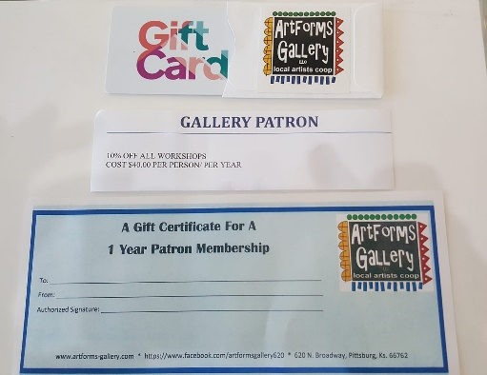

Give the gift of creativity with an

ArtForms Gallery Gift Card or a

Gallery Patron Membership!