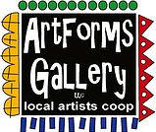
June 2023 Workshops
We have locally made gifts for the fathers in your life for Father’s Day!
620 N. Broadway, Pittsburg, KS 620-240-0165
ArtForms Gallery is a co-op of artists offering monthly workshops ranging from acrylic painting, watercolor, oil pastels, glass fusing, pottery, metalsmithing, jewelry, textiles, kids’ art and more! All workshops are held at the Gallery unless otherwise noted. Please call Artforms Gallery to register for any artist’s workshop. 620-240-0165
Refunds/Cancellations—Decisions regarding refunds and cancellations are determined by the artist leading the workshop. You can find individual contact information for each artist on the “Artists” page of our website, or just call the Gallery and we’ll get you in touch. Facebook:ArtFormsGallery620/
Art Explorations!
Are you looking for camaraderie while exploring your artistic side? Join Gallery artists Pat Glick every Tuesday afternoon for a fun time working on your own project or art! Bring your materials and create with us for free!
Every Tuesday
June 6, 13, 20, 27
12:30 – 2:30 p.m.
FREE~FREE~FREE!!!
Give the Gift of Art
- Original Art
- Local Artists
- Gift Cards

Gift cards may be purchased in any amount and do not expire. They may be redeemed for workshops or for original art!

To check the balance of your Gift Card online:
https://squareup.com/gift/46K96BF2TK6W7/check-balance
Website:www.artforms-gallery.com
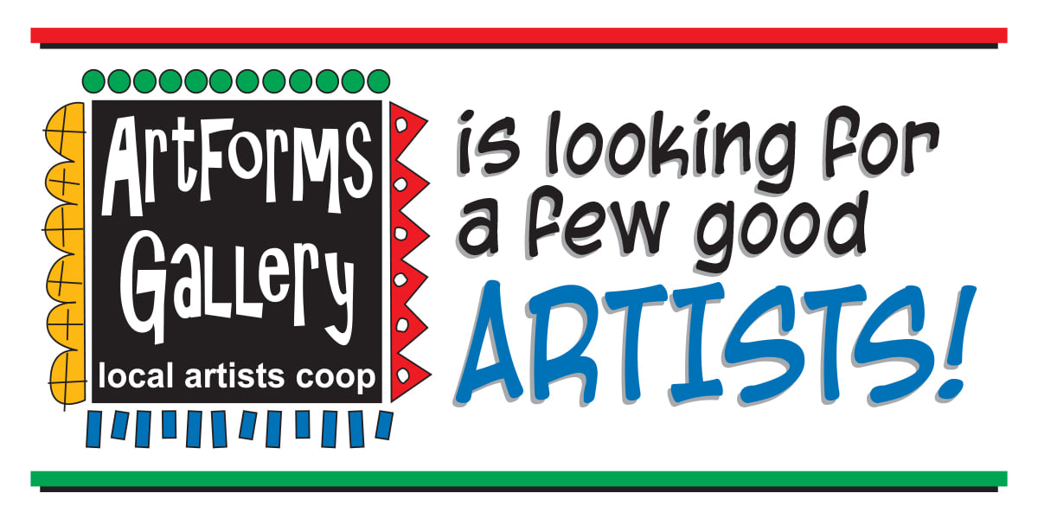
- Constant exposure in the community with minimal time and financial investment.
ArtForms Gallery artists extend a heartfelt thank you to everyone who participated in our Mini-Art Fundraiser in April. Your support allowed us to purchase our new Square Register for easier checkout sooner than we had even hoped! If you have driven by the Gallery or stopped in, you probably noticed the new light bars that make the art in the window more visible. Again, thank you!
We appreciate your support of our Gallery very much. Stay tuned as we are planning our 7th anniversary in the next few months!

Mini-Art Fundraiser winners:
Elementary: Owen G.
Middle School: Sophia R.
High School: Sasha M.
Adult: Mary L.

- Opportunity to be featured in special events and on the ArtForms Gallery website, Instagram, and Facebook pages.
- Participate in ArtForms Gallery group shows.
- Be a member of a supportive community of artists.
- Maximize sales with minimal effort. NO commission on sales through the Gallery.
- Offer workshops to increase income potential through the Gallery.
- Attend monthly meetings to discuss and offer input in Gallery operations.
- IT’S FUN!
Email info@ArtForms-Gallery.com For more information

Double Up! Artist: Debbie Southard
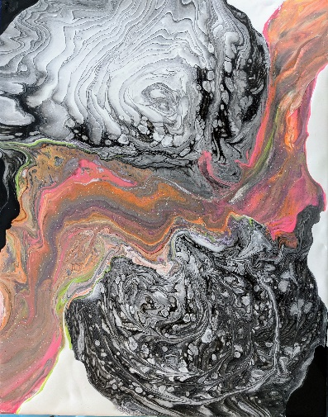
This month’s fluid art is a double type of technique. We will first do two ring pours and then we will put a colorful swipe between the two. We will be using a pallet knife to do this swipe.
- Saturday, June 2 | 2:00 – 4:00 p.m.
- Workshop Fee: $30, due at time of registration
- Class limit: 10
- Ages: 12 and older

Ceramic Windchimes Artist: Daria Claiborne
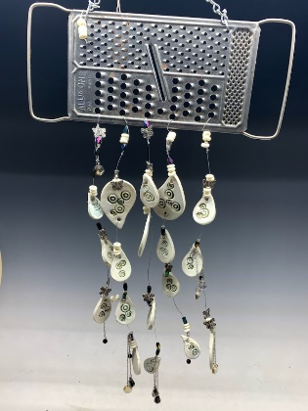
It's time to make ceramic wind chimes! This is a fun class divided into 2 sections. In the first part, you will create the ceramic pieces and work on the plan for the finished piece. The second part is for the actual construction of the wind chime! All supplies are provided, including kiln-firing.
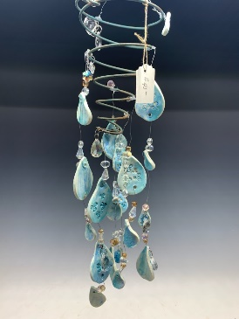
- Date: Sunday, June 11 | 1:00 p.m. – 3:00 p.m.
(Part 1)
- Date: Sunday, June 25 | 12:00 p.m. – 4:00 p.m.
(Part 2)
- Workshop Fee: $50, due at time of registration
- Class limit: 10
- Ages: 12 and older

ArtForms artists also offer pop-up workshops during the month. Follow the Gallery on our Facebook page and/or our website!
Facebook: ArtFormsGallery620/
Website: www.artforms-gallery.com
Do you have a birthday or special occasion to celebrate? Contact the Gallery to book a private party with an ArtForms Gallery artist!
Possibilities include:
- Sip and Paint  - Painting  - Jewelry  - Textiles  - Pour Painting | - Fused Glass/Stained Glass  - Pottery (ceramic birdhouse, windchime, pitchers)  - Fiber  - Glass and Resin
Have a workshop suggestion or special request for us?
Don’t hesitate to give us a call!

Become a
Gallery Patron
Save 10% on every workshop you take in a 12-month period!
Only $40.00

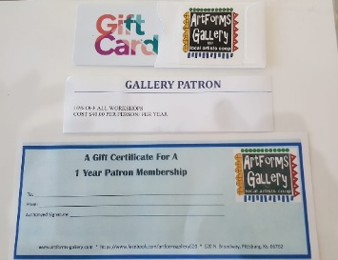
An ArtForms Gallery gift card makes the perfect gift for any occasion! Our gift cards may be purchased in any amount and they never expire.
See you soon in the Gallery!

