*Fantastic Workshops*

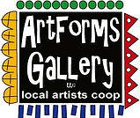
December 2023 Workshops
620 N. Broadway, Pittsburg, KS 620-240-0165
ArtForms Gallery is a co-op of artists offering monthly workshops ranging from acrylic painting, watercolor, oil pastels, glass fusing, pottery, metalsmithing, jewelry, textiles, kids’ art and more! All workshops are held at the Gallery unless otherwise noted. Please call ArtForms Gallery to register for any artist’s workshop.
Refunds/Cancellations—Decisions regarding refunds and cancellations are determined by the artist leading the workshop. You can find individual contact information for each artist on the “Artists” page of our website, or just call the Gallery and we’ll get you in touch. Facebook:ArtFormsGallery620/
Give the Gift of Art
- Original Art
- Local Artists
- Gift Cards

Gift cards may be purchased in any amount and do not expire. They may be redeemed for workshops or for original art!

To check the balance of your Gift Card online:
https://squareup.com/gift/46K96BF2TK6W7/check-balance
Website:www.artforms-gallery.com
Art Explorations!
Are you looking for camaraderie while exploring your artistic side? Join Gallery artists Pat Glick every Tuesday afternoon for a fun time working on your own project or art! Bring your materials and create with us for free!
Every Tuesday
Dec. 5, 12, 19, 26
12:30 – 2:30 p.m.
FREE~FREE~FREE!!!

Christmas Advent Calendar Houses Artist: Sarah Prince
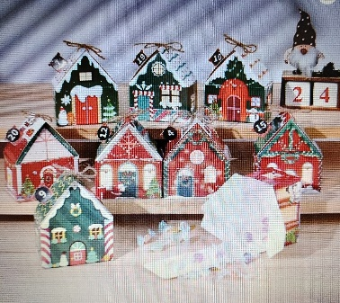
The countdown to Christmas is a very exciting time! Join us to make 24 Christmas Advent gift boxes. We will put them on strings so you can make a garland out of them or hang them on your tree. These will also make a fun table decoration. All materials will be provided, including candies, chocolates, and trinkets to put in the houses, or you can fill them with your own sentimental pieces.
- Date: Saturday, December 2 | 1:00 p.m. – 3:00 p.m.
- Workshop Fee: $40, due at time of registration
- Class size: 14
- Ages: 7-107 years

Ceramic Ornaments Artist: Daria Claiborne
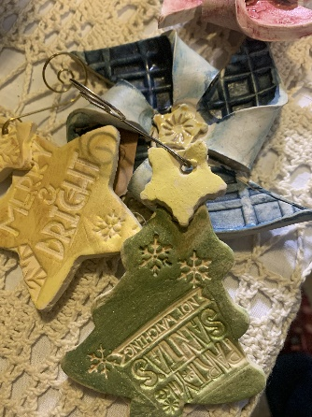
Create, decorate and color your own ceramic Christmas ornaments!! All supplies available! You will create up to eight ornaments!
- Date: Sunday, December 3 | 1:00 p.m. – 4:00 p.m.
- Workshop Fee: $50, due at time of registration
- Class size: 10
- Ages: All ages

Paper Marbling, Festive Colors! Artist: Mona Jurshak
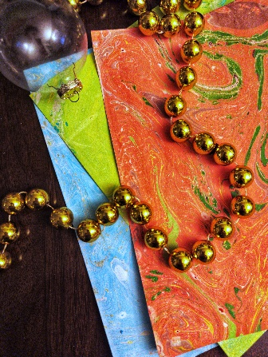
Get into the holiday spirit with paper marbling in festive colors. Whether you are a novice or an experienced crafter, you will enjoy this hands-on experience. All materials are provided. Plus, don't miss our upcoming origami class next week to turn your marbled paper into elegant stars. Join us for a creative and memorable holiday season!
- Date: Wednesday, December 6 | 6 p.m. – 8:00 p.m.
          - (Feel free to bring your dinner!)
- Workshop fee: $35, due at time of registration
- Ages: 12 years and older

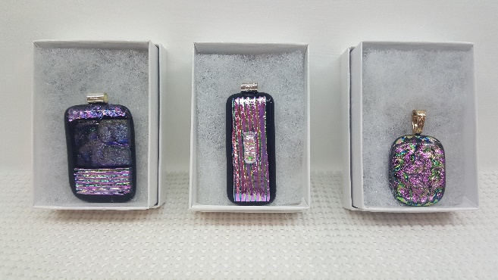
Fused Glass! Jewelry Artist: Dianne Miller
Perfect for gifting to your friends who love bling! Learn the basics of glass-cutting as you create a beautiful and stylish fused glass dichroic cabochons. Glass-cutting techniques will be taught so experience is not necessary. You should be able to create 4 in the time allowed. Each one will be finished with a bail ready for a cord or chain. There will be several cords available for $2.00 each. All supplies and tools are provided. Please wear close-toed shoes when working with glass.
- Date: Saturday, December 9 | 1:00 p.m. – 3:00 p.m.
- Workshop Fee: $50, due at time of registration
- Class size: 12
- Ages: 14 years and older

Christmas Ornaments Artist: Brenda Hayes
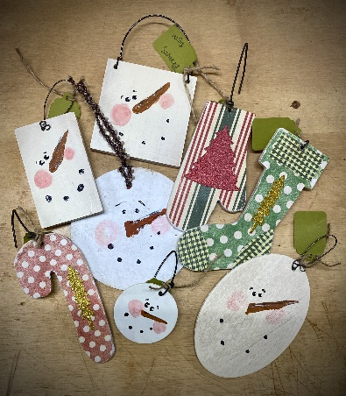
We will make an assortment of holiday ornament using paint, glue, fibers, and papers. We will crank up the Christmas music and celebrate the season!
- Date: Sunday, December 10 | 1:00 p.m. – 3:00 p.m.
- Workshop Fee: $30, due at time of registration
- Class size: 8
- Ages: 12 years and older

Origami Star Ornaments Artist: Mona Jurshak
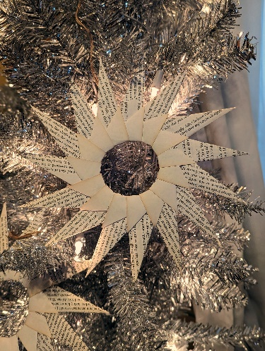
Unleash your creativity by folding beautiful origami stars! We'll provide a variety of papers, including pages from old books and more, to enhance your creations. If you attend our marbling workshop the previous week, you can even incorporate your marbled papers into these unique ornaments. This workshop is perfect for a post-present-opening activity, allowing you to repurpose wrapping paper and engage in a fun and educational crafting experience with friends and family and friends.
- Date: Wednesday, December 13 | 6 p.m. – 8:00 p.m.
      - (Feel free to bring dinner!)
- Workshop Fee: $30, due at time of registration
- Ages: All ages- under 14 accompanied by an adult

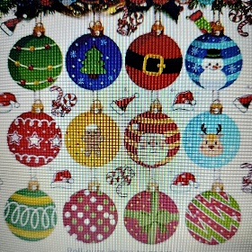
Diamond Painting Artist: Sarah Prince
Christmas Ornaments
Is there anything more satisfying than making your own Christmas ornaments to give away as gifts or spruce up your own tree? In this workshop, we will take resin ornaments and decorate them with diamonds. Each attendee will make 3-5 ornaments. There will be a wide array of ornaments to choose from and all materials are provided for you. This does take concentration and patience, but the outcome is so rewarding and beautiful.
- Date: Saturday, December 16 | 1:00 p.m. - 3:00 p.m.
- Fee: $35, due at time of registration
- Age Limit: 7-107 years
- Class limit: 14 people

Beginner Brush Calligraphy Artist: Neva Rowland
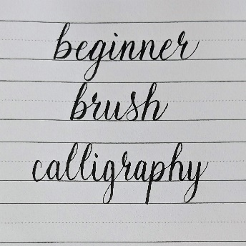
Did you miss the beginner calligraphy workshop last month? Good news! It will be offered again in December!
If you did attend the previous calligraphy workshop, then you can attend this one at a discounted rate for extra guided practice and the opportunity to design your own holiday greeting card!
Have you seen fancy calligraphy shared on Pinterest or Instagram and wanted to learn, but didn't know where to start? While there are many styles and tools to create beautiful calligraphy, this class will utilize a beginner friendly brush pen to build skills from basic strokes, to letters, to words. The skills learned in this class will serve as excellent base knowledge for exploring other calligraphy styles to showcase in everything from bullet journals to holiday cards.

Beginner Brush Calligraphy Details
- Date: Sunday, December 17, 2023 | Time: 1:00 p.m. - 3:00 p.m.
- Fee: $30 (first time), $10 (second time)
- Ages: 10+ (Those under 14 years of age must be accompanied by an adult. The adult need not pay the workshop fee unless they wish to participate.)
- Number of participants: 15

Will you have family home for the holidays? Now is the time to schedule a family-bonding and creative private art workshop with one of our talented artists! Just call us: 620-240-0165.
Facebook: ArtFormsGallery620/
Website: www.artforms-gallery.com

Do you have a birthday or special occasion to celebrate? Contact the Gallery to book a private party with an ArtForms Gallery artist!
Possibilities include:
- Sip and Paint  - Painting  - Jewelry  - Textiles  - Pour Painting | - Fused Glass/Stained Glass  - Hand-built Pottery (ceramic birdhouse, windchimes, toad houses, pitchers)  - Fiber
Have a workshop suggestion or special request for us?
Give us a call!

Purchasing a Gallery Patron membership for a friend or family member is a great gift any time of the year!
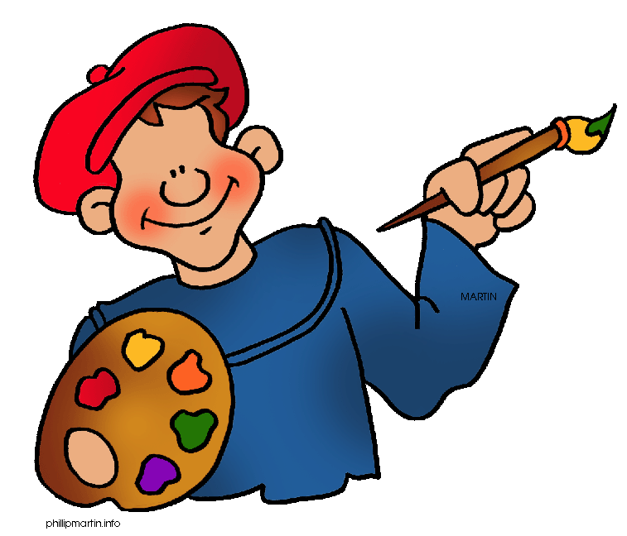
Become a
Gallery Patron
Save 10% on every workshop you take in a 12-month period!
Only $40.00

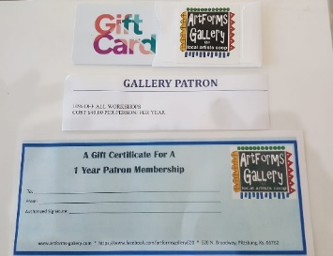
An ArtForms Gallery gift card makes the perfect gift for any occasion! Our gift cards may be purchased in any amount and they never expire.

