

January 2022 Workshops
620 N. Broadway, Pittsburg, KS 620-240-0165

Sun | 12:00 – 4:00 p.m.
Mon | Closed
Tues | 12:00 – 6:00 p.m.
Wed | 12:00 – 6:00 p.m.
Thur | 12:00 – 6:00 p.m.
Fri | 12:00 – 6:00 p.m.
Sat | 10:00 – 4:00 p.m.
Gallery hours

ArtForms Gallery is a co-op of artists offering monthly workshops ranging from acrylic painting, watercolor, glass fusing, pottery, metalsmithing, jewelry, textiles, kids’ art and more! All workshops are held at the Gallery unless otherwise noted. Please call Artforms Gallery to register for any artist’s workshop.
Refunds/Cancellations—Decisions regarding refunds and cancellations are determined by the artist leading the workshop. You can find individual contact information for each artist on the “Artists” page of our website, or just call the Gallery and we’ll get you in touch.
Website: www.artforms-gallery.com
Facebook: ArtFormsGallery620/
ArtForms Gallery artists are doing our part in maintaining a clean and safe environment for you to shop or take a workshop. At the time of this publication, we are still recommending wearing masks when shopping and during workshops. Please watch for announcements or call the Gallery for updates as these guidelines may be adjusted according to changing health conditions in our community. We look forward to seeing you soon!

Give the gift of local art with an ArtForms Gallery Gift Card!
Gift cards may be purchased in any amount and do not expire.

To check the balance of your Gift Card online:
https://squareup.com/gift/46K96BF2TK6W7/check-balance

Meet Our New Artists!

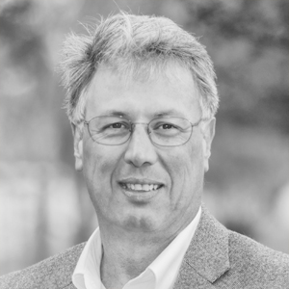
Michael Cessna
I'm a passionate photographer, artist, creator, writer, and poet. Like most artistic individuals, I'm an incredibly visual person and have always had an eye for beauty, whether natural or created. Using my openness and empathy, I’m always striving to capture and express an idea, message, or emotion through my works. The primary goal of my works is to express the ideas of friendship, romance, and love.
Look for Michael’s workshop January 22!!

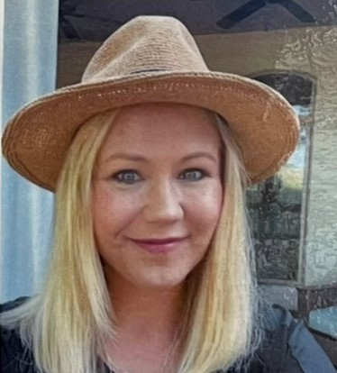
Rolanda Root
Growing up on a farm in rural Iowa I have always felt a close attachment to nature and the earth. 2-D art is my main focus; however, I do like to dabble in anything art related. I love to learn and create, especially if the topic is art related! Over the years I have been creating with pastel, oil, acrylic, encaustic, felting and mixed media. I have created many landscapes with pastel, oil and acrylic. I have recently started to work with leaves and paper dyeing. Creating my first dye pot was an experience. Whether it was mordanting paper, or adding bark, dried leaves, and iron to water and bringing to a boil the process felt like alchemy. With the art I create I want the viewer to feel an appreciation for our world and peace that is felt through nature.

Art Exploration! Free! Free! Free! Artists: Pat Glick and Laura Wright
Are you looking for camaraderie while exploring your artistic side? Join Gallery artists Pat Glick and Laura Wright every Tuesday afternoon for a fun time working on your own project or art! Bring your materials and create with us for free!
- Tuesdays, January 4, 11, 18, 25 | 12:30 – 2:30 p.m.
- Workshop Fee: FREE~FREE~FREE!!!

Weekly Beginning Painting Instruction Artists: Laura Wright and Pat Glick

Join Pat and Laura on Tuesdays 3:30 – 5:30 p.m. for beginning painting instruction! Materials and supplies will be provided. For a nominal fee of $15 for each session, you will learn basic brush strokes, shading, blending, and more!
- Tuesdays, January 4, 11, 18, 25 | 3:30 – 5:30 p.m.
- Workshop Fee: $15 per session, payable at time of registration each week to reserve a spot
- Ages: 11 and older

Beginning Stained Glass Artist: Dianne Miller
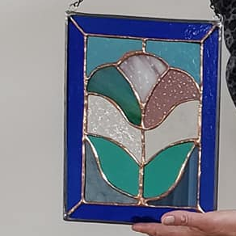
This 12-15 hour course is for the beginning stained glass art student or for someone who wishes to improve stained glass skills. You will learn to score, break, groze, grind, copper foil and solder your creation. You will take home a completed stained glass panel (approximately 8” x 10”) that you will be proud to display! An emphasis will be placed on glass considerations for different patterns, glass-cutting techniques and the steps to assemble a Tiffany-style glass panel. (Sample picture is one made in last year’s workshop. You will have a choice of 6 patterns.)
In a fun and relaxed atmosphere for learning, there will be demos, handouts, skills practice and plenty of time for questions. No experience is necessary. All tools, glass, and supplies will be provided by the Gallery and instructor.
Protective eyewear is required. Regular eyeglasses are sufficient. Please do not wear open-toed shoes when working with glass! Class is limited to 6 participants to allow for social distancing. Face masks are optional in the Gallery.
- Sundays, January 2, 9, 16, 23, 30 | 1:00 – 4:00 p.m.
- Attending each session is required to complete the project.
- Workshop fee: $150 per person, payable at time of registration
- Class size: 6
- Ages: 16 and older
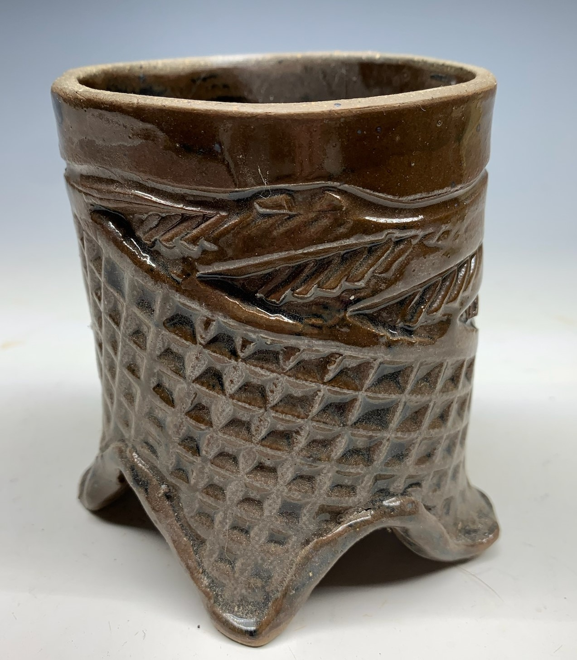
Ceramic Cups Artist: Daria Claiborne
So, you have made a pitcher with Daria? Let's make matching cups! We will work with slabs to create wonderful, usable cups! All supplies are provided.
- Saturday, January 15 | 2:00 – 4:00 p.m.
- Workshop fee: $40 for two cups; each additional cup $15, payable at registration
- Class size: 8
- Ages: 14 and older

First-time Offering by New Artist Mike Cessna!
Fun With Bookmarks! Artist: Mike Cessna
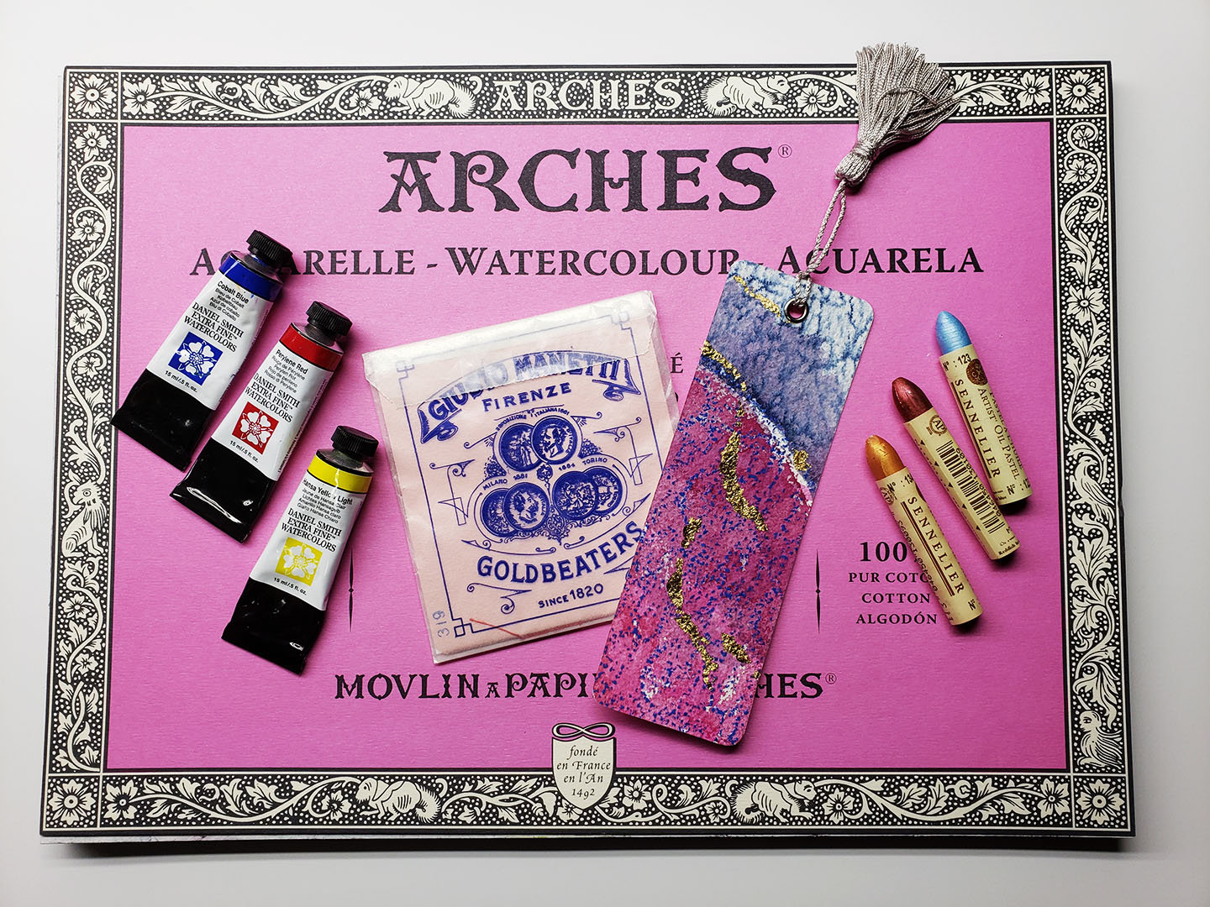
Create as many bookmarks using watercolor, oil pastels, tassels, and genuine 23.75 karat gold leaf as you can in 2.5 hour period using an 11 x 14 piece of Arches watercolor paper. Students will be sent home with a bonus tin of handmade watercolor with watercolor pans of iron oxide yellow, iron oxide red, and ultramarine blue. Each student will receive a full sheet of 23.75 karat gold leaf to incorporate into the artwork during the class.
- Saturday, January 22 | 2:00 p.m. – 4:30 p.m.
- Workshop fee: $30, payable at time of registration
- Class size: 6
- Age Limits: Adult

Paint Your Pet! A Paint & Sip Experience Artist: Nicole Meyer-Foresman
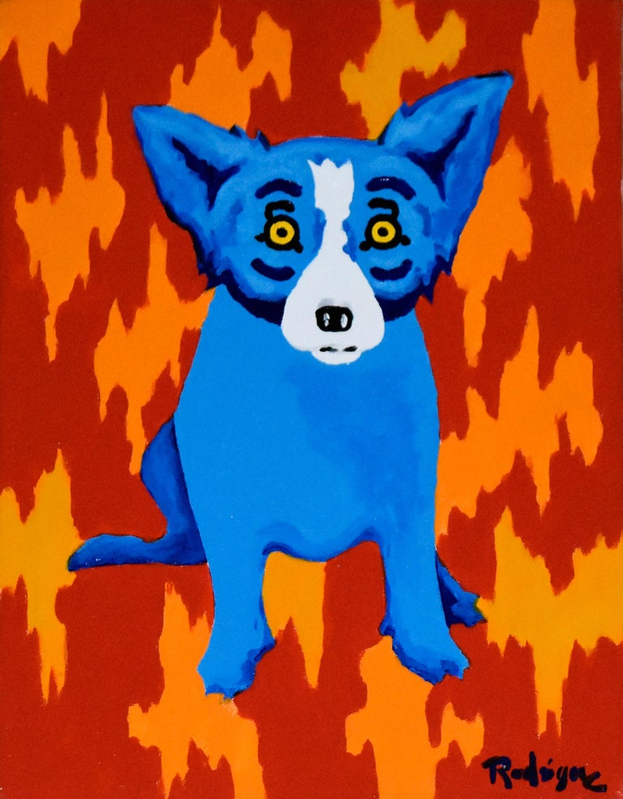
Who wouldn't want a custom one-of-a-kind portrait of your best friend to hang on your wall? In this workshop you will create a 16"x20" pop art style pet portrait inspired by George Rodrique. No painting experience necessary! Simply email the instructor (nmeyer@girard248.org) a good photo of your pet after paying for your spot in the class, and a sketch will be prepared for you.
Anyone over 21 is invited to bring your own beverage!
- Saturday, January 29 | 5:00 p.m. – 7:00 p.m.
- Workshop fee: $50, payable at registration
- Class size limited to 8
- Masks optional

Check our Facebook page during the month as artists may offer “popup” workshops!
ArtForms artists also offer pop-up workshops during the month. Follow the Gallery on its Facebook page and/or its website!
- Facebook: ArtFormsGallery620/
- Website: www.artforms-gallery.com
Do you have a birthday or special occasion to celebrate? Contact the Gallery to book a private party with an ArtForms Gallery artist!
Possibilities include:
- Sip and Paint  - Painting  - Jewelry  - Textiles | - Fused Glass/Stained Glass  - Pottery (ceramic birdhouse, windchime, pitchers)  - Fiber
Have a workshop suggestion or special request for us?
Don’t hesitate to give us a call!


Become a
Gallery Patron
Save 10% on every workshop you take in a 12-month period!!!
Only $40.00


Give the gift of creativity with an
ArtForms Gallery Gift Card or a
Gallery Patron Membership!

