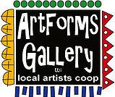
July 2023 Workshops
620 N. Broadway, Pittsburg, KS 620-240-0165
ArtForms Gallery is a co-op of artists offering monthly workshops ranging from acrylic painting, watercolor, oil pastels, glass fusing, pottery, metalsmithing, jewelry, textiles, kids’ art and more! All workshops are held at the Gallery unless otherwise noted. Please call Artforms Gallery to register for any artist’s workshop. 620-240-0165
Refunds/Cancellations—Decisions regarding refunds and cancellations are determined by the artist leading the workshop. You can find individual contact information for each artist on the “Artists” page of our website, or just call the Gallery and we’ll get you in touch. Facebook:ArtFormsGallery620/
Art Explorations!
Are you looking for camaraderie while exploring your artistic side? Join Gallery artists Pat Glick every Tuesday afternoon for a fun time working on your own project or art! Bring your materials and create with us for free!
Every Tuesday
July 11, 18, 25
12:30 – 2:30 p.m.
FREE~FREE~FREE!!!
Give the Gift of Art
- Original Art
- Local Artists
- Gift Cards

Gift cards may be purchased in any amount and do not expire. They may be redeemed for workshops or for original art!

To check the balance of your Gift Card online:
https://squareup.com/gift/46K96BF2TK6W7/check-balance
Website:www.artforms-gallery.com

Meet our new artists!

Neva Rowland!
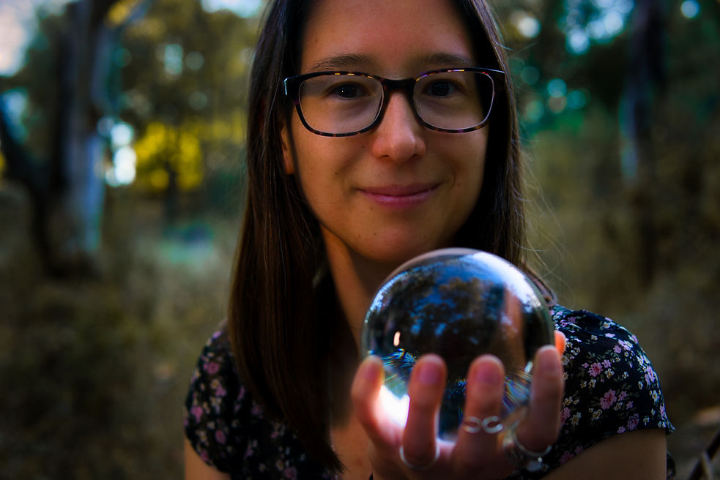
While I'm a musician by training, I love any activity where I can stretch my creative muscles. As a child, I watched all the drawing and painting shows I could get my hands on, but as an adult, I slowly lost the time to create. In February 2021, I decided to relearn and teach myself - beginning with traditional pencil and paper, and eventually buying an iPad and beginning digital art. Now I create fluid art, jewelry, and accessories, and offer intuitive art commissions.
Join Neva in her first workshop at ArtForms Gallery. See the details under the Workshop section!
​Website: https://linktr.ee/neva.rowland

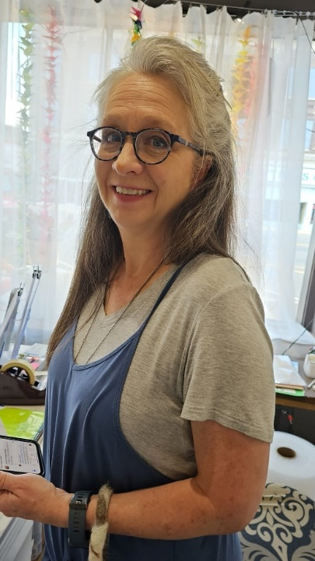
Kathy Mustain
Full-time nurse, wife, mother of 3 adult sons and a grandmother. I have worked for St. John’s/Mercy—Joplin, since 1986. (Do the math!) I am a former adjunct nursing clinical instructor for NEO A&M. My interest with anatomy and physiology feeds into awe with the beautiful care my Creator puts into nature …. from the cellular level to the vastness of the universe.
I’m currently playing with several different mediums. I’ve been doing stained glass, both 2D and 3D creations, as well as applying the copper foil techniques with jewelry creations. Playing with copper has led me to some applications of copper combining wood and stained glass furnishings. The wood I use comes from trees on the family farm. I love the look of live-edge wood. Somehow curiosity about wet felting piqued my interest a few years back, and I have grown to appreciate how it can be beautiful art as well as useful. This has led to making felted bags, scarves, shoes, and a few journal covers. I use natural colored wool as well as some dyed wool. I have experimented with using alpaca fleece also. Recently, I have dug my paint brushes out of the closet and dusted off a few decades of dust. Watercolor, pencil, and ink, etc. are coming back too into this season of life.
Each season is a beautiful gift to be treasured and I am blessed.

Workshops!
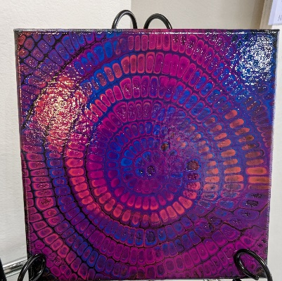
Chameleon Cells Fluid Art Artist: Neva Rowland
Great paint pour class for everyone from beginners to advanced students alike! This very calming and therapeutic technique will add a funky pattern to a basic flip cup. Participants will take home a 6"x6" artwork after their paint has dried.
Date: Saturday, July 15 | 1:00—2:00 p.m.
Fee: $35, due at time of registration
Age: 14+
Class Limit: 13

Create your own Garden Stepping Stone Artist: Sarah Prince
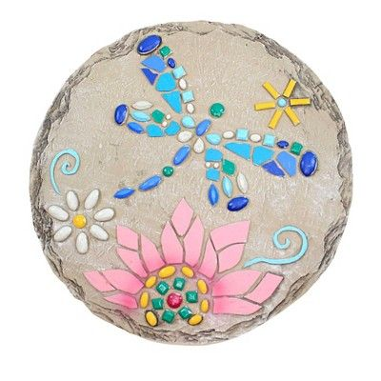
Create a colorful, beautiful concrete steppingstone for your garden or walkway. We will pour our homemade concrete into a mold and decorate with gorgeous jewels, rocks, marbles, glitter, and so much more. All materials are provided. These will stay in the gallery to dry, and you can pick them up after 24 hours. Come in and let your creative side shine!
Date: Saturday, July 22 | 2:00 - 4:00 p.m.
Ages: 8 - 100
Fee: $30, due at time of registration
Class Limit: 14 people
Fused Glass Workshops Return!!

Fused Glass Pocket Vases and Nightlights Artist: Dianne Miller
Two projects = twice the fun!
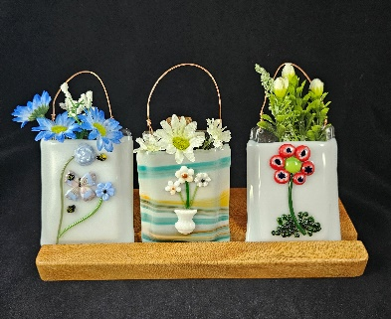
Pocket Vase: Decorate a pre-fused glass pocket vase with other glass embellishments of your choice. These sweet pocket vases will be finished after fusing with a copper wire to hang on a wall or window. You can fill it with real flowers (as the vase holds water), a small succulent, or silk flowers.
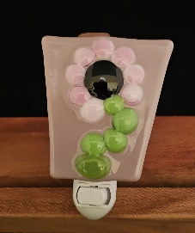
Nightlight: Decorate a fusible glass base with your own creative design. Basic glass-cutting skills will be demonstrated during the workshop, so prior glass experience is not necessary. After fusing, your glass will be mounted to a nightlight fixture and ready to light your way during the night!

Both projects will make great gifts for the coming holiday season, so plan now to attend!

Date: Saturday, July 29 | 1:00 - 3:00 p.m.
Fee: $50, due at time of registration
Ages: 12 years and older
Class Limit: 10 people

All supplies are included. Please do not wear open-toed shoes when working with glass.

ArtForms artists also offer pop-up workshops during the month. Follow the Gallery on our Facebook page and/or our website!
Facebook: ArtFormsGallery620/
Website: www.artforms-gallery.com
Do you have a birthday or special occasion to celebrate? Contact the Gallery to book a private party with an ArtForms Gallery artist!
Possibilities include:
- Sip and Paint  - Painting  - Jewelry  - Textiles  - Pour Painting | - Fused Glass/Stained Glass  - Pottery (ceramic birdhouse, windchime, pitchers)  - Fiber  - Glass and Resin
Have a workshop suggestion or special request for us?
Don’t hesitate to give us a call!

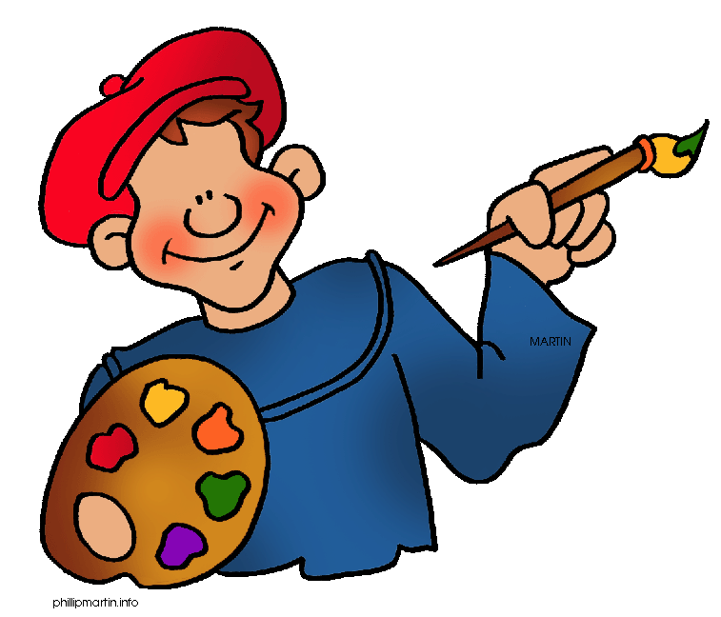
Become a
Gallery Patron
Save 10% on every workshop you take in a 12-month period!
Only $40.00

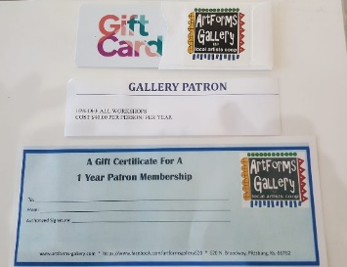
An ArtForms Gallery gift card makes the perfect gift for any occasion! Our gift cards may be purchased in any amount and they never expire.
See you soon in the Gallery!

