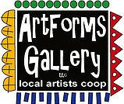
August 2022 Workshops
620 N. Broadway, Pittsburg, KS 620-240-0165
ArtForms Gallery artists currently have work on display until July 31 at Memorial Auditorium in Pittsburg! Check it out!

ArtForms Gallery is a co-op of artists offering monthly workshops ranging from acrylic painting, watercolor, glass fusing, pottery, metalsmithing, jewelry, textiles, kids’ art and more! All workshops are held at the Gallery unless otherwise noted. Please call Artforms Gallery to register for any artist’s workshop. 620-240-0165

Refunds/Cancellations—Decisions regarding refunds and cancellations are determined by the artist leading the workshop. You can find individual contact information for each artist on the “Artists” page of our website, or just call the Gallery and we’ll get you in touch.
Give the Gift of Art
- Original Art
- Local Artists
- Gift Cards

Gift cards may be purchased in any amount and do not expire. They may be redeemed for workshops or for original art!

To check the balance of your Gift Card online:
https://squareup.com/gift/46K96BF2TK6W7/check-balance
Website: www.artforms-gallery.com
Facebook: ArtFormsGallery620/

Each month Gallery artists design and design and stage our front window for your viewing pleasure!
July: Michael Cessna and Dianne Miller are planning an Americana/patriotic theme so drop by to check it out!
August: Metalsmith Janet Lewis and Woodturner Jim Miller
.

Art Exploration/Weekly Beginning Painting Instruction
Artist: Pat Glick
Are you looking for camaraderie while exploring your artistic side? Join Gallery artists Pat Glick every Tuesday afternoon for a fun time working on your own project or art! Bring your materials and create with us for free!
- Tuesdays, August 2, 9, 16, 23, 30 | 12:30 – 2:30 p.m.
- Art Exploration Workshop Fee: FREE~FREE~FREE!!!
- Beginning Painting Workshop Fee: $15 per session, payable at time of registration each week to reserve a spot
- Ages: Adults only

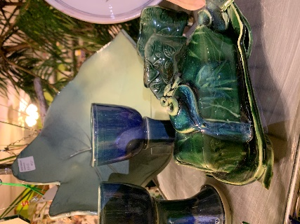
Ceramic Butter Dishes
Create your one-of-a kind butter dish. Add fun embellishments! All supplies will be included.
- Date: Sunday, August 14 | 1:00 p.m. – 4:00 p.m.
- Fee: $45, payable at time of registration
- Class limit: 8
- Age: 14 years and older
- Become a Patron and get 10% off your fee!

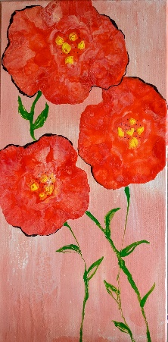
Blown Flowers Acrylic Pour Painting Artist: Debbie Southard
Make beautiful blooms on canvas using acrylic paints and pour painting. All supplies and instruction are provided. This fun workshop is for those who have no experience or lots of experience. Once varnished, your art is very touchable and can be wiped off easily with a damp cloth to clean.
- Date: Saturday, August 20 | 2:00 p.m. – 4:00 p.m.
- Fee: $35, payable at time of registration
- Class limit: 10
- Age: 14 years and older

Check our Facebook page during the month as artists may offer “popup” workshops!
ArtForms artists also offer pop-up workshops during the month. Follow the Gallery on its Facebook page and/or its website!
- Facebook: ArtFormsGallery620/
- Website: www.artforms-gallery.com
Do you have a birthday or special occasion to celebrate? Contact the Gallery to book a private party with an ArtForms Gallery artist!
Possibilities include:
- Sip and Paint  - Painting  - Jewelry  - Textiles | - Fused Glass/Stained Glass  - Pottery (ceramic birdhouse, windchime, pitchers)  - Fiber
Have a workshop suggestion or special request for us?
Don’t hesitate to give us a call!

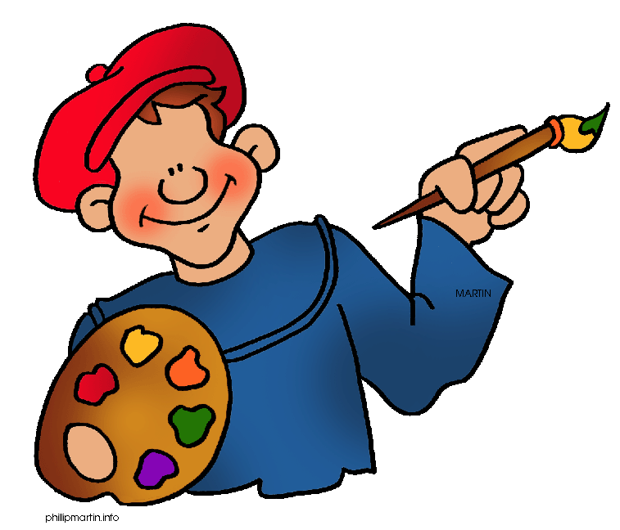
Become a
Gallery Patron
Save 10% on every workshop you take in a 12-month period!!!
Only $40.00

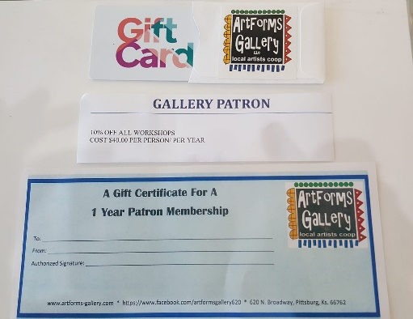
Give the gift of creativity with an
ArtForms Gallery Gift Card or a
Gallery Patron Membership!

