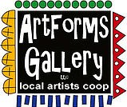
Late July/August 2020 Workshops
- Broadway, Pittsburg, KS 620-240-0165

ArtForms Gallery artists love when you visit our Gallery in search of the unique, handmade gift or a new art piece for your home or office! However, we also want our customers and artists to remain safe during the changing health conditions in our community. Please maintain appropriate social distancing and wear a mask when visiting. We will do our part in maintaining a clean and safe environment for you to shop or take a workshop. We look forward to seeing you again soon!

ArtForms Gallery is a co-op of 20 different artists offering monthly workshops ranging from oil painting, glass fusing, pottery, wood carving, metalsmithing, jewelry, textiles, kids’ art, photography, and more! All workshops are held at the Gallery unless otherwise noted. Please call Artforms Gallery to register for any artist’s workshop. 620-240-0165

Refunds/Cancellations—Decisions regarding refunds and cancellations are determined by the artist leading the workshop. You can find individual contact information for each artist on the “Artists” page of our website, or just call the Gallery and we’ll get you in touch.

Beginning Stained Glass Artist: Dianne Miller
This 15-hour course is for the beginning stained glass art student or for someone who wishes to refresh stained glass skills. You will learn to score, break, groze, grind, copper foil and solder your creation. You will take home a small, completed stained glass panel that you will be proud to display! An emphasis will be placed on glass considerations for different patterns, glass-cutting techniques and the steps to assemble a Tiffany-style glass panel.
In a fun and relaxed atmosphere for learning, there will be demos, handouts, skills practice and plenty of time for questions. No experience is necessary. All tools, glass, and supplies will be provided by the Gallery and instructor.
Protective eyewear is required. Regular eyeglasses are sufficient. Please do not wear open-toed shoes when working with glass! Class is limited to 4 participants.
Please bring a mask.
Please specify whether you will attend Saturday or Sunday sessions!
- Saturdays, July 25, August 1, 8, 15, 22
- Sundays, July 26, August 2, 9, 16, 23
- 2:00 – 5:00 p.m.
- $150, payable at time of registration
- Ages 18 and older

Beginner Mandala Workshop Artist: Rebecca
Drawing a mandala by hand is a great way to improve your drawing skills. Using repeating patterns and concentric circles, let structure build a beautiful drawing you can share proudly with friends and family. There will be time to not only draw your mandala, but to add a bit of color also. Whether you like to draw or would like a stepping stone into the world of drawing, this is a great class for you! All materials will be supplied.

- August 1
- 6:00 p.m. – 8:00 p.m.
- Fee: $25
- Class limit: 8
- Age: 12 years and older

Check our Facebook page during the month as artists may offer “popup” workshops!

Art Exploration! Free! Free! Free!

Are you looking for camaraderie while exploring your artistic side? Join Gallery artist Pat Glick every Tuesday afternoon, 1 p.m. – 3 p.m. to explore different art techniques. Pat will lead you through a creative art experience every week. Feel free to bring something you are working on also. We will have opportunities to participate in community activities and charities at times.
Art Exploration is free so you just bring your willingness to try something new in art!
- Every Tuesday
- 1:00 p.m. – 3:00 p.m.
Important!!!
Call ArtForms Gallery each Tuesday to confirm Art Exploration is definitely scheduled before coming.

ArtForms artists also offer pop-up workshops during the month. Follow the Gallery on its Facebook page and/or its website!
- Facebook: ArtFormsGallery620/
- Website: www.artforms-gallery.com

Do you have a birthday or special occasion to celebrate? Contact the Gallery to book a private party with an ArtForms Gallery artist!
Possibilities include:
- Sip and Paint  - Painting  - Jewelry  - Textiles | - Fused Glass/Stained Glass  - Pottery (ceramic birdhouse, windchime, pitchers, wheel-throwing)  - Woodcarving
Have a workshop suggestion or special request for us?
Don’t hesitate to give us a call!

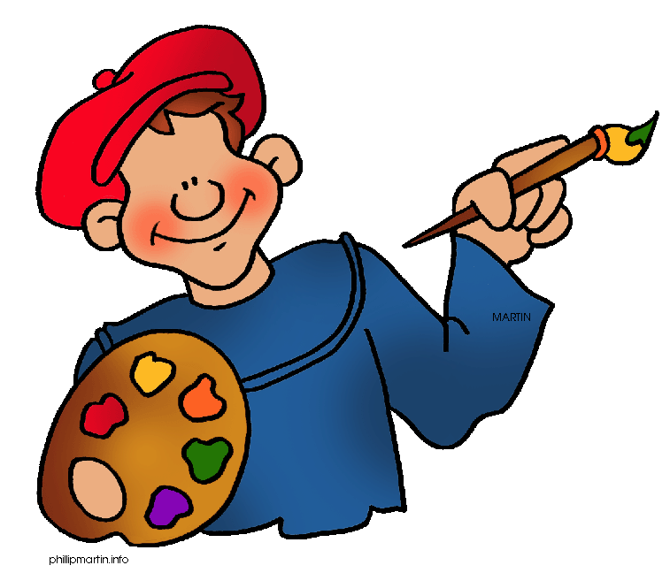
Become a
Gallery Patron
Save 10% on every workshop you take in a 12-month period!!!
Only $40.00

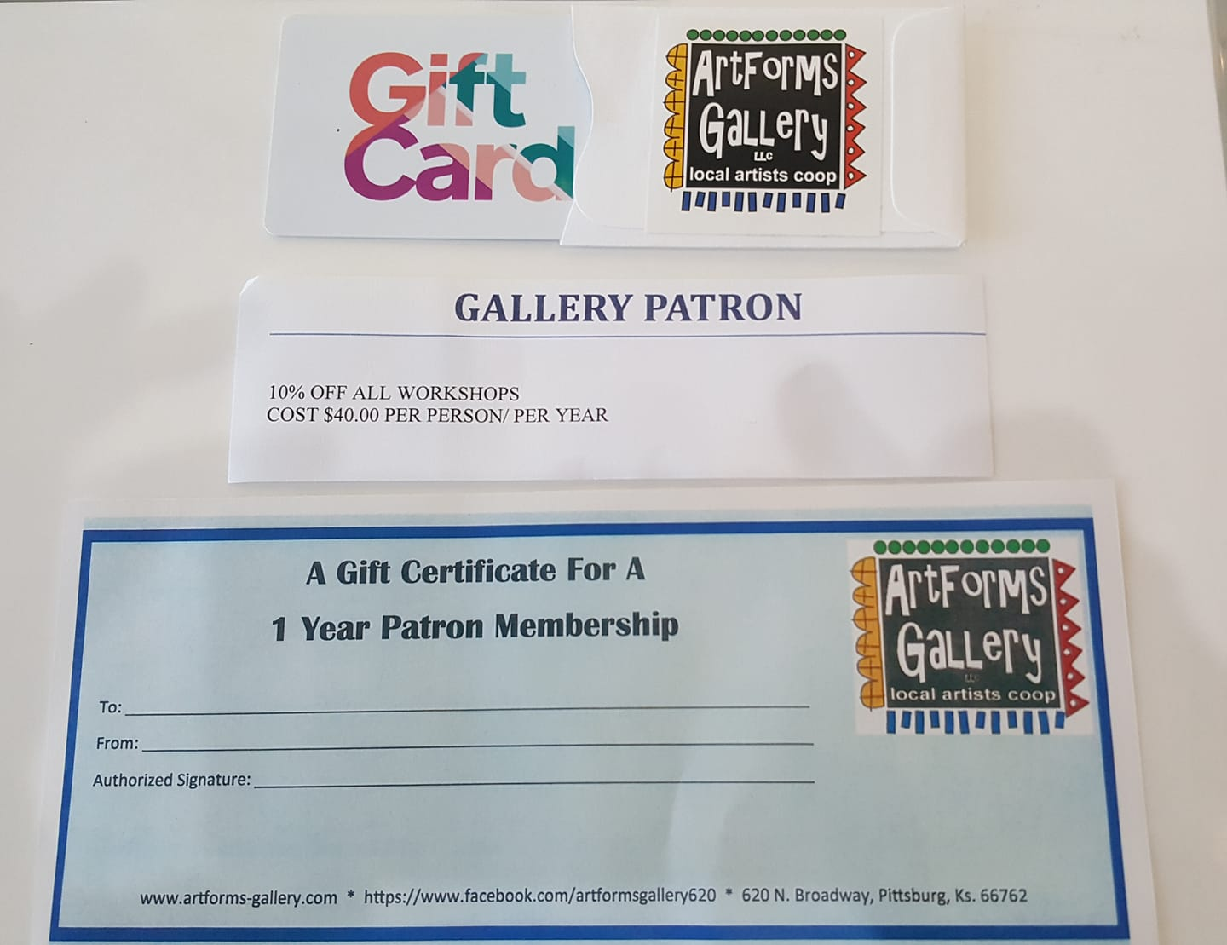
Give the gift of creativity with an ArtForms Gallery Gift Card or a Gallery Patron Membership!

