
September 2019 Workshops
620 N. Broadway, Pittsburg, KS 620-240-0165

ArtForms Gallery is a co-op of 21 different artists offering monthly workshops ranging from oil painting, glass fusing, pottery, wood carving, metalsmithing, jewelry, textiles, kids’ art, photography, and more! All workshops are held at the Gallery unless otherwise noted. Please call Artforms Gallery to register for any artist’s workshop. 620-240-0165

Refunds/Cancellations—Decisions regarding refunds and cancellations are determined by the artist leading the workshop. You can find individual contact information for each artist on the “Artists” page of our website, or just call the Gallery and we’ll get you in touch.

Woodcarving Coffee & Tea Scoops (Part II) Artist: Lanny
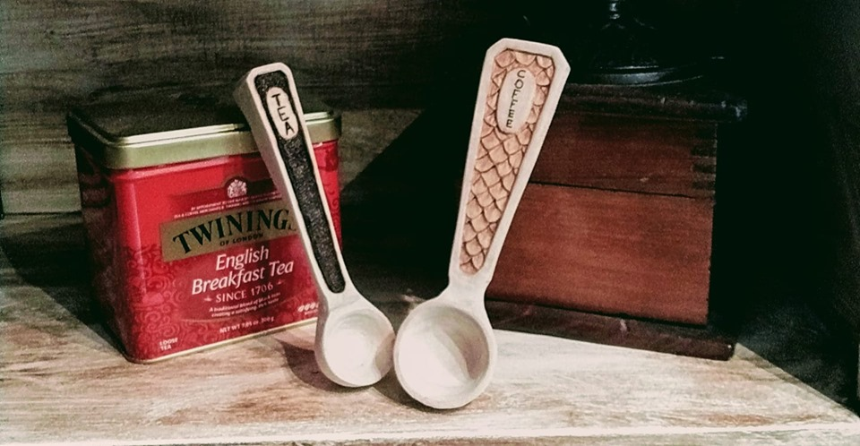
This session is a continuation of a workshop offered in August, so it’s too late to sign up for this session. But if woodcarving interests you, watch for Lanny Logan’s future workshops which range from beginner to more advanced skills.

- Saturday, September 21; 10:00 a.m. -- 1:00 p.m.
(No new registrations.)

Dangle Earrings Workshop Artist: Janet

Custom design and create your own pair of artistic dangle earrings with artist Janet Lewis. After walking you through the design process, she will show you how to use a jeweler’s saw to cut metal or other materials into your desired shapes. Then you will learn how to drill through your shapes and to use various types of jeweler’s pliers to assemble your earrings using “cold” connection methods. There is no example photo because your design will be as unique as you are!

- Saturday, September 28; 1:00 p.m. -- 4:00 p.m.
- Workshop Fee: $40.00, due by Friday, September 27, 2:00 p.m.
- Class size is limited to 8
- Ages 16 and older

Funky Fold Form Bracelet Class Artist: Kristin
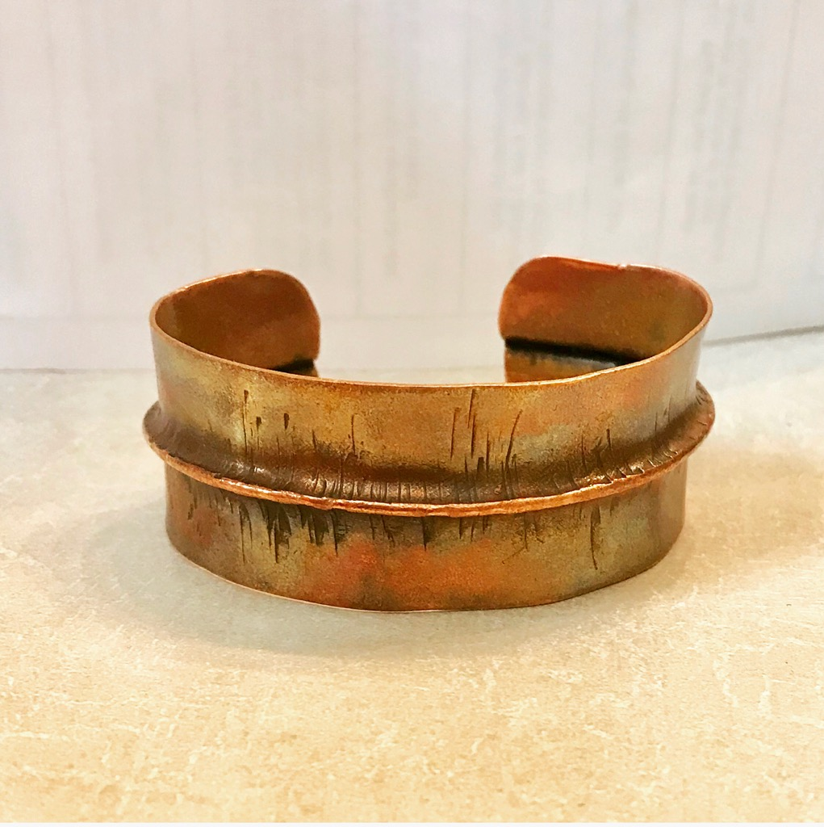

Make a funky copper bracelet using the fold form technique. Beginner level class. All tools and materials included in the workshop cost.
- Sunday, September 29
2:00 p.m. -- 4:00 p.m.
- Workshop Fee: $35.00
- Class size is limited to 8
- Ages 16 and older

ArtForms artists also offer pop-up workshops during the month. Follow the Gallery on its Facebook page and/or its website!
- Facebook: https://www.facebook.com/ArtFormsGallery620/
- Website: www.artforms-gallery.com

Do you have a birthday or special occasion to celebrate? Contact the Gallery to book a private party with an ArtForms Gallery artist!
Possibilities include:
- Sip and Paint evening
- Oil or acrylic painting
- Jewelry
- Fused Glass
- Pottery (ceramic birdhouse, windchime, pitchers)
- Textiles and more!

Have a workshop suggestion or special request for us? Don’t hesitate to give us a call!


Become a
Gallery Patron
Save 10% on every workshop you take in a 12-month period!!!
Only $40.00



Give the gift of creativity with an
ArtForms Gallery Gift Card or a
Gallery Patron Membership!

