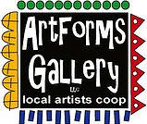**September 2023 Workshops**

**620 N. Broadway, Pittsburg, KS 620-240-0165**

ArtForms Gallery is a co-op of artists offering monthly workshops ranging from acrylic painting, watercolor, oil pastels, glass fusing, pottery, metalsmithing, jewelry, textiles, kids’ art and more! All workshops are held at the Gallery unless otherwise noted. Please call Artforms Gallery to register for any artist’s workshop. **620-240-0165**

**Refunds/Cancellations—Decisions regarding refunds and cancellations are determined by the artist leading the workshop.** You can find individual contact information for each artist on the “Artists” page of our website, or just call the Gallery and we’ll get you in touch. Facebook:[ArtFormsGallery620/](https://www.facebook.com/ArtFormsGallery620/)

**Art Explorations!**

Are you looking for camaraderie while exploring your artistic side? Join Gallery artists Pat Glick **every** Tuesday afternoon for a fun time working on your own project or art! Bring your materials and create with us for free!

Every Tuesday

August 1, 8, 15, 22, 29

12:30 – 2:30 p.m.

FREE~FREE~FREE!!!

**Give the Gift of Art**

* Original Art
* Local Artists
* Gift Cards

Gift cards may be purchased in any amount and do not expire. They may be redeemed for workshops or for original art!

To check the balance of your Gift Card online:

[https://squareup.com/gift/46K96BF2TK6W7/check-balance](https://squareup.com/gift/46K96BF2TK6W7/check-balance?fbclid=IwAR1iEqUd4ASMldq6Fm8eoysfMKfOYcFHXH1Rb1SFKIGHspD2yyCQCQInoJ8)

Website:[www.artforms-gallery.com](http://www.artforms-gallery.com)

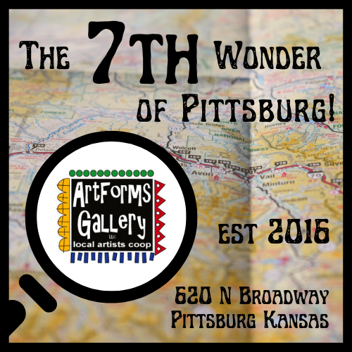

In honor of its 7th anniversary, ArtForms Gallery is declaring itself the 7th wonder of Pittsburg! Join us in a scavenger hunt for six more “wonderful” community artworks in the surrounding area for chances to win special anniversary artworks created by ArtForms artists.

A display of the anniversary artworks, scavenger hunt maps, and giveaway guidelines will be available at the Gallery. Artists will be doing demonstrations there throughout the day on Saturday, September 2, from 9:00 a.m. to 6:00 p.m. The drawing to win one of the 7th anniversary artworks will be held at 6:00 p.m. that evening.

Pittsburg Fall ArtWalk!!!

Friday, September 29

5 p.m. – 9 p.m.

ArtForms Gallery artists will be on the street

and INSIDE the Gallery!

Plan now to attend!

**Pour Over September Artist: Debbie Southard**

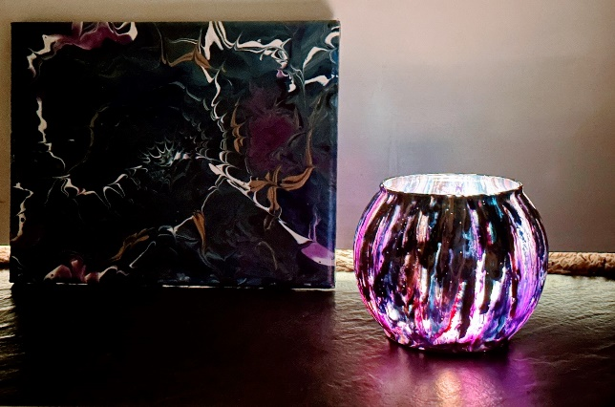Come pour over a votive holder to warm your home this coming Fall. Leaves will be falling soon so let's get prepared to make things at home cozy.

* Date: Saturday, September 2
* Time: 2:00 p.m. – 4:00 p.m.
* Fee: $35, due at time of registration
* Class size: 10
* Ages: 12 years and older

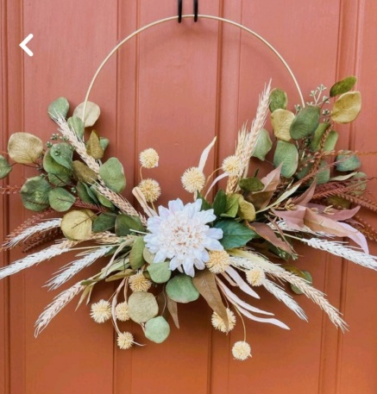**Make your Own Fall Wreath Artist: Sarah Prince**

Add a little spice to your fall decorating by creating your own unique fall wreath. It can be hung on any door or wall. You will have a large display of flowers, pumpkins, ribbon, etc. and everything you need to create something that goes along with your style. A demonstration and all materials are provided.

* Date: September 9 | 2:00 p.m. – 4:00 p.m.
* Workshop fee: $30, due at time of registration
* Ages: 10-100 - We will be working with hot glue!
* Class size: 14 participants

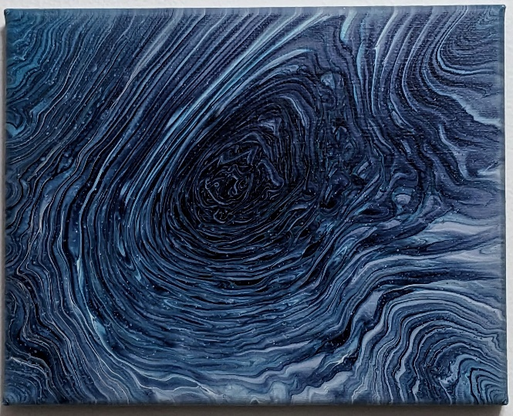**Fluid Art Paint Mixing AND Ring Pour Artist: Neva Rowland**

Pre-mixed fluid art paint is fine but can also be expensive. There are many videos on the internet that will swear by their preferred formula, but their mixture is often costly. (Believe me, I've tried them.)

In this workshop, I will share the tried-and-true, cost-effective, and non-toxic fluid art formula that I come back to every time as my favorite.

There will be many paint colors to choose from, so every participant can use their favorite color palette. After mixing our paints, we will use them in a beginner-friendly Ring Pour painting.

Participants will leave with their extra mixed paint and a blank canvas to try on their own at home. The paintings we complete in class will be available to be picked up a few days after they have dried.

* Date: Sunday, September 10, 2023 | 1:00pm - 4:00pm
* Fee: $50, due at time of registration
* Ages: 10+ (Those under 14 must be accompanied by an adult. The adult need not pay the workshop fee unless they wish to participate.)
* Number of Participants: 12

Facebook: [ArtFormsGallery620/](https://www.facebook.com/ArtFormsGallery620/)

Website: [www.artforms-gallery.com](http://www.artforms-gallery.com)

Do you have a birthday or special occasion to celebrate? Contact the Gallery to book a private party with an ArtForms Gallery artist!

Possibilities include:

|  |  |
| --- | --- |
| * Sip and Paint * Painting * Jewelry * Textiles * Pour Painting | * Fused Glass/Stained Glass * Pottery (ceramic birdhouse, windchime, pitchers) * Fiber * Glass and Resin |
| **Have a workshop suggestion or special request for us?**  **Give us a call!**  See the source image  **Become a**  **Gallery Patron**  Save 10% on **every** workshop you take in a 12-month period!  Only $40.00 | |

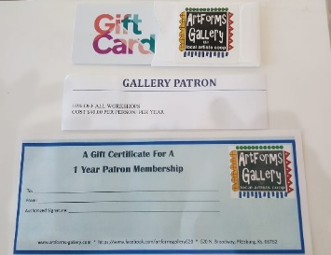  
An ArtForms Gallery gift card makes the perfect gift for any occasion! Our gift cards may be purchased in any amount and they never expire.