
Were you lucky enough to receive a gift card for ArtForms Gallery? You may use it for one of these great workshops or art!

Start the New Year off by taking
one of our workshops!

January 2024 Workshops
620 N. Broadway, Pittsburg, KS 620-240-0165

ArtForms Gallery is a co-op of artists offering monthly workshops ranging from acrylic painting, watercolor, glass fusing, pottery, metalsmithing, jewelry, textiles, kids’ art and more! All workshops are held at the Gallery unless otherwise noted. Please call Artforms Gallery to register for any artist’s workshop. 620-240-0165
Refunds/Cancellations—Decisions regarding refunds and cancellations are determined by the artist leading the workshop. You can find individual contact information for each artist on the “Artists” page of our website, or just call the Gallery and we’ll get you in touch.
Website: www.artforms-gallery.com
Facebook: ArtFormsGallery620/

Give the gift of local art with an ArtForms Gallery Gift Card!
Gift cards may be purchased in any amount and do not expire.

To check the balance of your Gift Card online:
https://squareup.com/gift/46K96BF2TK6W7/check-balance

Art Exploration! Free! Free! Free! Artist: Pat Glick
Are you looking for camaraderie while exploring your artistic side? Join Gallery artist Pat Glick every Tuesday afternoon for a fun time working on your own project or art! Bring your materials and create with us for free!
- Tuesdays, January 2. 9, 16, 23, 30 | 12:30 – 3:30 p.m.
- Workshop Fee: FREE~FREE~FREE!!!

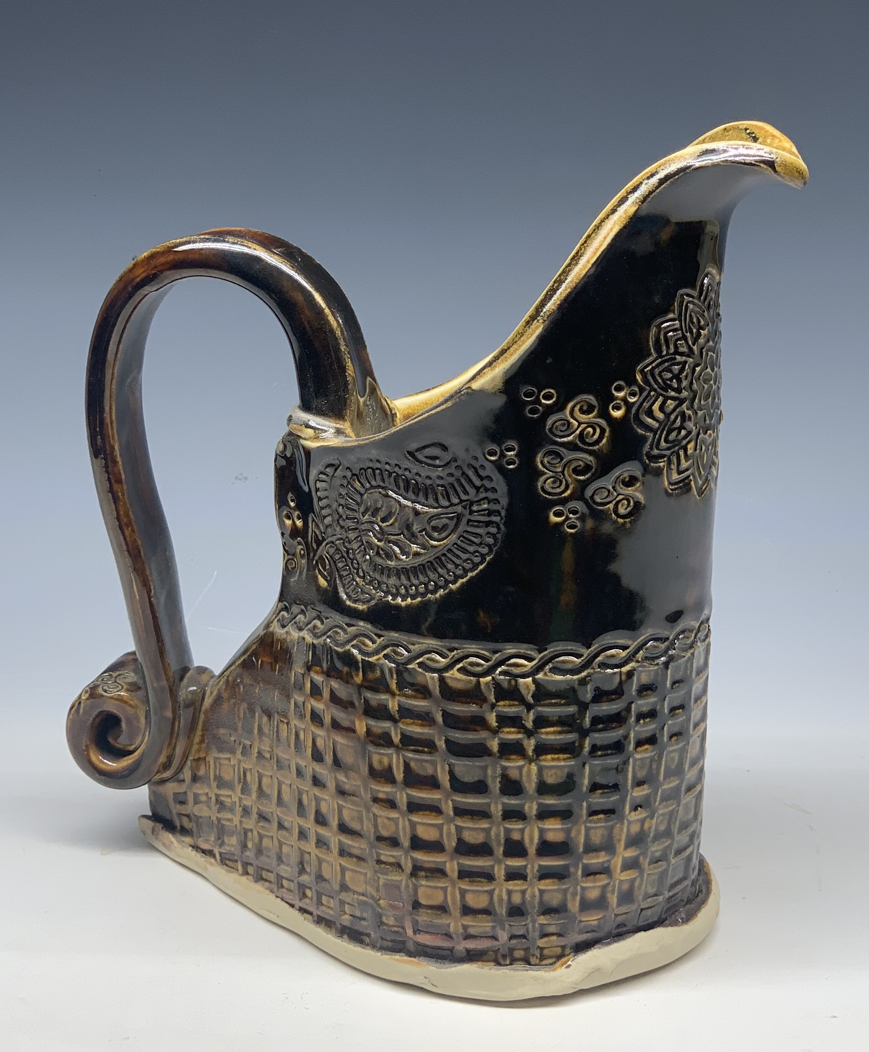
Ceramic Pitchers Artist: Daria Claiborne
Hand built with lots of textures. All supplies are included. Bring your imagination and end up with a functional pitcher.
- Date: Sunday, January 7 | 1:00 p.m. - 4:00 p.m.
- Workshop fee: $50, due at time of registration
- Class limit: 10
- Minimum age: 12 years

Fused Glass Lanterns Artist: Dianne Miller
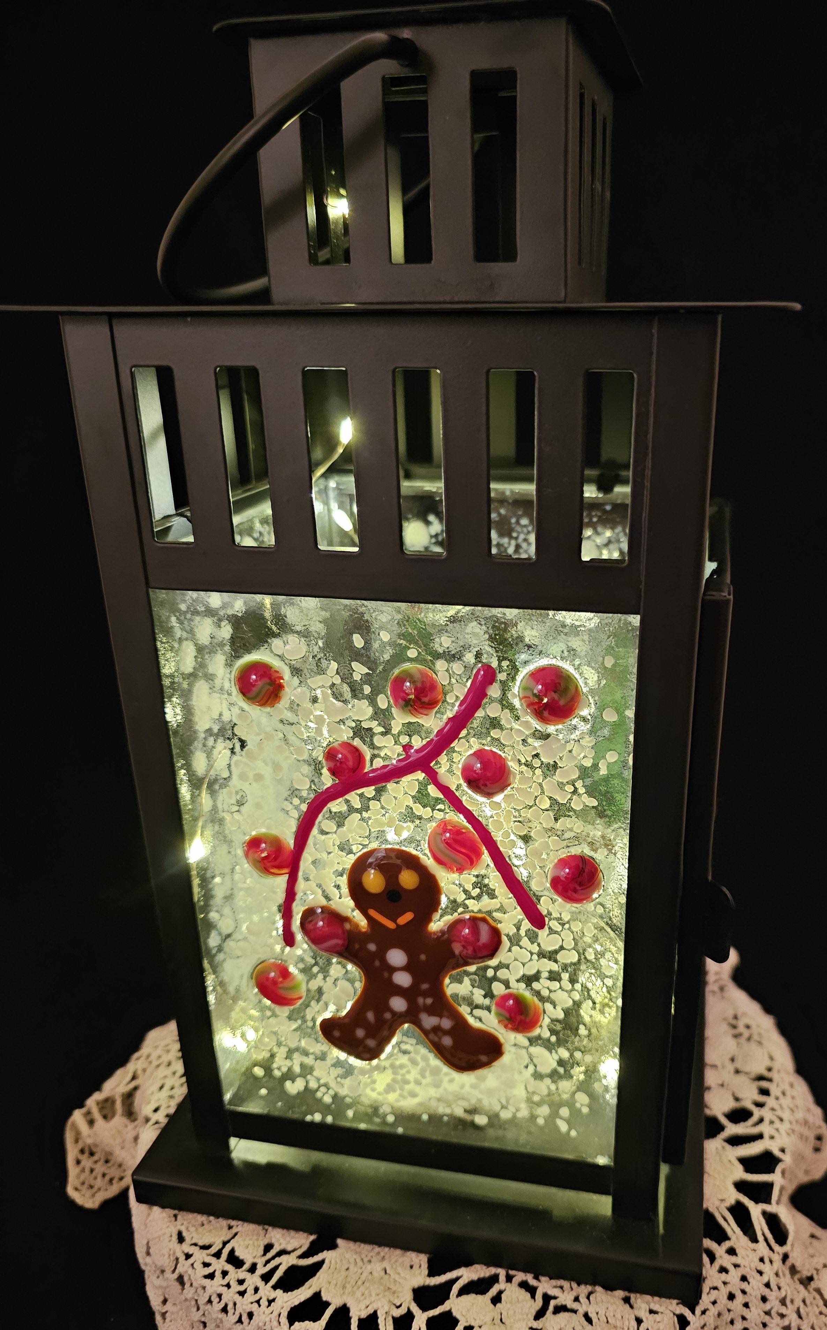
Add a warm glow to your evenings with a fused glass lantern! Participants will learn to cut and arrange glass embellishments on four glass panels so that each side of the lantern presents a different scene. Metal lanterns are included in the workshop fee, along with all glass, and a kiln firing. No experience is necessary as basic glass-cutting skills will be demonstrated. Please wear close-toed shoes when working with glass.
- Date: Saturday, January 13 | 1:00 p.m. - 4:00 p.m.
- Workshop fee: $65, due at time of registration
- Class limit: 8
- Minimum age: 14 years

Jacket Jewelry Artist: Brenda Hayes
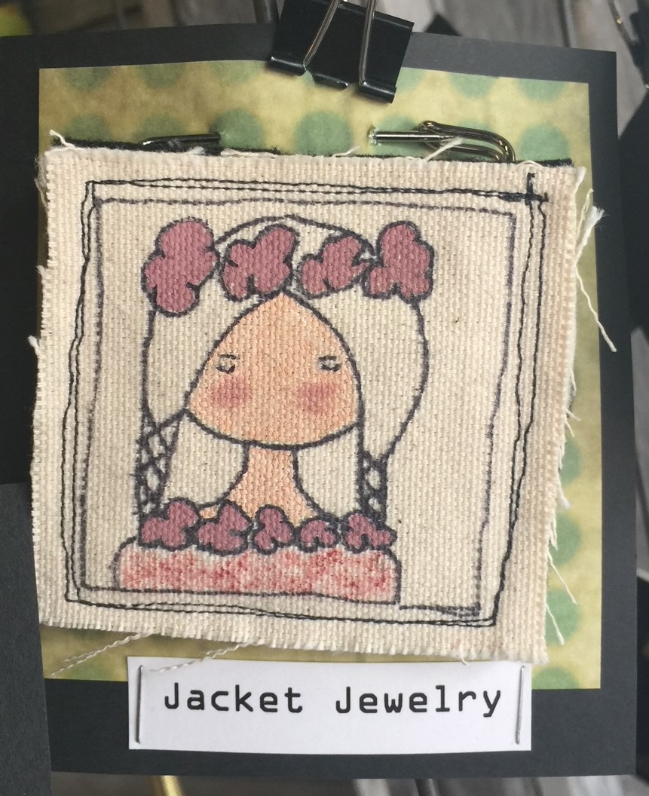
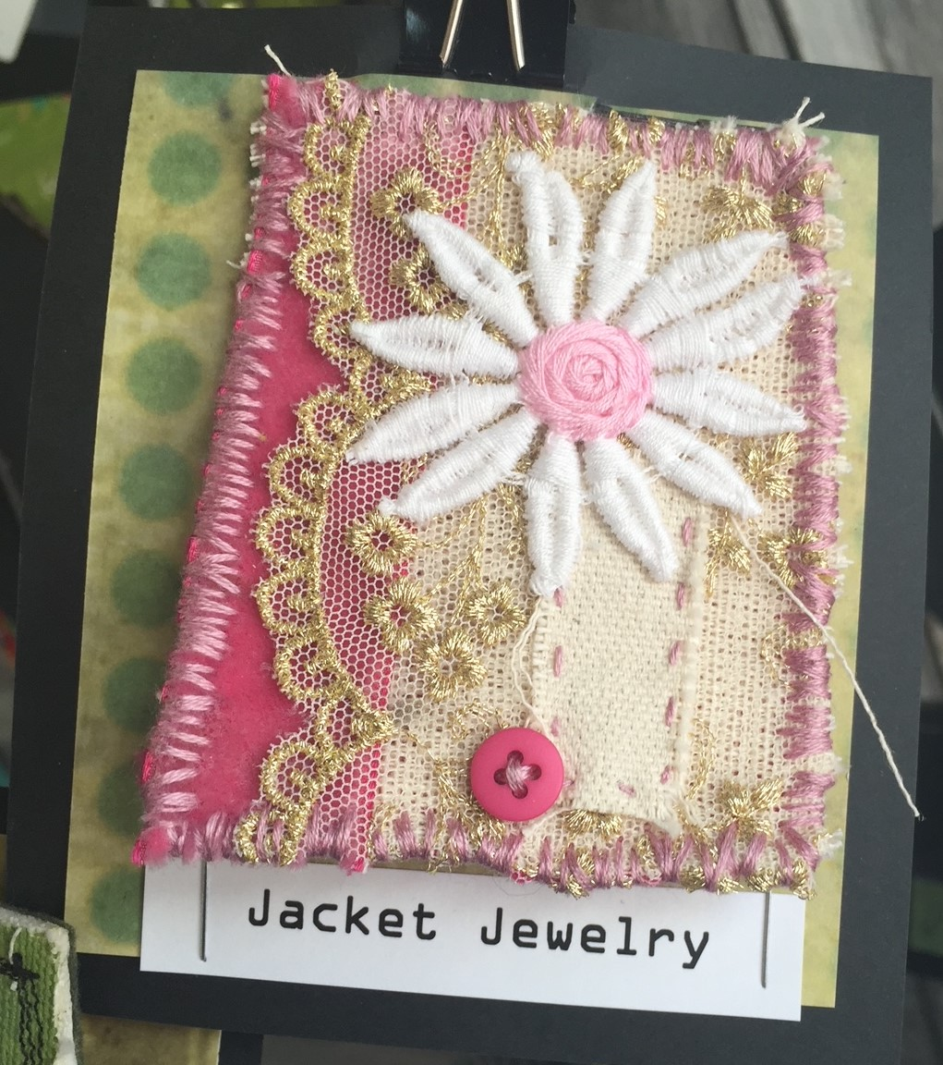
Make some cute bling for your jackets, coats, and bags. We will use fabrics, paints, vintage laces, and buttons. Hand and machine stitching. All materials will be provided.
- Sunday, January 21 | 1:00 p.m. - 3:00 p.m.
- Workshop fee: $40, due at time of registration
- Class limit: 8
- Minimum age: 12 years

Spinning Wheel—Pour Painting Artist: Debbie Southard
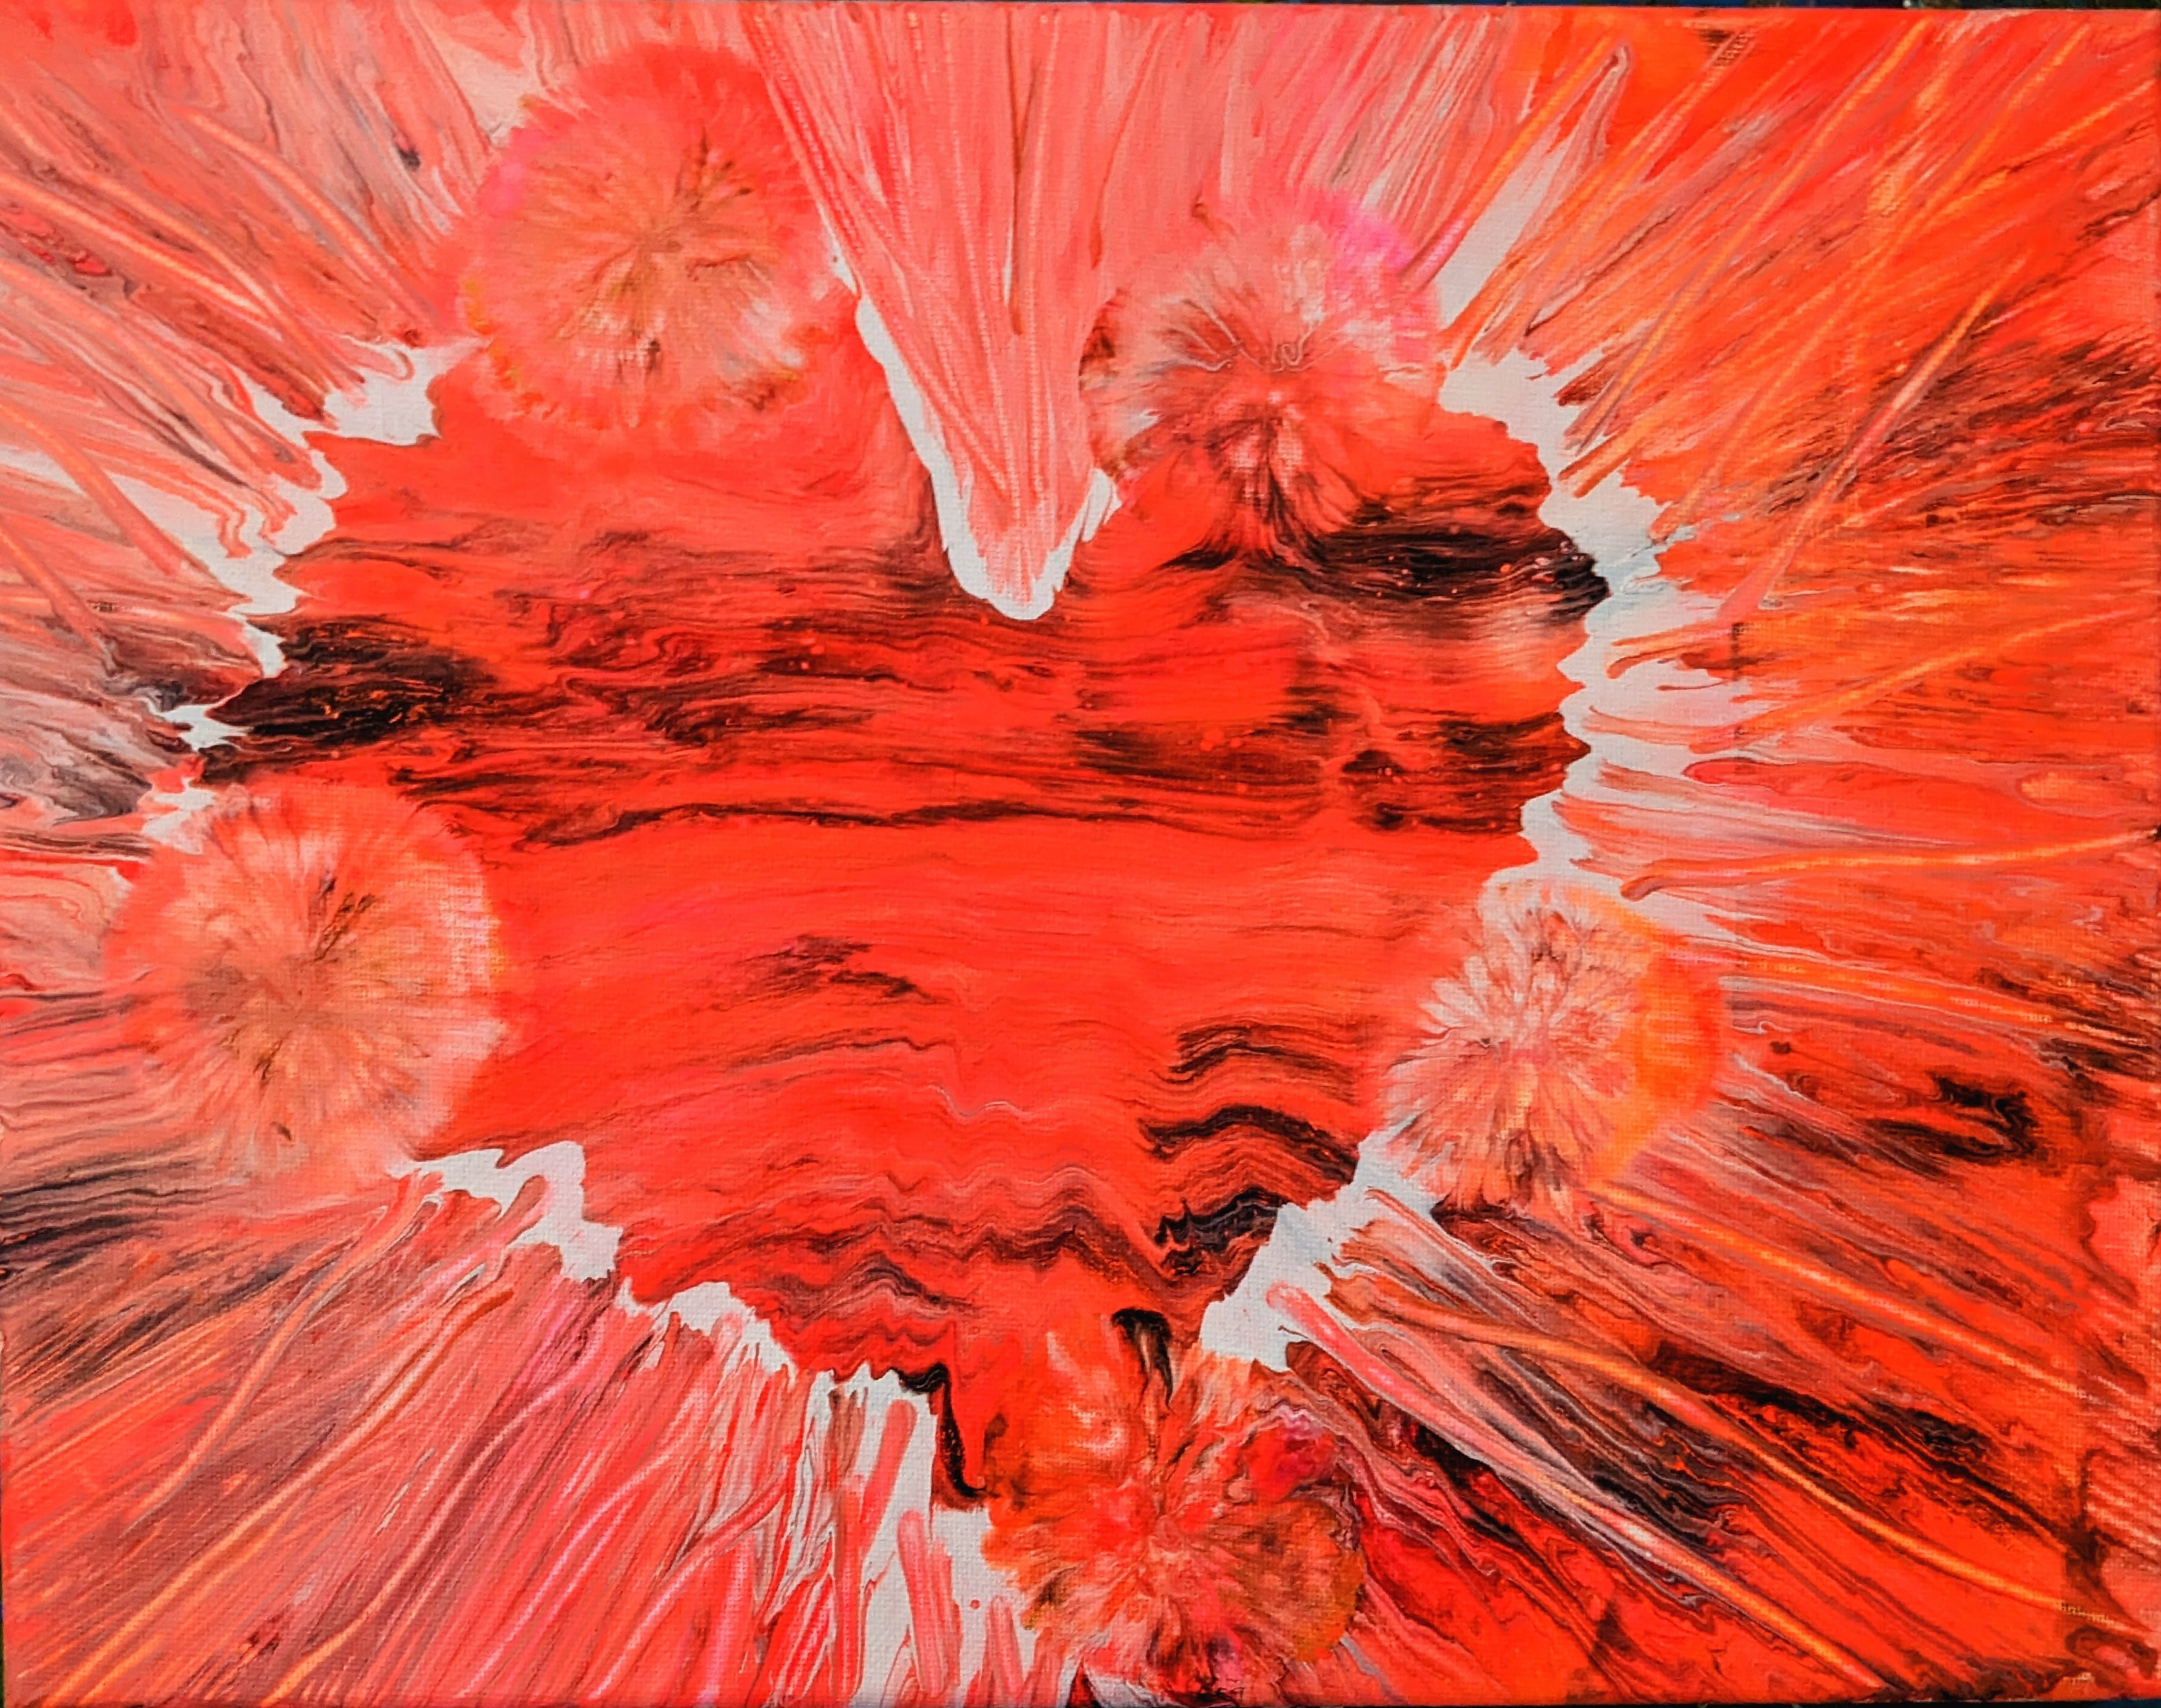
Let's get together and do some spinning and make a heart for Valentine's or just because you'd like to have some fun!
- January 27 | 2:00 – 4:00 p.m.
- Workshop fee: $40, due at time of registration
- Ages 12 and up
- Class size: 10
Someone is waitin' just for you
Spinnin' wheel spinnin' true
Drop all your troubles by the riverside
Catch a painted pony on the spinnin' wheel ride. (“Spinning Wheel” by Blood, Sweat and Tears)

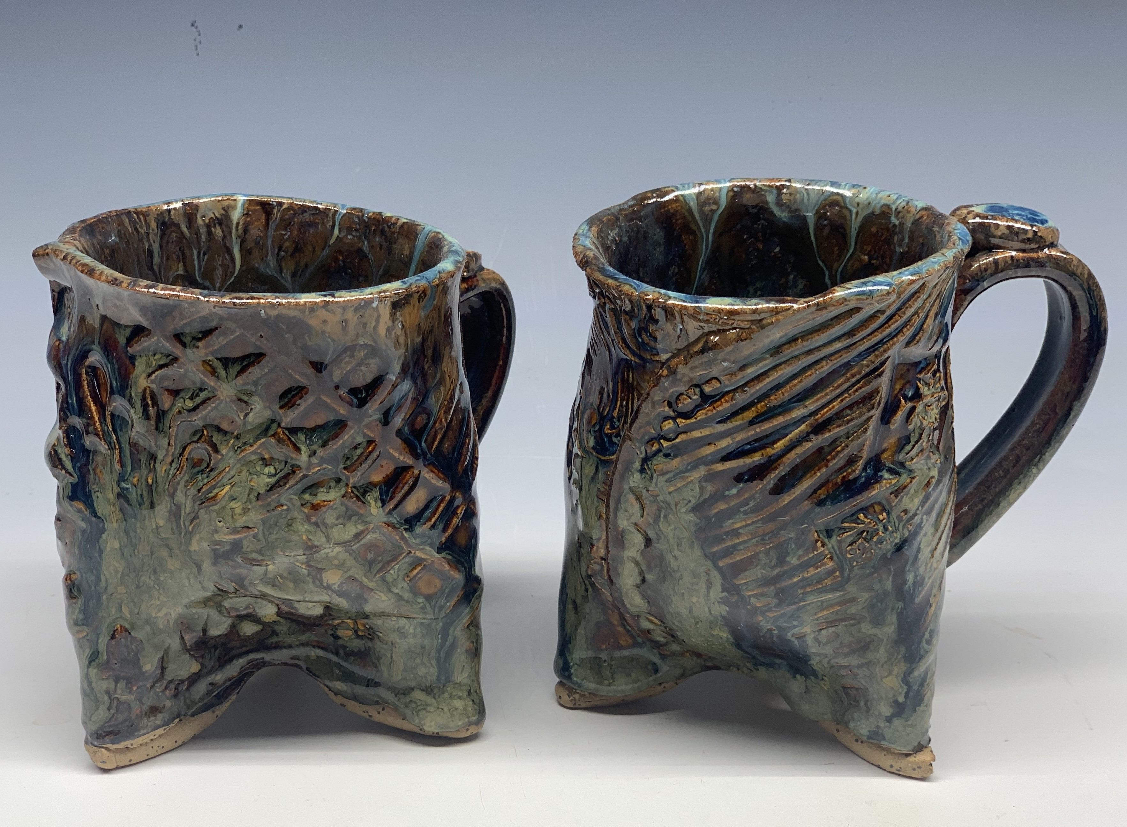
Ceramic Tumblers Artist: Daria Claiborne
Hand built (They could compliment the pitchers created January 7). All supplies are included.
- Sunday, January 28 | 1:00 – 4:00 p.m.
- Workshop fee: $50, due at time of registration
- Ages: 12 and up
- Class size: 10
Check our Facebook page during the month as artists may offer “popup” workshops!
ArtForms artists also offer pop-up workshops during the month. Follow the Gallery on its Facebook page and/or its website!
- Facebook: ArtFormsGallery620/
- Website: www.artforms-gallery.com
Do you have a birthday or special occasion to celebrate? Contact the Gallery to book a private party with an ArtForms Gallery artist!
Possibilities include:
- Sip and Paint  - Painting  - Jewelry  - Textiles | - Fused Glass/Stained Glass  - Pottery (ceramic birdhouse, windchime, pitchers)  - Fiber
Have a workshop suggestion or special request for us?
Don’t hesitate to give us a call!


Become a
Gallery Patron
Save 10% on every workshop you take in a 12-month period!!!
Only $40.00


Give the gift of creativity with an
ArtForms Gallery Gift Card or a
Gallery Patron Membership!

