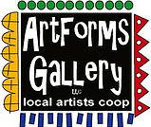
May 2023 Workshops
You can count on ArtForms Gallery to have the most unique Mother’s Day gifts! May 14
620 N. Broadway, Pittsburg, KS 620-240-0165
ArtForms Gallery is a co-op of artists offering monthly workshops ranging from acrylic painting, watercolor, oil pastels, glass fusing, pottery, metalsmithing, jewelry, textiles, kids’ art and more! All workshops are held at the Gallery unless otherwise noted. Please call Artforms Gallery to register for any artist’s workshop. 620-240-0165
Refunds/Cancellations—Decisions regarding refunds and cancellations are determined by the artist leading the workshop. You can find individual contact information for each artist on the “Artists” page of our website, or just call the Gallery and we’ll get you in touch. Facebook:ArtFormsGallery620/
Art Explorations!
Are you looking for camaraderie while exploring your artistic side? Join Gallery artists Pat Glick every Tuesday afternoon for a fun time working on your own project or art! Bring your materials and create with us for free!
Every Tuesday
May 2, 9, 16, 23, 30
12:30 – 2:30 p.m.
FREE~FREE~FREE!!!
Give the Gift of Art
- Original Art
- Local Artists
- Gift Cards

Gift cards may be purchased in any amount and do not expire. They may be redeemed for workshops or for original art!

To check the balance of your Gift Card online:
https://squareup.com/gift/46K96BF2TK6W7/check-balance
Website:www.artforms-gallery.com
Join the ArtForms Gallery Artists
during the Pittsburg ArtWalk!!!
Friday, April 21 | 5:00 – 9:00 p.m.
Artists will be inside ArtForms and on the street.
- Sarah Prince, stained glass, Fox Theater
- Lacy Warfel, belly dancing troupe, near Eclectic Soul
- Rebecca Lomshek and the PHS Art Club
- Dianne Miller, ArtForms Gallery classroom

The Voting Has Begun!
Stage 2 of our Mini Art contest is in full swing! Entries have been submitted and are now displayed in the Gallery. They are arranged by age group and numbered. To vote for your favorite or even your own, stop in and vote as many times as you wish with your coins and even paper money. The bottle with the most money donated in each age group wins a fantastic gift basket of art supplies!
Voting concludes at the close of the Pittsburg ArtWalk, April 21.
- Age Groups
    - Elementary School
    - Middle School
    - High School
    - 18 years and over crowd.
- Round up your family and friends to vote for you!
- Winners will be notified Saturday, April 22.

All funds raised from the Mini Art Contest will go toward upgrading ArtForms Gallery from our front window to our classroom. We appreciate your support in providing art in our community!

Neurographic Art! Artist: Debbie Southard
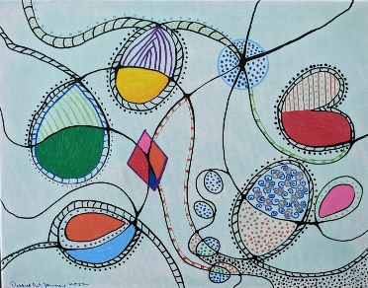
This class helps you to work through different areas of life that you may be wanting to change or are struggling in. Neurographic art helps to form new neural paths in the brain. This is a relatively new technique and has been used about 5 years. It was developed by a Russian psychologist to help his patients work through different areas of life. When you are finished with the process you can use markers, crayolas, or pencils to color in the areas. You are then left with your own unique piece of art.
- Saturday, May 20 | 2:00 – 4:00 p.m.
- Workshop Fee: $30, due at time of registration
- Class limit: 10
- Ages: 18 and older

7th Annual Young Artist Camp 2023!
Presented by the Dynamic Duo Nicole Meyer-Foresman and Kristin Girard!
Fun while creating!
We are excited to offer an "Art for the Body" theme workshop for our young creatives!
Questions? Contact Nicole: nmeyer@girard248.org
Ages | Time
6-9 | 9:00 – 10:00 a.m.
10-12 | 11:00 – 12:30 p.m.
13-18 | 1:30 – 3:00 p.m.
- Fri May 26
- Tues May 30
- Wed May 31
- Thurs June 1

Workshop fee: $60 per student Class size: 12

For the Adults: *Hoops and Pearls*
Join Nicole Meyer-Foresman and Kristin Girard for an adult jewelry workshop series. Learn pearl knotting, metal forging, and soldering when you make a modern pearl necklace and hoop earrings.
- Tues May 30
Time: 4:00 – 6:00 p.m. each day
Workshop fee: $90
Class size: 8
Ages: 18 and older

- Wed May 31
- Thurs June 1

ArtForms artists also offer pop-up workshops during the month. Follow the Gallery on our Facebook page and/or our website!
Facebook: ArtFormsGallery620/
Website: www.artforms-gallery.com
Do you have a birthday or special occasion to celebrate? Contact the Gallery to book a private party with an ArtForms Gallery artist!
Possibilities include:
- Sip and Paint  - Painting  - Jewelry  - Textiles  - Pour Painting | - Fused Glass/Stained Glass  - Pottery (ceramic birdhouse, windchime, pitchers)  - Fiber  - Glass and Resin
Have a workshop suggestion or special request for us?
Don’t hesitate to give us a call!

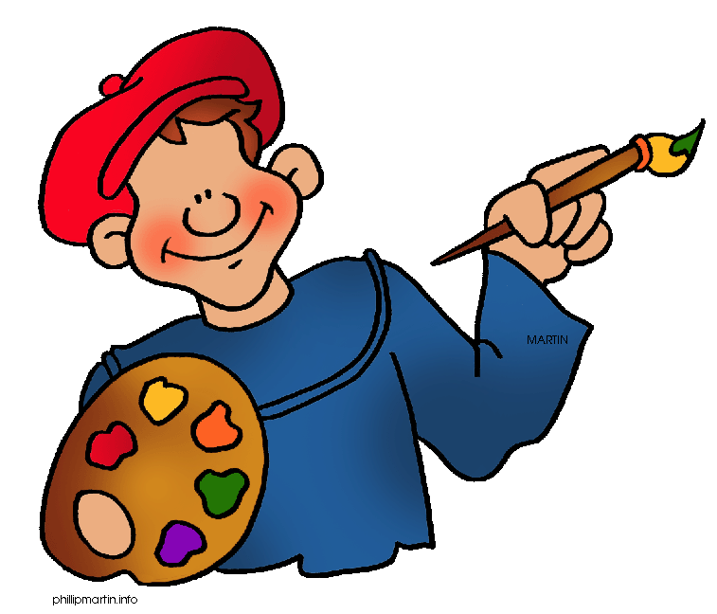
Become a
Gallery Patron
Save 10% on every workshop you take in a 12-month period!
Only $40.00

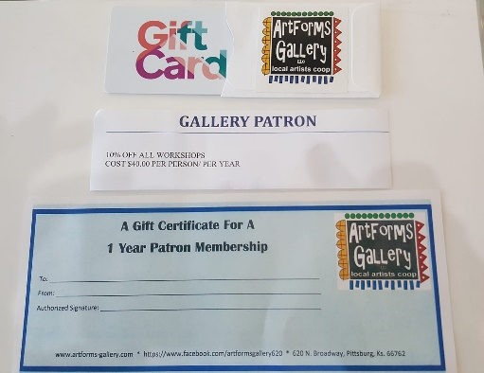
An ArtForms Gallery gift card makes the perfect gift for any occasion! Our gift cards may be purchased in any amount and they never expire.

