
ArtForms Gallery
December 2020 Workshops
620 N. Broadway, Pittsburg, KS 620-240-0165

ArtForms Gallery artists love when you visit our Gallery in search of the unique, handmade gift or a new art piece for your home or office! However, we also want our customers and artists to remain safe during the changing health conditions in our community. Please maintain appropriate social distancing and wear a mask when visiting. We will do our part in maintaining a clean and safe environment for you to shop or take a workshop. We look forward to seeing you again soon!

ArtForms Gallery is a co-op of 21 different artists offering monthly workshops ranging from oil painting, watercolor, glass fusing, pottery, wood carving, metalsmithing, jewelry, textiles, kids’ art and more! All workshops are held at the Gallery unless otherwise noted. Please call Artforms Gallery to register for any artist’s workshop. 620-240-0165

Refunds/Cancellations—Decisions regarding refunds and cancellations are determined by the artist leading the workshop. You can find individual contact information for each artist on the “Artists” page of our website, or just call the Gallery and we’ll get you in touch.

Handmade for the Holidays! Artist: Nicole
Small Metals Workshop
Participants will use silver, copper, and brass to design and fabricate either a pair of earrings or a pendant. Techniques to to be taught include sawing, filing, texture rolling, piercing, riveting and oxidize finishing.

- Saturday: December 5 | 4:00—6:00 p.m.
- Class size is limited to 8, ages 15 years and older
- $45, payable at registration
- All supplies are provided.

Fused Glass Pendants Workshop Artist: Dianne

Join Dianne to MAKE your gifts this holiday! Learn how to cut glass and reassemble to create 4 dichroic glass fused pendants! This workshop filled both times in November, so call soon to register! Previous glass-cutting experience is not necessary. Just bring your enthusiasm and willingness to learn a new skill!
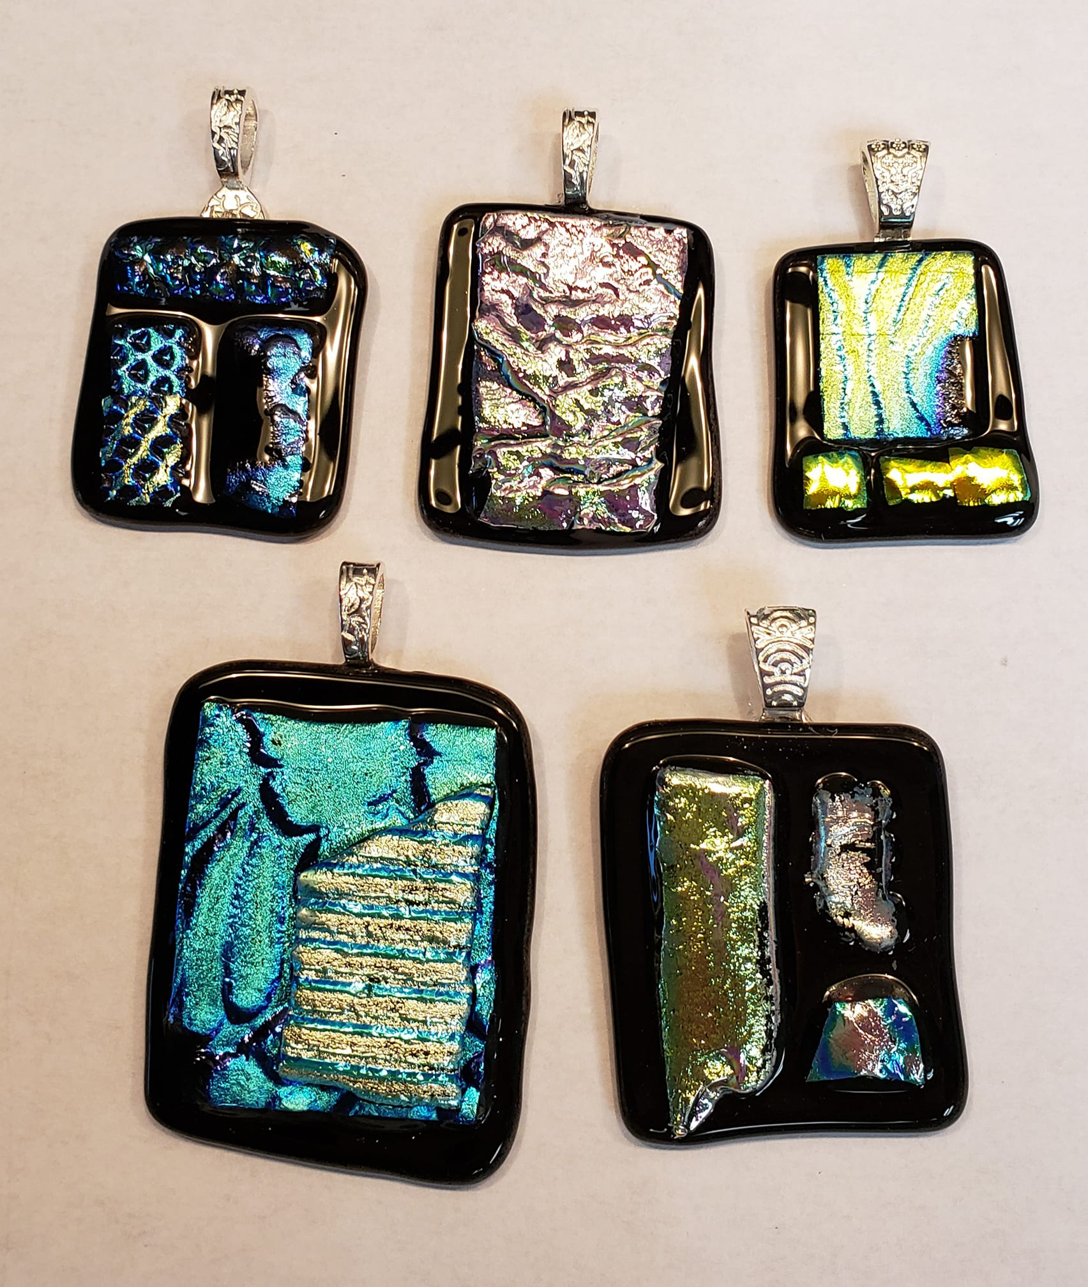 | The pendants in the picture were made by a student in November!  - Sunday: December 6 1:00—3:00 p.m.  - $40, ages 14 and older.  - Please do not wear open-toe shoes when learning with glass.  - All supplies are provided.

Check our Facebook page during the month as artists may offer “popup” workshops!

ArtForms artists also offer pop-up workshops during the month. Follow the Gallery on its Facebook page and/or its website!
- Facebook: ArtFormsGallery620/
- Website: www.artforms-gallery.com


Do you have a birthday or special occasion to
celebrate? Contact the Gallery to book a private
party with an ArtForms Gallery artist!

Possibilities include:

- Sip and Paint  - Painting  - Jewelry  - Textiles | - Fused Glass/Stained Glass  - Pottery (ceramic birdhouse, windchime, pitchers, wheel-throwing)  - Woodcarving

Have a workshop suggestion or special request for us?
Don’t hesitate to give us a call!

Art Exploration! Free! Free! Free!

Are you looking for camaraderie while exploring your artistic side? Join Gallery artist Pat Glick every Tuesday afternoon, 1 p.m. – 3 p.m. to explore different art techniques. Pat will lead you through a creative art experience every week. Feel free to bring something you are working on also. We will have opportunities to participate in community activities and charities at times.
Art Exploration is free so you just bring your willingness to try something new in art!
- Every Tuesday
- 1:00 p.m. – 3:00 p.m.
Important!!!
Call ArtForms Gallery each Tuesday to confirm Art Exploration is definitely scheduled before coming.

Give the gift of creativity with an
Become a
Gallery Patron
Save 10% on every workshop you take in a 12-month period!!!
Only $40.00

ArtForms Gallery Gift Card or a

Gallery Patron Membership!

