
ArtForms Gallery
November 2020 Workshops
620 N. Broadway, Pittsburg, KS 620-240-0165

ArtForms Gallery artists love when you visit our Gallery in search of the unique, handmade gift or a new art piece for your home or office! However, we also want our customers and artists to remain safe during the changing health conditions in our community. Please maintain appropriate social distancing and wear a mask when visiting. We will do our part in maintaining a clean and safe environment for you to shop or take a workshop. We look forward to seeing you again soon!

ArtForms Gallery is a co-op of 21 different artists offering monthly workshops ranging from oil painting, watercolor, glass fusing, pottery, wood carving, metalsmithing, jewelry, textiles, kids’ art and more! All workshops are held at the Gallery unless otherwise noted. Please call Artforms Gallery to register for any artist’s workshop. 620-240-0165

Refunds/Cancellations—Decisions regarding refunds and cancellations are determined by the artist leading the workshop. You can find individual contact information for each artist on the “Artists” page of our website, or just call the Gallery and we’ll get you in touch.

Fused Glass Pendants Artist: Dianne Miller
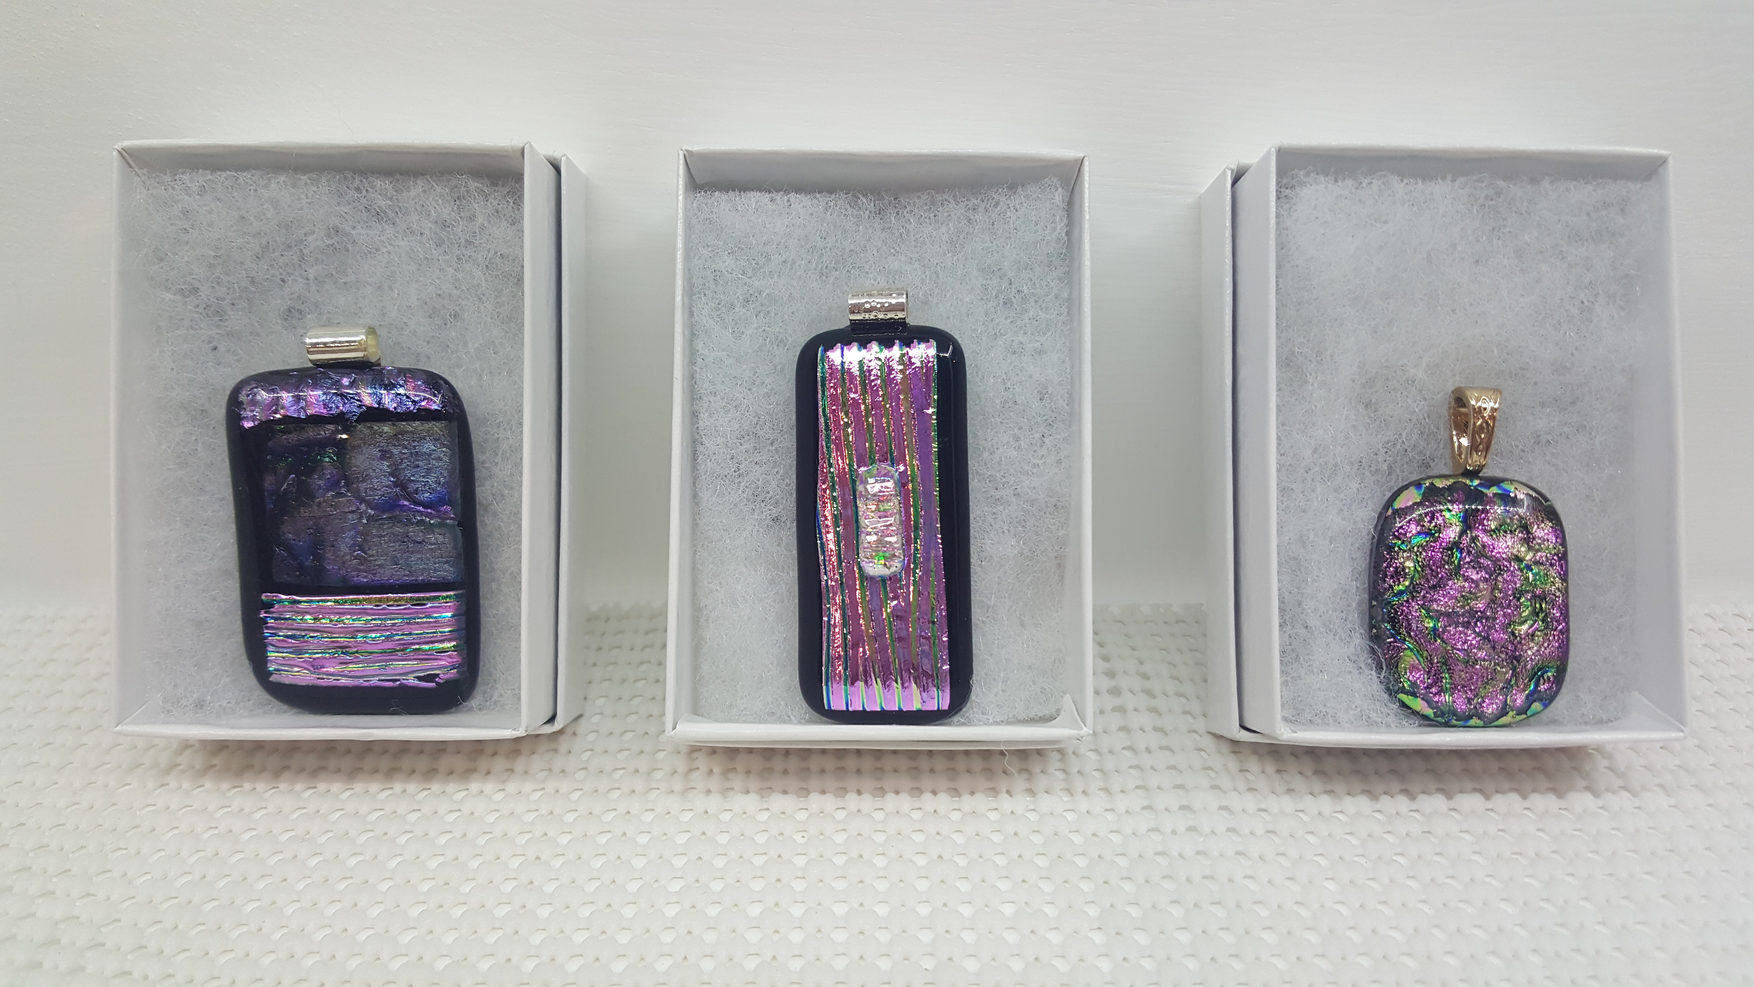
Because this workshop filled quickly for the October workshop, it is being offered in November!

Give your own uniquely handcrafted gifts this season! Join Dianne in this fused glass workshop using dichroic glass to design 4 stunning pendants. Basic glass-cutting skills are demonstrated. Individual instruction is provided along with all glass tools and material. After fusing in my home studio, your exquisite pendants will be returned to the Gallery and ready for you to pickup November 5.

Please do not wear open-toed shoes when working with glass.
- Sunday, November 1 1:00 p.m. – 3:00 p.m.
- Workshop fee: $40; payable at time of registration
- Ages 14 and older
- Class limit: 8

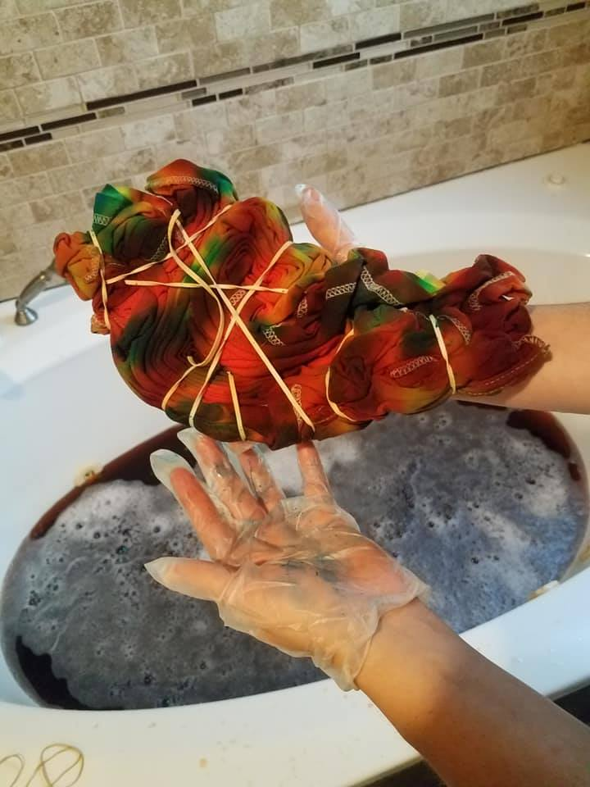
Dyes and Ties Artist: Jordaine
Let’s welcome our newest artist, Jordaine Pollard, as she holds her first workshop! Jordaine, a fiber artist, brings at least 10 years of dying fibers experience to us!

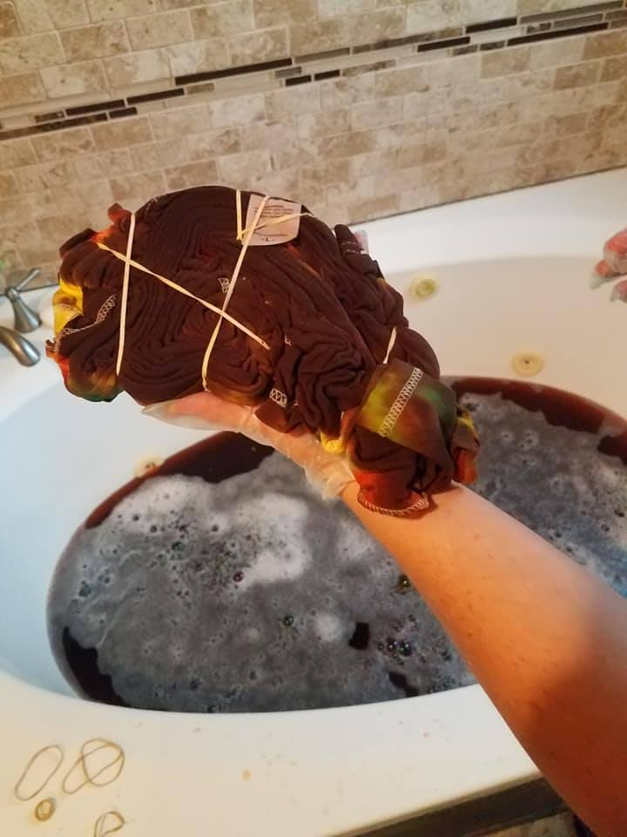
This workshop is an introduction to professional level materials and techniques for advanced tie-dying. In this two-part workshop, learn unique folding and saturation for high quality wearable art. Create your own custom piece as Jordaine demonstrates the process. Complete your dye-work with a stress-free washout provided. Your creation will be ready to take home in 24 hours.
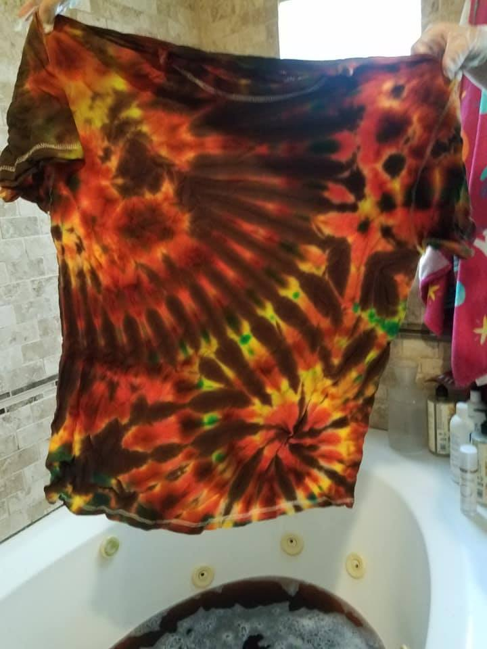
- Friday, Nov. 13 | 4 p.m. – 6 p.m.
- Saturday, Nov. 14 | 2 p.m. – 4 p.m.
- Workshop fee: $20; payable at time of registration
- Ages: 16 and older
- Class limit: 8
- All materials are supplied. Please provide the appropriate T-shirt size at the time of registration!!!

Fused Glass Holiday Ornaments Artist: Dianne
Create your own original fused glass ornaments for the holiday! Learn basic cutting skills as you design and construct several glass ornaments to give as gifts or place on your tree. All tools, glass and kiln firings are included. Bring your creativity and give the gift of handmade this Christmas! Please do not wear open-toed shoes when working with glass.
- Sunday, Nov. 15 | 1:00 p.m. – 4:00 p.m.
- Workshop fee: $40, payable at time of registration
- Ages: 14 and older
- Class limit: 8

Check our Facebook page during the month as artists may offer “popup” workshops!

ArtForms artists also offer pop-up workshops during the month. Follow the Gallery on its Facebook page and/or its website!
- Facebook: ArtFormsGallery620/
- Website: www.artforms-gallery.com

Do you have a birthday or special occasion to celebrate? Contact the Gallery to book a private party with an ArtForms Gallery artist!
Possibilities include:
- Sip and Paint  - Painting  - Jewelry  - Textiles | - Fused Glass/Stained Glass  - Pottery (ceramic birdhouse, windchime, pitchers, wheel-throwing)  - Woodcarving
Have a workshop suggestion or special request for us?
Don’t hesitate to give us a call!

Art Exploration! Free! Free! Free!
Important!!!
Call ArtForms Gallery each Tuesday to confirm Art Exploration is definitely scheduled before coming.

Are you looking for camaraderie while exploring your artistic side? Join Gallery artist Pat Glick every Tuesday afternoon, 1 p.m. – 3 p.m. to explore different art techniques. Pat will lead you through a creative art experience every week. Feel free to bring something you are working on also. We will have opportunities to participate in community activities and charities at times.
Art Exploration is free so you just bring your willingness to try something new in art!
- Every Tuesday
- 1:00 p.m. – 3:00 p.m.

Become a
Gallery Patron
Save 10% on every workshop you take in a 12-month period!!!
Only $40.00




Give the gift of creativity with an
ArtForms Gallery Gift Card or a
Gallery Patron Membership!

