

September 2021 Workshops
620 N. Broadway, Pittsburg, KS 620-240-0165

ArtForms Gallery is a co-op of 17 different artists offering monthly workshops ranging from oil painting, watercolor, glass fusing, pottery, metalsmithing, jewelry, textiles, kids’ art and more! All workshops are held at the Gallery unless otherwise noted. Please call Artforms Gallery to register for any artist’s workshop. 620-240-0165
Refunds/Cancellations—Decisions regarding refunds and cancellations are determined by the artist leading the workshop. You can find individual contact information for each artist on the “Artists” page of our website, or just call the Gallery and we’ll get you in touch.
Website: www.artforms-gallery.com
Facebook: ArtFormsGallery620/

ArtForms Gallery artists are doing our part in maintaining a clean and safe environment for you to shop or take a workshop. At the time of this publication, we are still recommending wearing masks when shopping and requiring them during workshops as many of our younger participants have not yet had the opportunity to be vaccinated. Please watch for announcements or call the Gallery for updates as these guidelines may be adjusted according to changing health conditions in our community. We look forward to seeing you soon!
Art Exploration! Free! Free! Free!
Are you looking for camaraderie while exploring your artistic side? Join Gallery artists Pat Glick and Laura Wright every Tuesday afternoon for a fun time working on your own project or art! Bring your materials and create with us for free!
- Tuesdays, September 7, 14, 21, 28 | 12:30 – 2:30 p.m.
- Workshop Fee: FREE~FREE~FREE!!!

Starting in September, join Pat and Laura on Tuesdays 3:30 – 5:30 p.m. for beginning painting instruction! Materials and supplies will be provided. For a nominal fee of $15 for each session, you will learn basic brush strokes, shading, blending, and more!
- Tuesdays, September 7, 14, 21, 28 | 3:30 – 5:30 p.m.
- Workshop Fee: $15 per session, payable at time of registration to reserve a spot
- Ages: 11 and older
- Please call and register if you plan to attend.

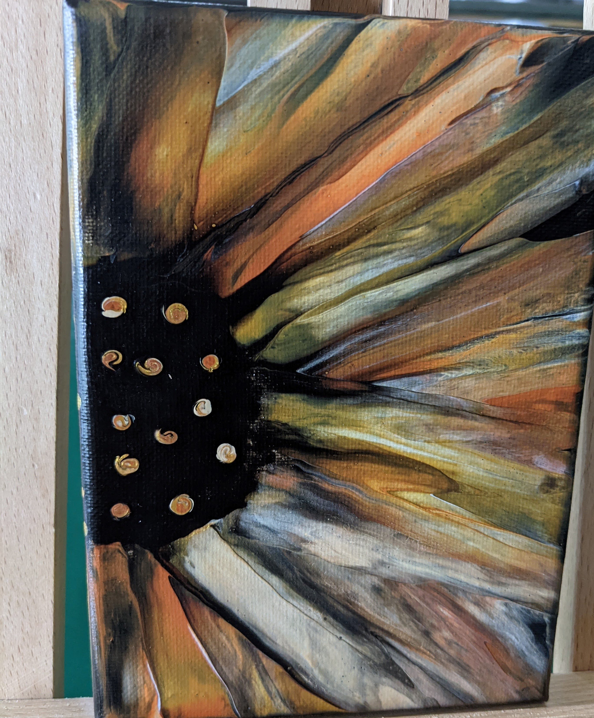
Swiping a Sunflower!! Artist: Debbie Southard
We are going to use the swipe technique to create a sunflower painting 🌻 So let's be busy bees and get together!
Buzzzzz buzzzzz buzzzzz 🐝🐝🐝
- Saturday, September 4 | 2 p.m.
- Workshop fee: $35 per person
- Class size: 10
- Ages: 12 and older
- Masks are required in this workshop.

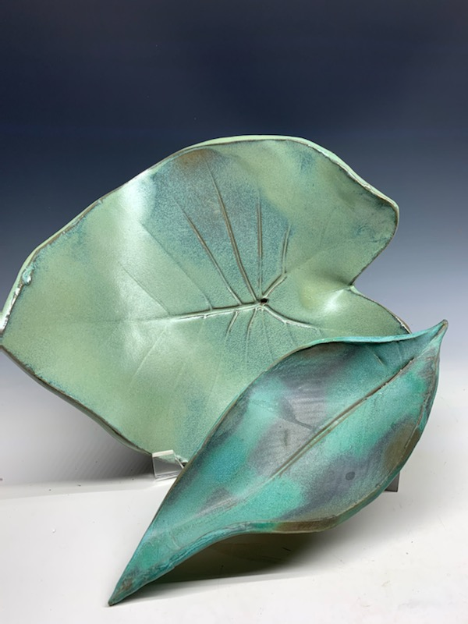
Ceramic Fall Leaves Artist: Daria
Using actual leaves and a slab of clay, participants will create ceramic lovely trays shaped like leaves. All supplies are provided. Masks are recommended. Get dirty with Daria!
- Sunday, September 12 | 2:00 – 5:00 p.m.
- Workshop Fee: $45, payable at time of registration
- Ages: 16 and older
- Class size: 8
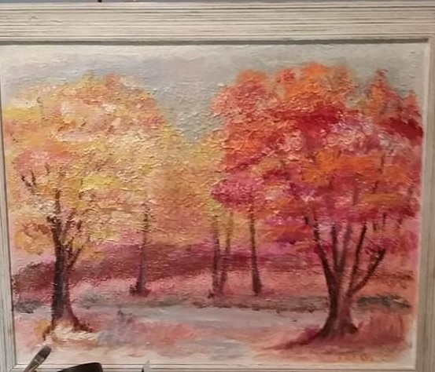
Beginning Painting Artist: Pat
Join acrylic painter Pat Glick for beginning painting instruction. All supplies, including the canvas, are provided. You will create a landscape as you learn how to use dry brush techniques and sea sponges to create texture in painting. Wear some old clothes. This is fun and messy!

- Sunday, September 19 | 1:00 – 3:00 p.m.
- Fee $35 payable at time of registration
- Class limit: 6
- Ages: 11 years through adult

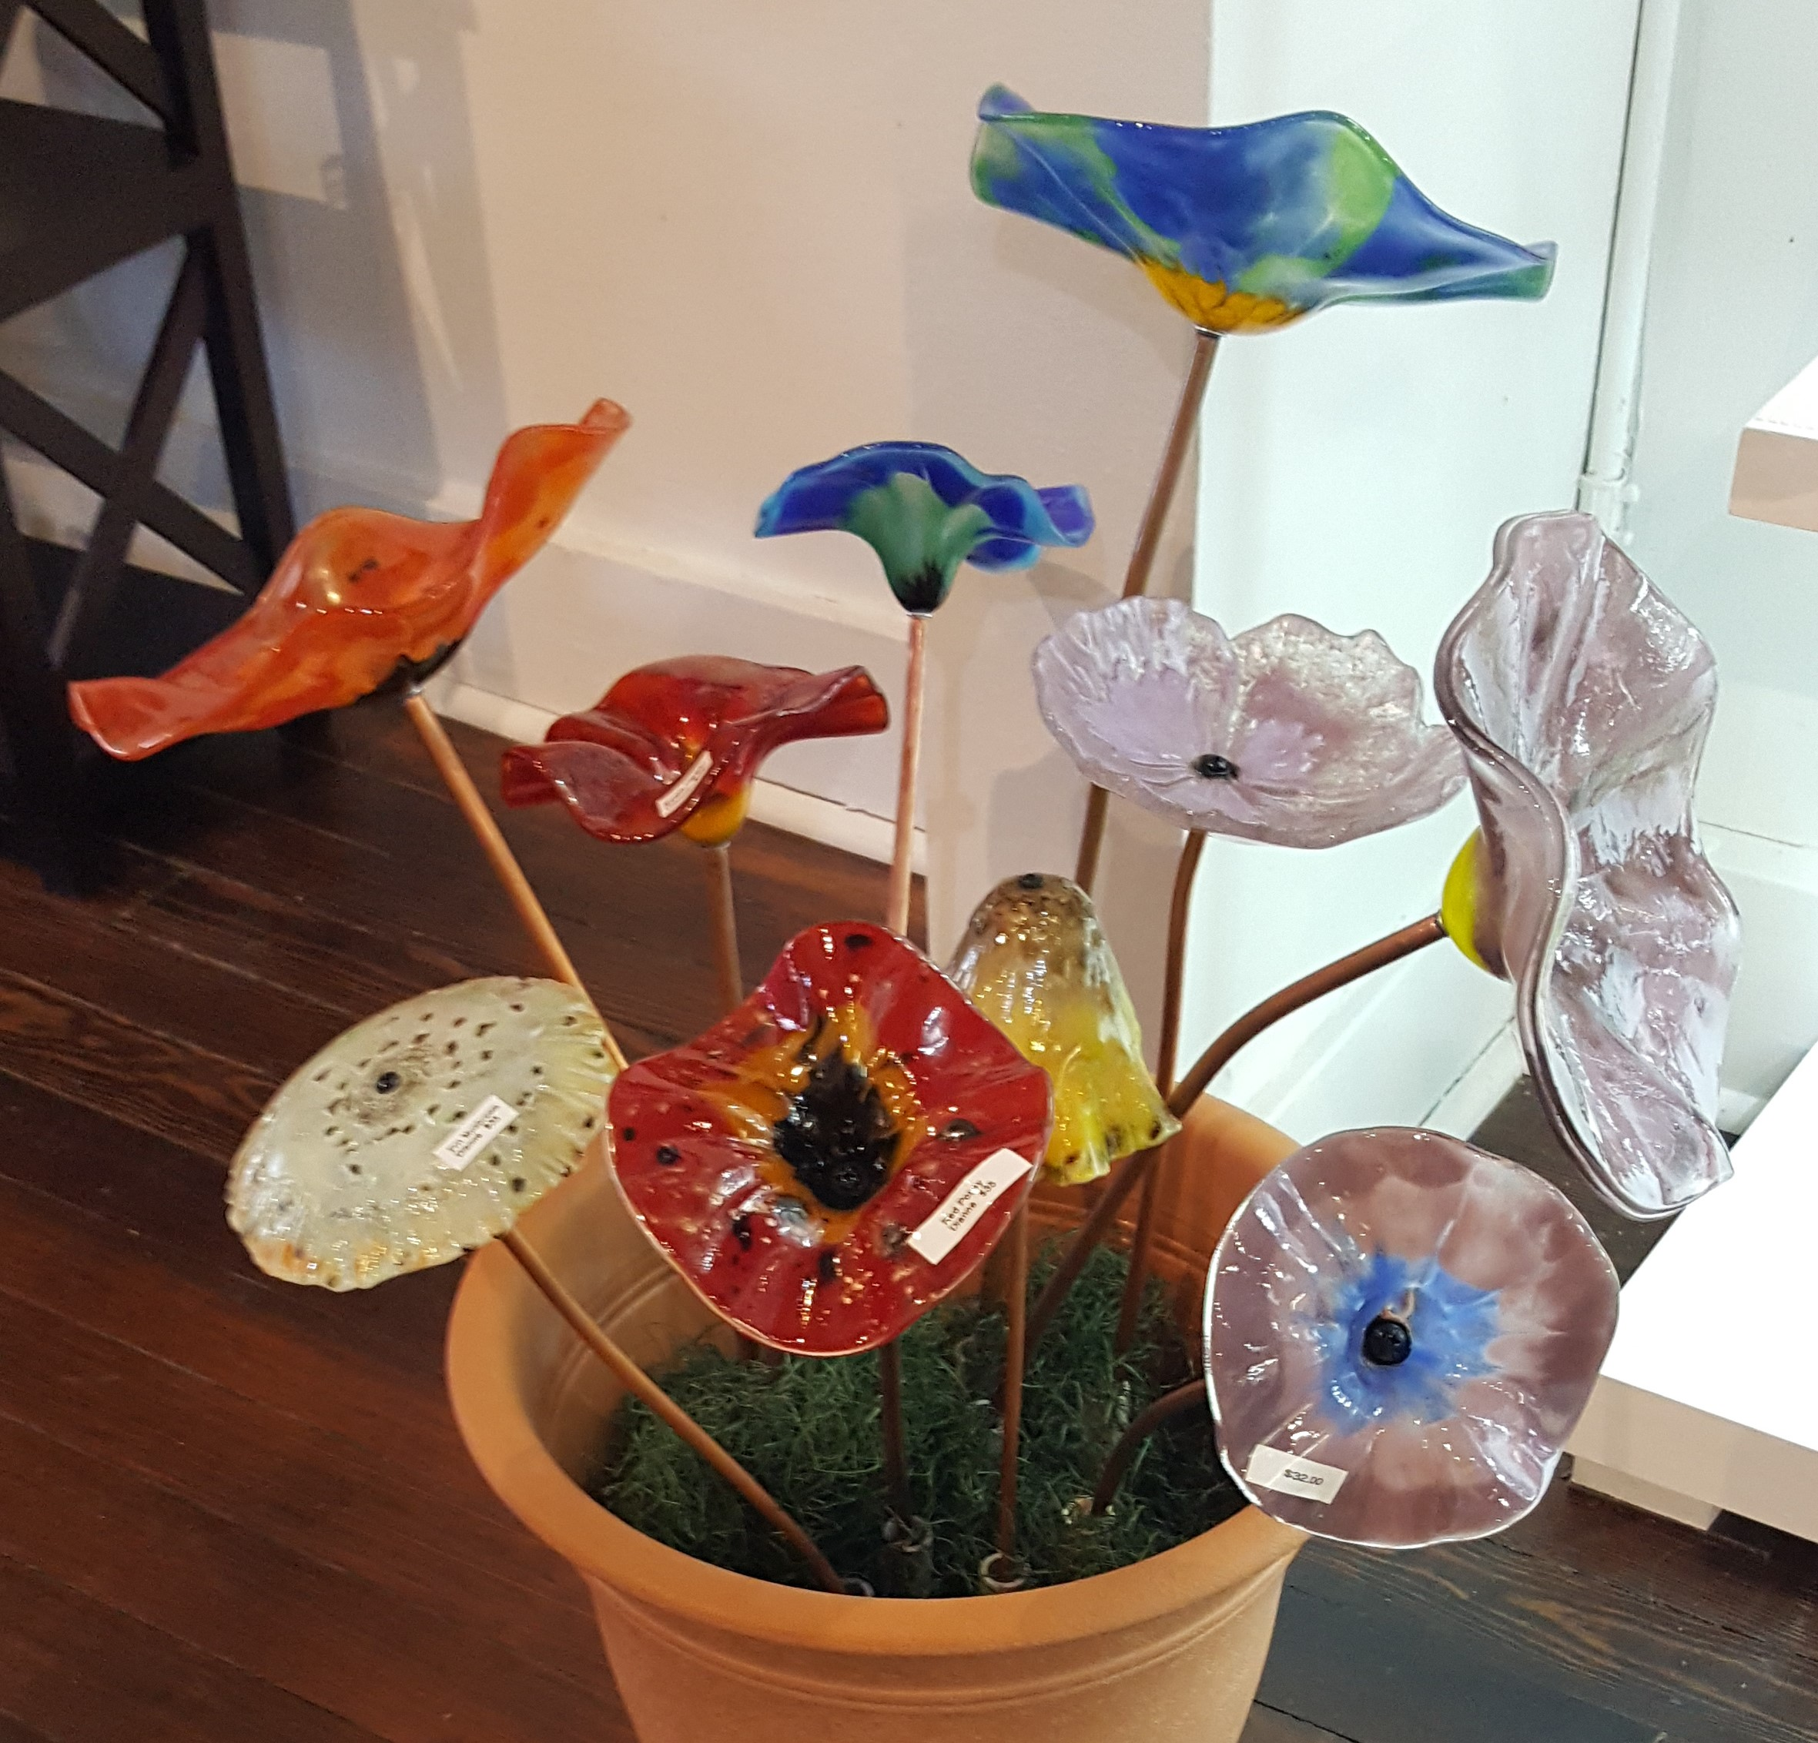
Fused Glass Flowers Artist: Dianne
Using glass powders and water, participants will create a slurry in a variety of colors and design a glass flower to be fused on a ceramic mold. After drilling a hole, a copper tube will be inserted to make a free-standing flower for your home or flower bed. Since you will be working with glass powders, please bring a mask (N95 recommended or double mask) and wear close-toed shoes.
- Saturday, September 25 | 1:00 p.m. – 3:30 p.m.
- Fee: $30 for one slurry flower; $55 for two slurry flowers
  - $35 for one dry powder cast into a ceramic flower mold (Hibiscus, Pansy, Daisy, Poppy, Zinnia)
  - $40 for one large slurry flower
- Class limit: 10
- Age: All ages; however, children under 12 require adult supervision

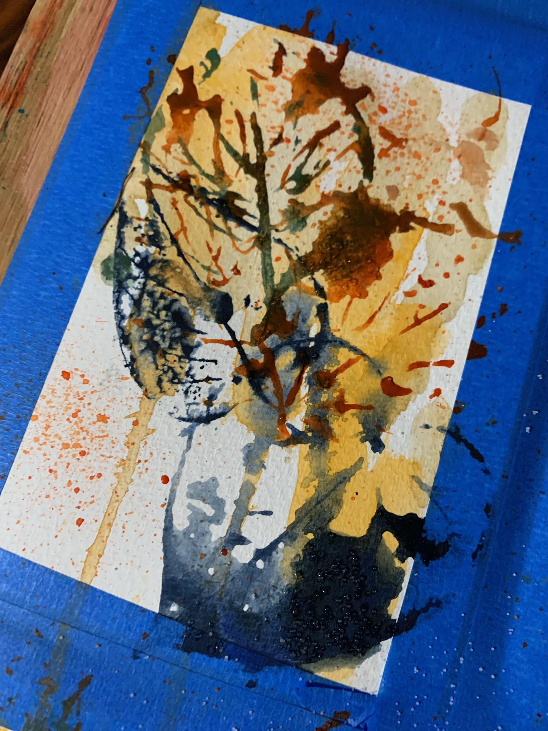
Fall Leaf Watercolor Cards Artist: Daria Create beautiful watercolor cards worthy of framing! All supplies included. Masks recommended.
- Sunday, September 26 | 2:00 – 4:00 p.m.
- Workshop Fee: $35, payable at time of registration
- Ages: 14 and older

Check our Facebook page during the month as artists may offer “popup” workshops!
ArtForms artists also offer pop-up workshops during the month. Follow the Gallery on its Facebook page and/or its website!
- Facebook: ArtFormsGallery620/
- Website: www.artforms-gallery.com
Do you have a birthday or special occasion to celebrate? Contact the Gallery to book a private party with an ArtForms Gallery artist!
Possibilities include:
- Sip and Paint  - Painting  - Jewelry  - Textiles | - Fused Glass/Stained Glass  - Pottery (ceramic birdhouse, windchime, pitchers)  - Fiber
Have a workshop suggestion or special request for us?
Don’t hesitate to give us a call!


Become a
Gallery Patron
Save 10% on every workshop you take in a 12-month period!!!
Only $40.00


Give the gift of creativity with an
ArtForms Gallery Gift Card or a
Gallery Patron Membership!

