
Were you lucky enough to receive a gift card for ArtForms Gallery? You may use it for one of these great workshops or art!
Grab your Valentine and
take a fun workshop together!

February 2024 Workshops
620 N. Broadway, Pittsburg, KS 620-240-0165
Do you want to engage your kids during spring break in March? Get together a small group and book a special workshop for them and their buddies with one of our great artists! Now is the time to put it together!!!

ArtForms Gallery is a co-op of artists offering monthly workshops ranging from acrylic painting, watercolor, glass fusing, pottery, metalsmithing, jewelry, textiles, kids’ art and more! All workshops are held at the Gallery unless otherwise noted. Please call Artforms Gallery to register for any artist’s workshop. 620-240-0165
Refunds/Cancellations—Decisions regarding refunds and cancellations are determined by the artist leading the workshop. You can find individual contact information for each artist on the “Artists” page of our website, or just call the Gallery and we’ll get you in touch.
Website: www.artforms-gallery.com
Facebook: ArtFormsGallery620/

Give the gift of local art with an ArtForms Gallery Gift Card!
Gift cards may be purchased in any amount and do not expire.

To check the balance of your Gift Card online:
https://squareup.com/gift/46K96BF2TK6W7/check-balance

Art Exploration! Free! Free! Free! Artist: Pat Glick
Are you looking for camaraderie while exploring your artistic side? Join Gallery artist Pat Glick every Tuesday afternoon for a fun time working on your own project or art! Bring your materials and create with us for free!
- Tuesdays, February 6, 13, 20, 27 | 12:30 – 3:30 p.m.
- Workshop Fee: FREE~FREE~FREE!!!

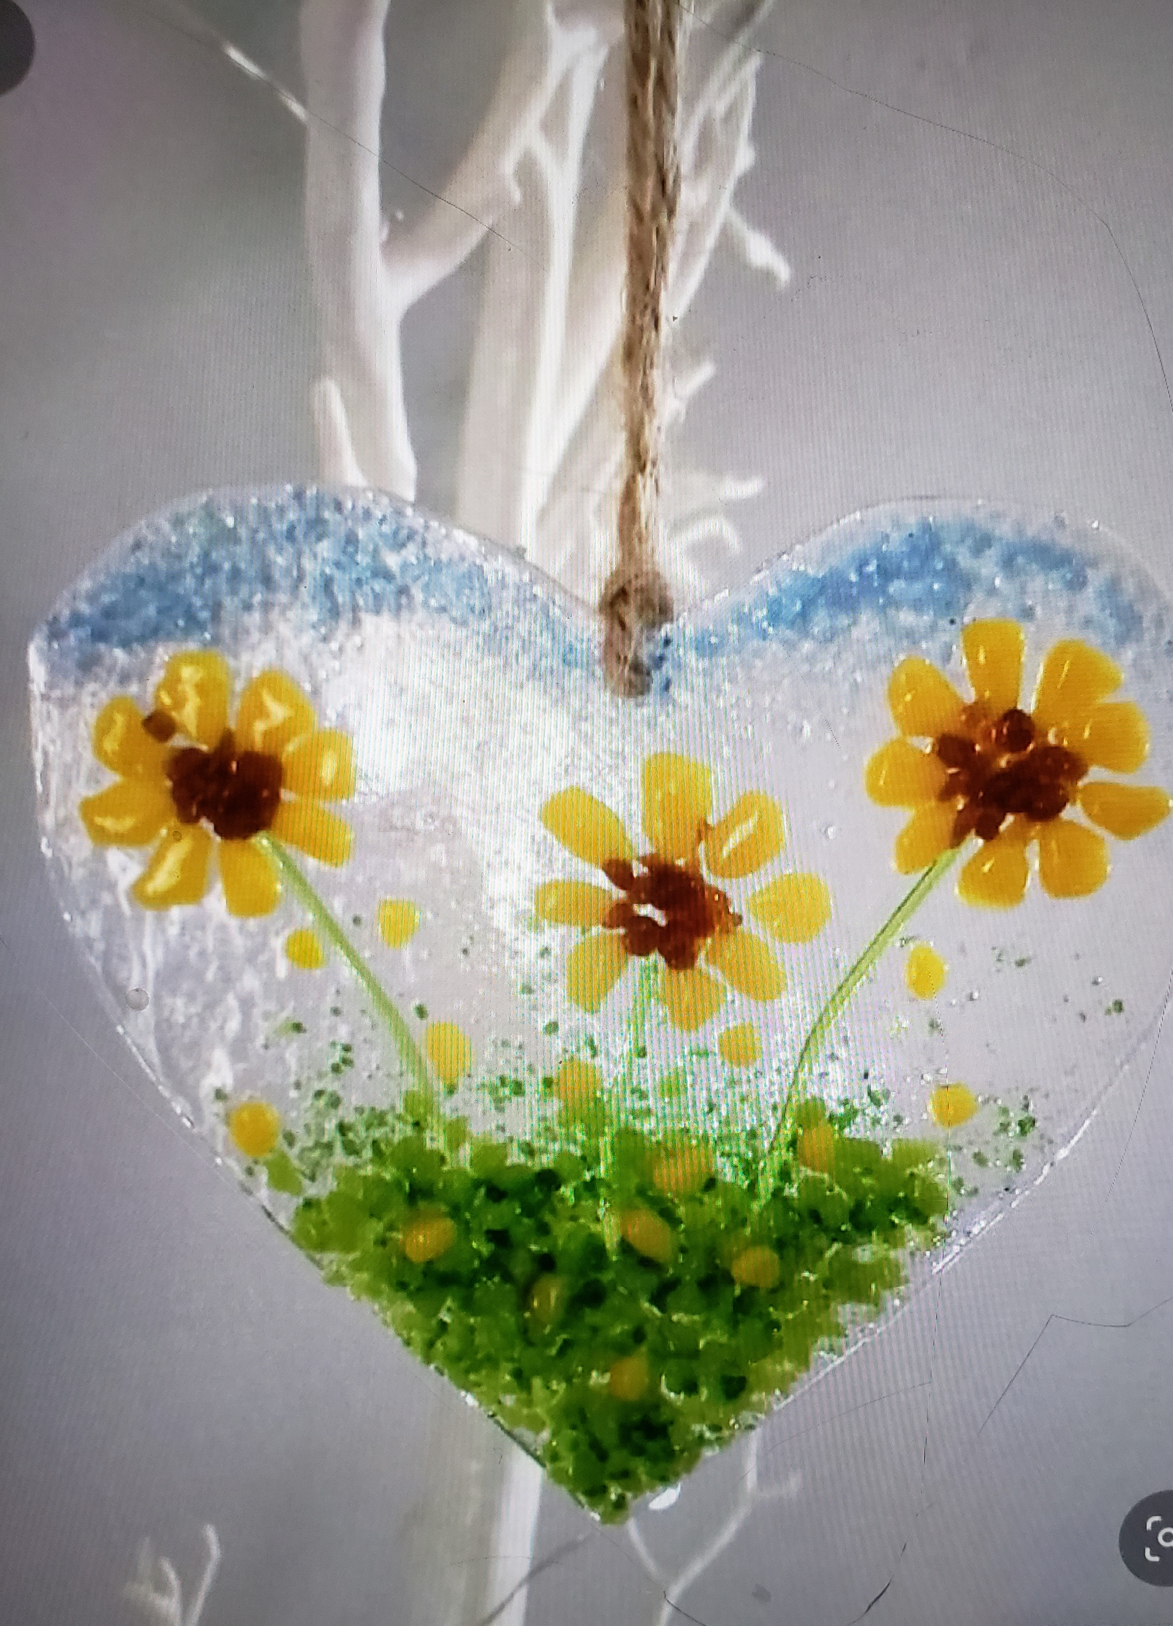
Show Your Heart! Artist: Dianne Miller
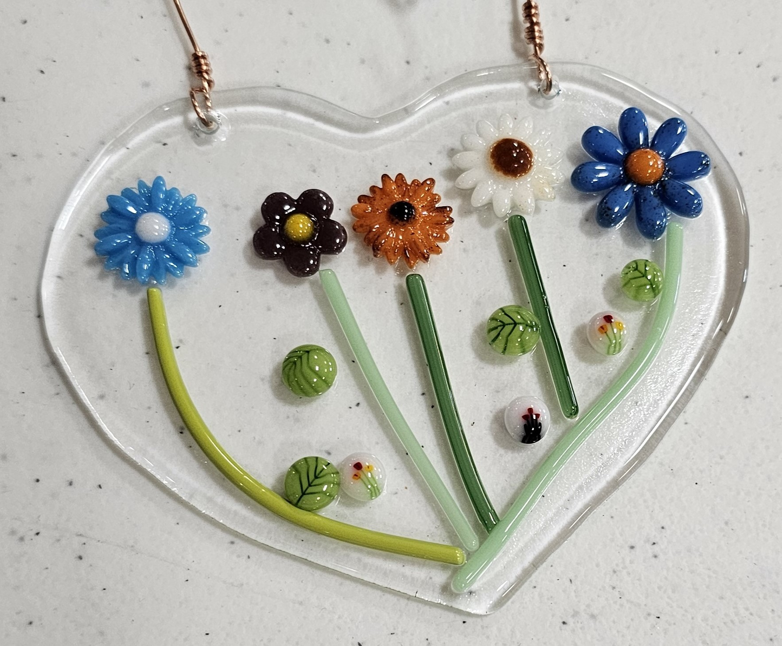
Unlock your creativity and join our Fused Glass Heart Workshop! Immerse yourself in the art of glass fusion, where vibrant colors and your personal touch come together to craft a unique heart masterpiece. Discover the joy of creating beautiful, one-of-a-kind glass art.
Choose glass embellishments to layer on a precut clear glass heart (approximately 5") that will be fused in a glass kiln to permanently signify your love for someone special--spouse, child, parent, dear friend, or even yourself!

A wide assortment of compatible glass shapes will be available from which you may choose. No glass-cutting is required! Bring your creativity and a N95 mask (in case you use glass powder), and please wear close-toed shoes. Basic glass-cutting skills are demonstrated, so prior experience is not necessary. A clear glass heart will be your canvas and fusible glass embellishments are provided for you to use.
- Date: Sunday, February 4 | 1:00 – 3:00 p.m.
- Workshop fee: $40, due at time of registration to guarantee your seat
- Ages: 12 years and up
- Class size: 10

Time for the M"ART"y PARTY Artist: Debbie Southard
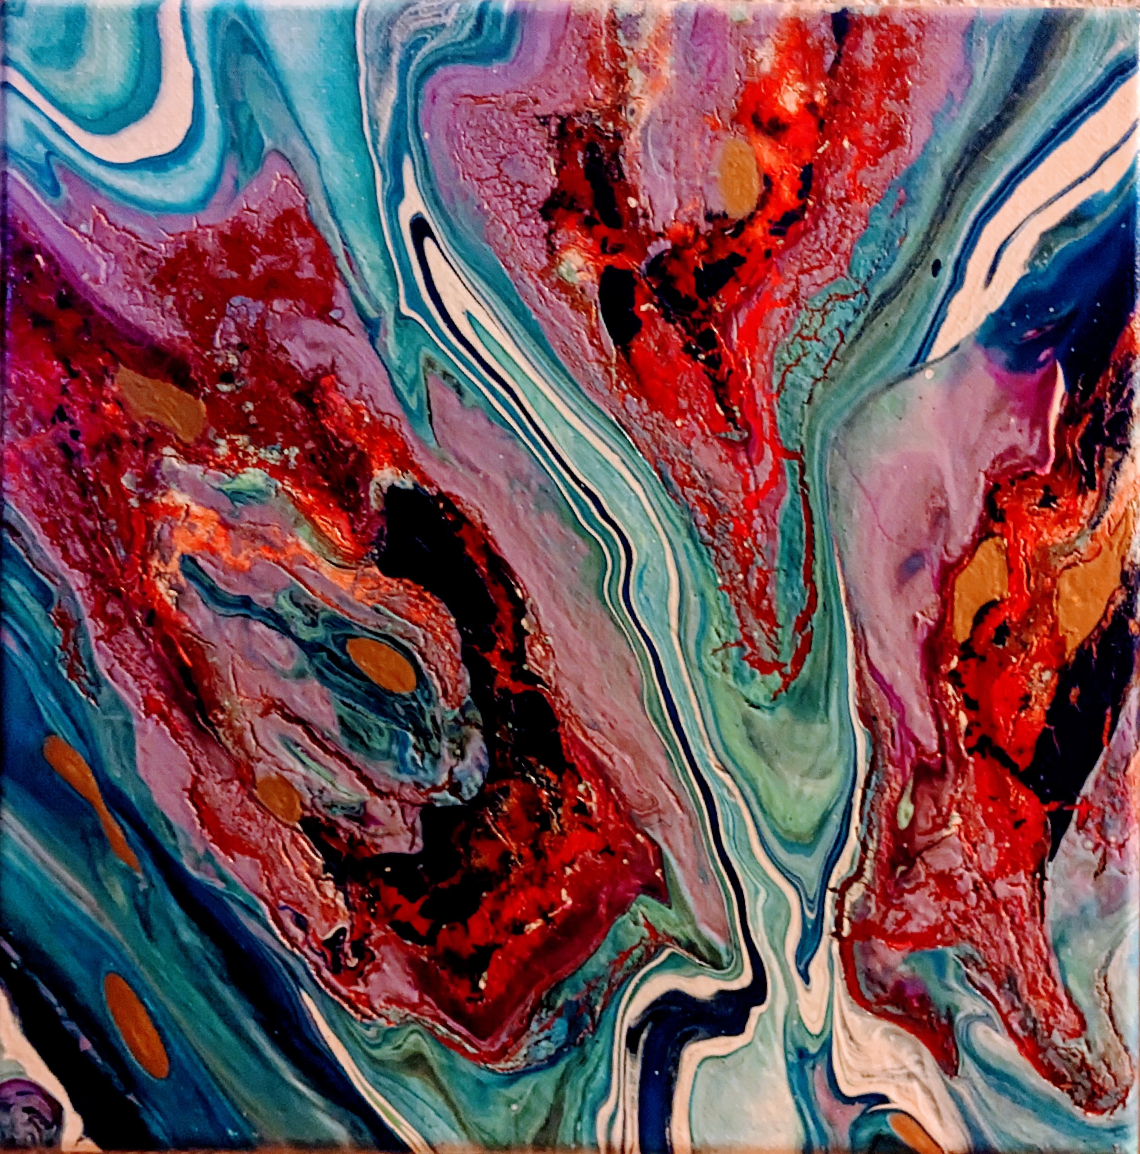
TIME FLIES WHEN YOU'RE HAVING FUN
Let's do a dirty pour and then wreck it!
This would be a good class for someone who has not painted before or has never done pouring art before.
There will be a Mardi gras cake to share! Whoever gets the baby wins a prize!!!
- Date: February 10 | 2:00 – 4:00 p.m.
- Workshop fee: $40, due at time of registration
- Ages: 12 and up
- Class size: 10

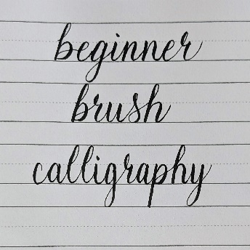
Beginner Brush Calligraphy Artist: Neva Rowland
Have you seen fancy calligraphy shared on Pinterest or Instagram and wanted to learn, but didn't know where to start? While there are many styles and tools to create beautiful calligraphy, this class will utilize a beginner friendly brush pen to build skills from basic strokes, to letters, to words. The skills learned in this class will serve as excellent base knowledge for exploring other calligraphy styles to showcase in everything from bullet journals to holiday cards. If you attended a previous calligraphy workshop, then you can attend this one at a discounted rate for extra guided practice and the opportunity to design a greeting card!
- Date: Sunday, February 11, 2024 | Time: 1:00 p.m. - 3:00 p.m.
- Fee: $30 (first time), $10 (second time)
- Ages: 10+ (Those under 14 years of age must be accompanied by an adult. The adult need not pay the workshop fee unless they wish to participate.)
- Number of participants: 15

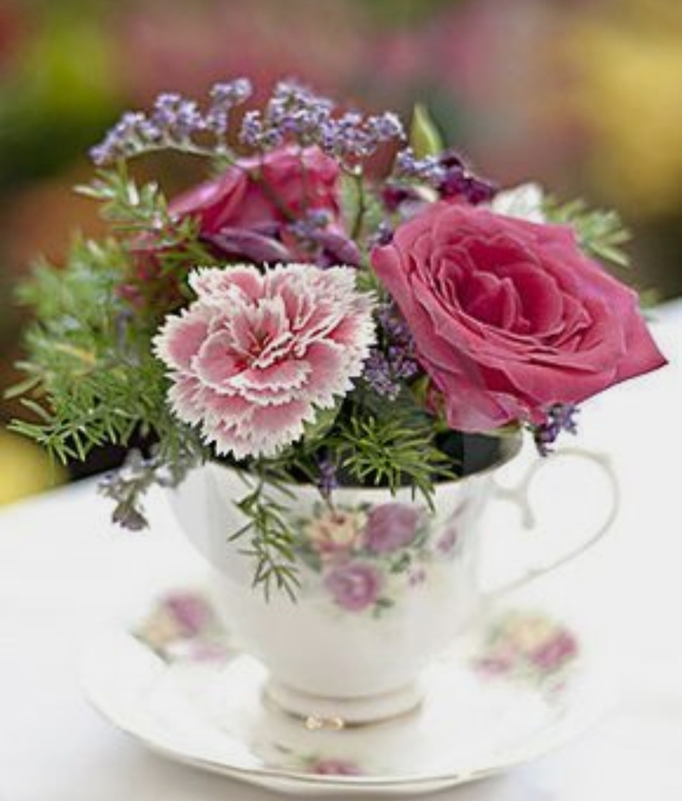
Tea Time Collaboration Artist: Sarah Prince
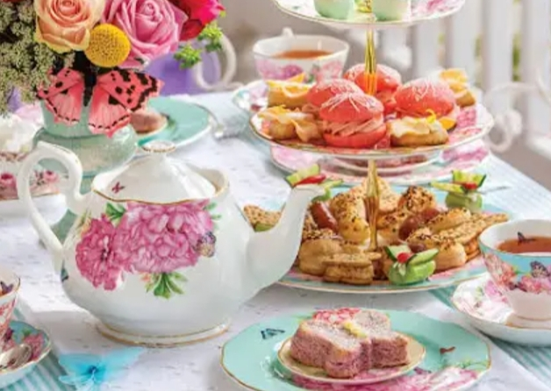
Sip, Sip, Hooray! It’s tea time!!
"Designer Florals by Rilie" will be demonstrating how to make our very own teacup flower arrangement. Each person will make one and take it home.
Sarah Prince will be catering in traditional afternoon teatime hors d'oeuvres and fresh tea, of your choosing. A fun afternoon for friends or a family date. Register quickly because this will fill up fast.
- Date: Saturday, February 17 | 1:00 – 3:00 p.m.
- Workshop fee: $40, pay at time of registration to guarantee your seat
- Class size: 16
- Ages: 8 – 108 years

Upcycled Sweater Hats Artist: Brenda Hayes
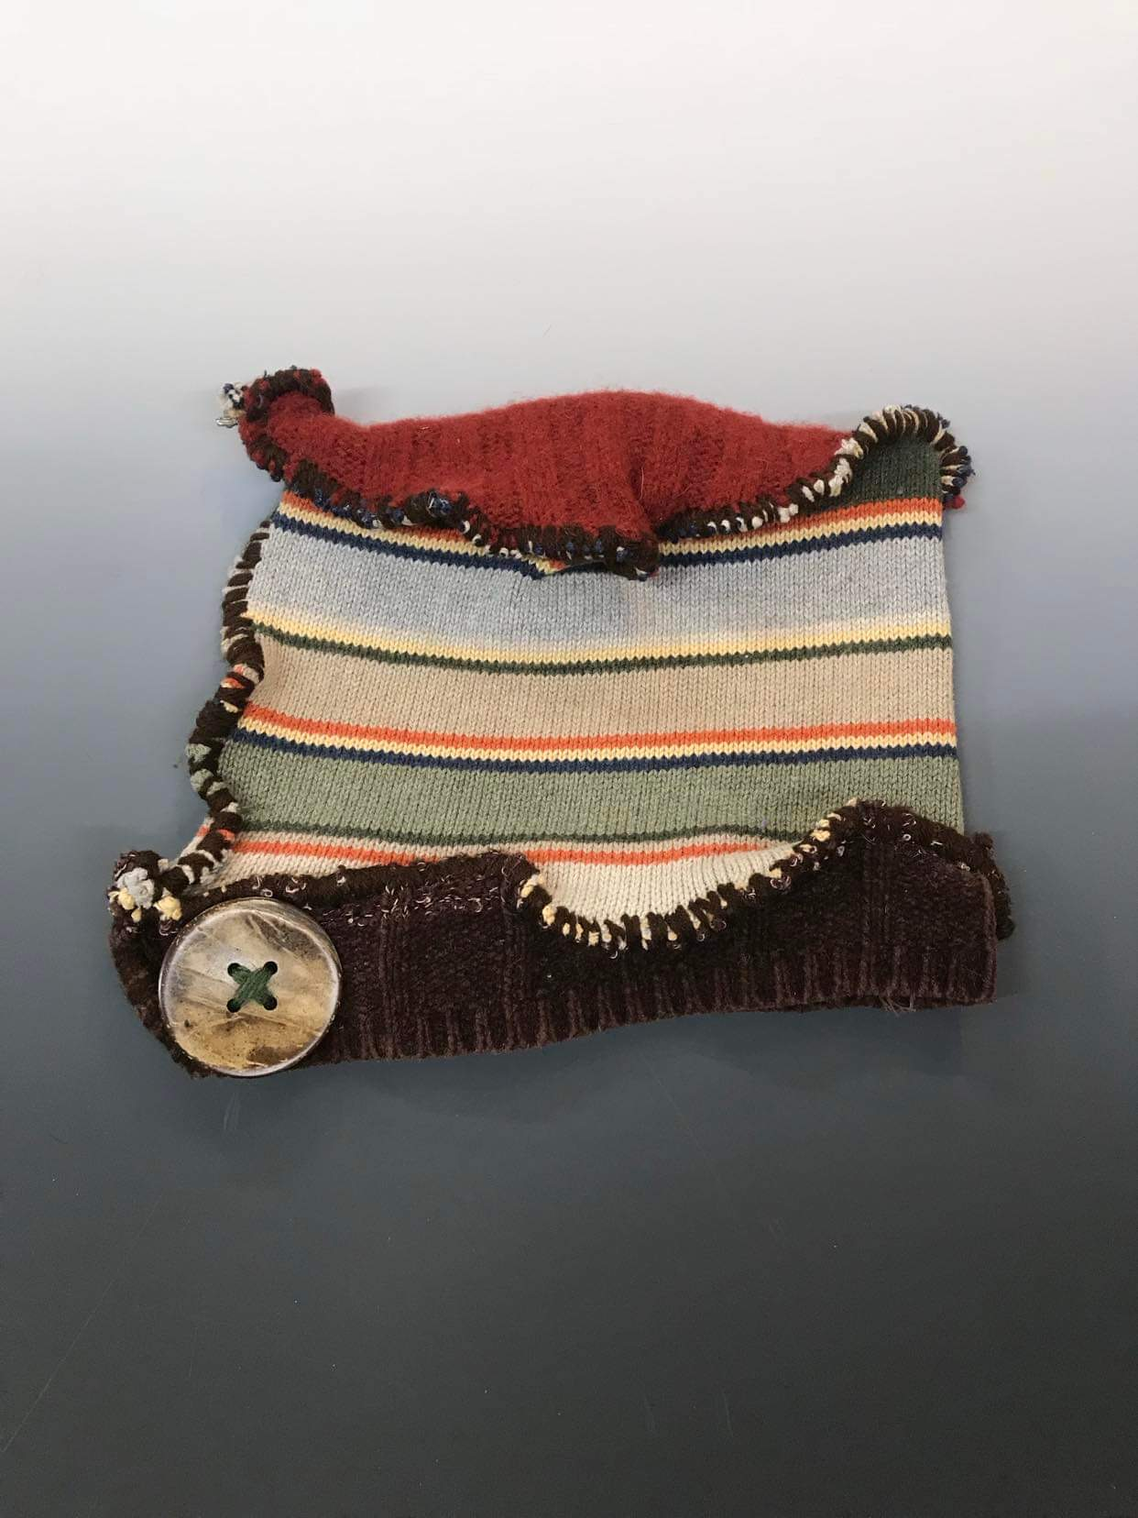
Make your own unique hat using old sweaters. Brenda will provide all the materials. We will handstitch and embellish using buttons and beads.
If you have an old sweater that you would like to use, feel free to bring it.
- Date: Sunday, February 18 | 1:00 to 3:00 p.m.
- Workshop fee: $30.00, pay at time of registration to guarantee your seat
- Ages: 14 and older

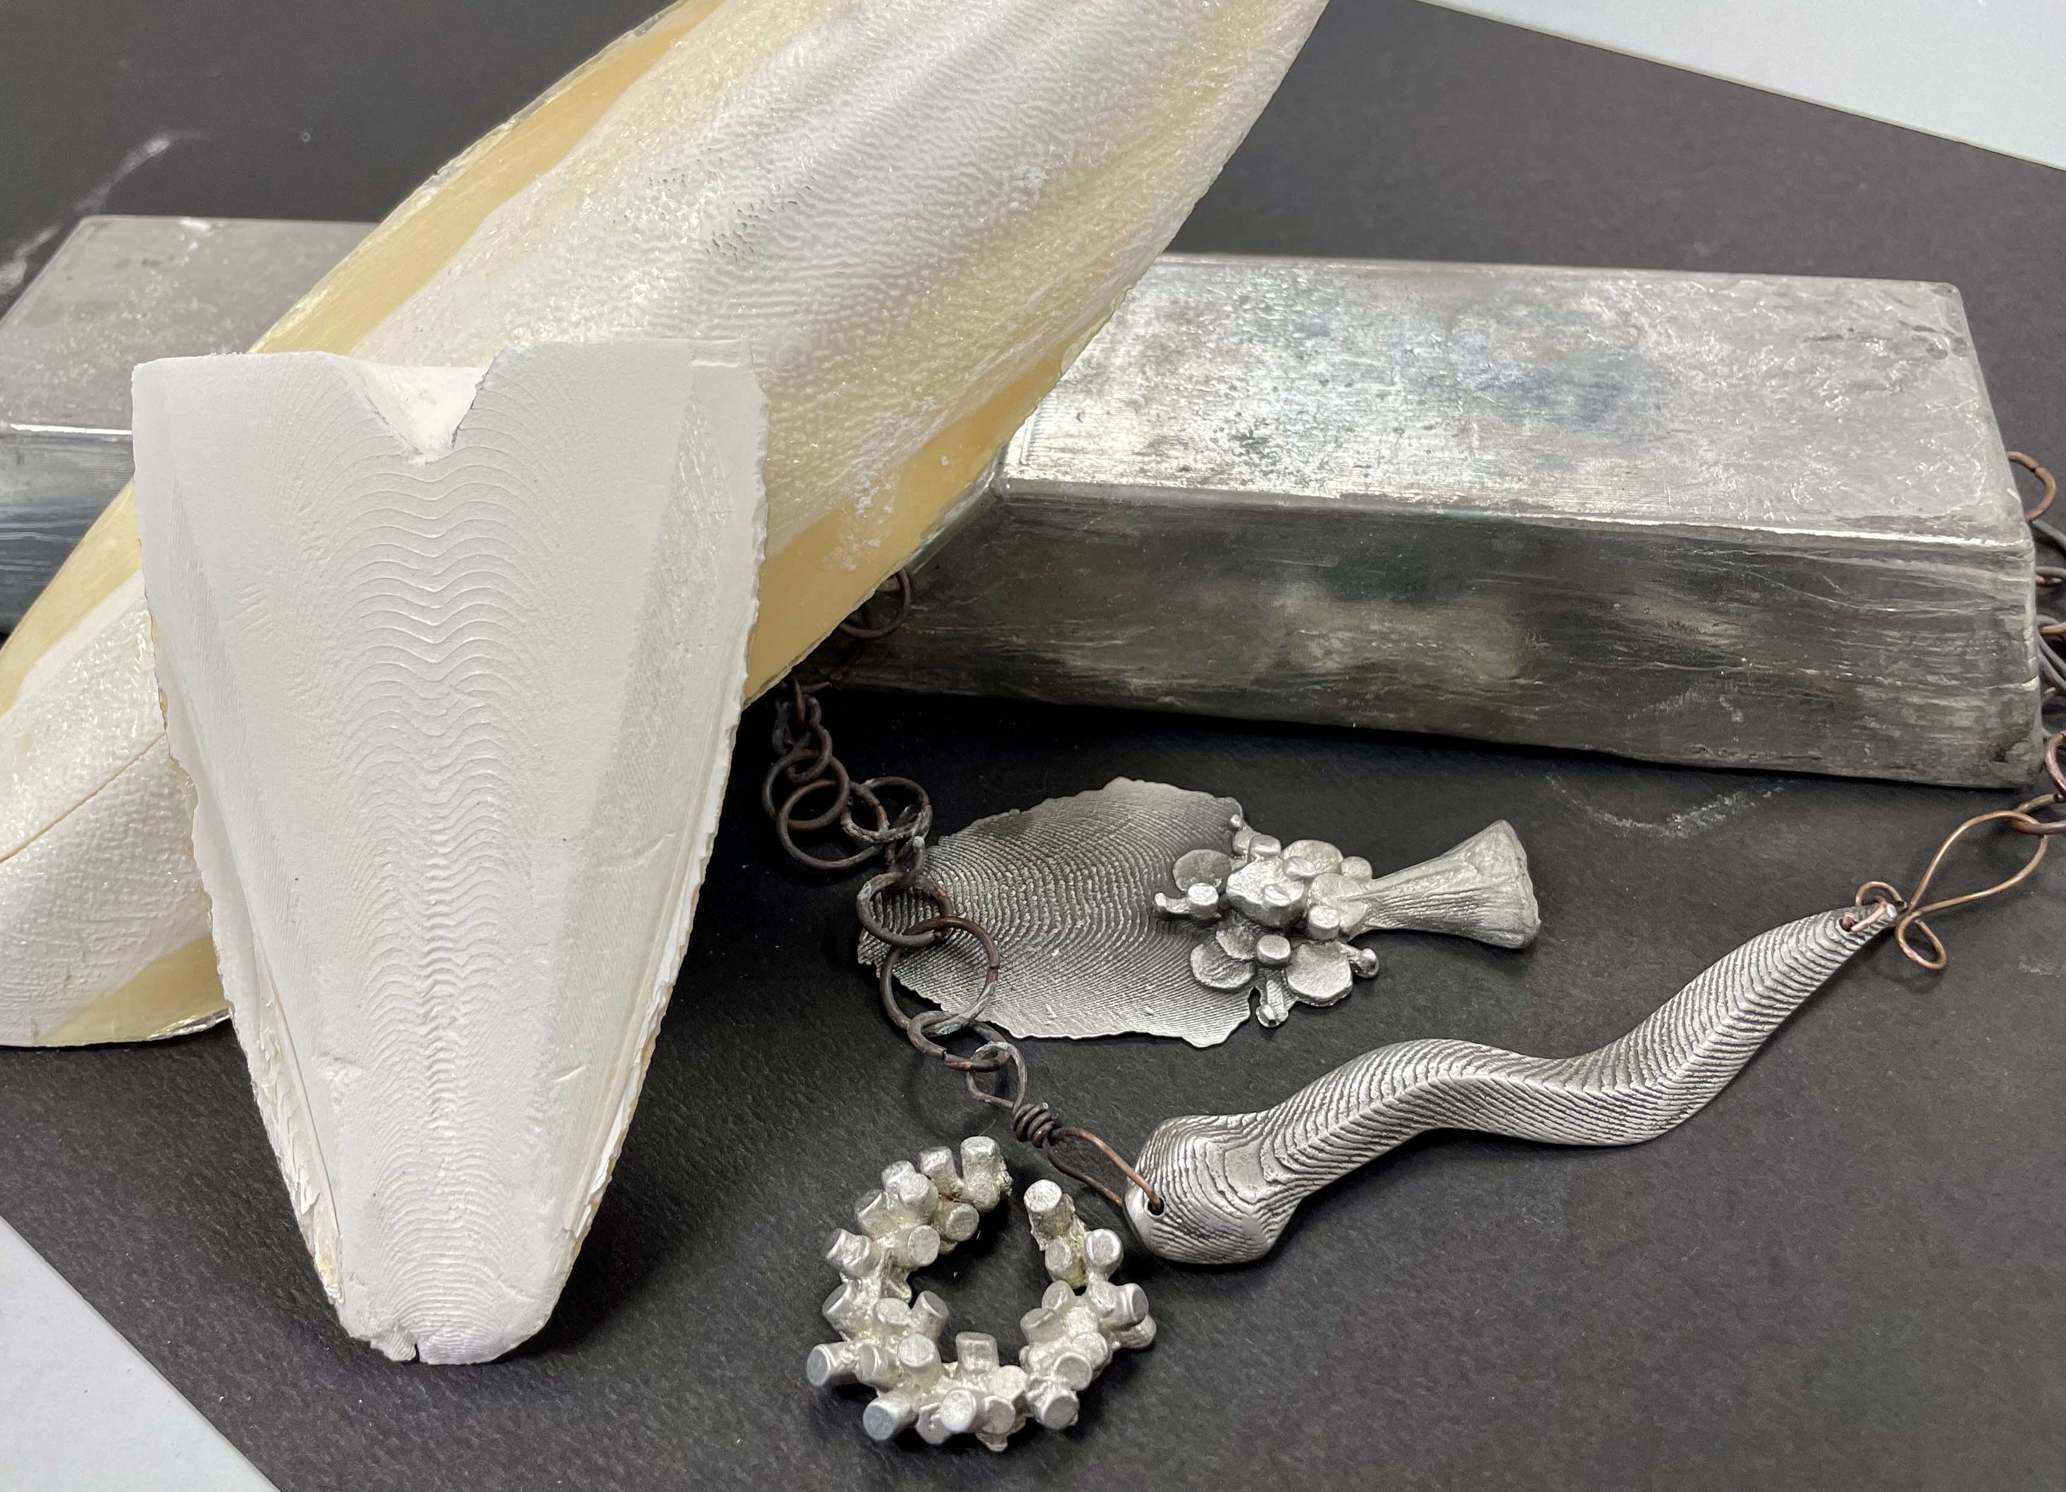
Cuttlebone Casting Artist: Nicole Meyer-Foresman
Learn to carve and cast into the dried bone of a cuttlefish! The organic layers of this material create beautiful textures and patterns into any design, naturally. Each participant will have an opportunity to make a flat back piece as well as a 2-part mold cast. We will be working with Pewter.
- Date: Saturday, February 24 | 1:00 – 4:00 p.m.
- Workshop fee: $50, pay at time of registration to guarantee your seat
- Minimum age: 12 and above
- Class size: 10

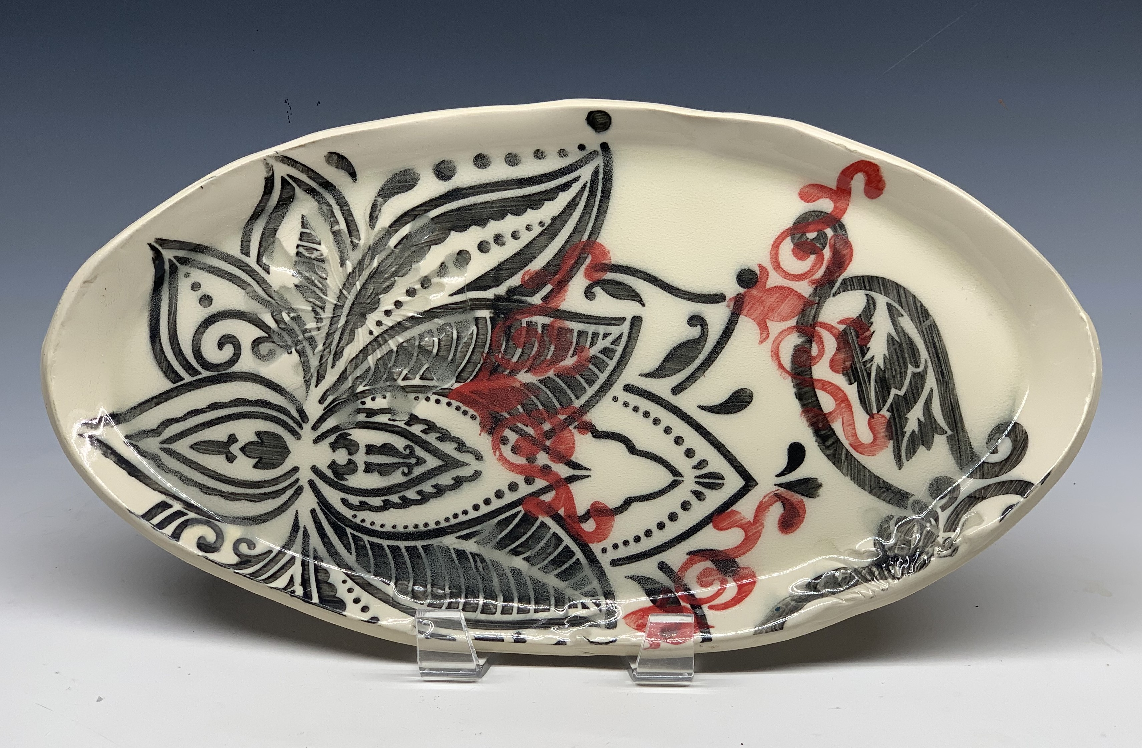
Ceramic Stenciled Trays Artist: Daria Claiborne
Let's make functional art pieces with fun intricate designs using stencils!
All supplies are included.
- Date: Sunday, February 25 | 1:00 – 4:00 p.m.
- Workshop fee: $50, pay at time of registration to guarantee your seat
- Ages: 14 and up
- Class size: 10 participants

Check our Facebook page during the month as artists may offer “popup” workshops!
ArtForms artists also offer pop-up workshops during the month. Follow the Gallery on its Facebook page and/or its website!
- Facebook: ArtFormsGallery620/
- Website: www.artforms-gallery.com

Do you have a birthday or special occasion to celebrate? Contact the Gallery to book a private party with an ArtForms Gallery artist!
Possibilities include:
- Sip and Paint  - Painting  - Jewelry  - Textiles | - Fused Glass/Stained Glass  - Pottery (ceramic birdhouse, windchime, pitchers)  - Fiber
Have a workshop suggestion or special request for us?
Don’t hesitate to give us a call! 620-240-0165

Become a
Gallery Patron
Save 10% on every workshop you take in a 12-month period!!!
Only $40.00




Give the gift of creativity with an
ArtForms Gallery Gift Card or a
Gallery Patron Membership!

