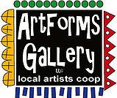
November 2023 Workshops
620 N. Broadway, Pittsburg, KS 620-240-0165
ArtForms Gallery is a co-op of artists offering monthly workshops ranging from acrylic painting, watercolor, oil pastels, glass fusing, pottery, metalsmithing, jewelry, textiles, kids’ art and more! All workshops are held at the Gallery unless otherwise noted. Please call Artforms Gallery to register for any artist’s workshop.

Refunds/Cancellations—Decisions regarding refunds and cancellations are determined by the artist leading the workshop. You can find individual contact information for each artist on the “Artists” page of our website, or just call the Gallery and we’ll get you in touch. Facebook:ArtFormsGallery620/
Art Explorations!
Are you looking for camaraderie while exploring your artistic side? Join Gallery artists Pat Glick every Tuesday afternoon for a fun time working on your own project or art! Bring your materials and create with us for free!
Every Tuesday
November 7, 14, 21, 28
12:30 – 2:30 p.m.
FREE~FREE~FREE!!!
Give the Gift of Art
- Original Art
- Local Artists
- Gift Cards

Gift cards may be purchased in any amount and do not expire. They may be redeemed for workshops or for original art!

To check the balance of your Gift Card online:
https://squareup.com/gift/46K96BF2TK6W7/check-balance
Website:www.artforms-gallery.com

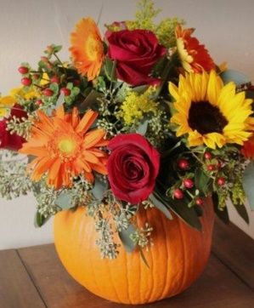
Pumpkin Fall Centerpiece Artist: Sarah Prince
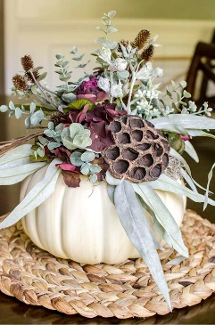
Would you like to have a pumpkin fall centerpiece that all your Thanksgiving guests will “ooh” and “ahh” over? Why not make it yourself? Workshop attendees will learn how to prepare a pumpkin vase with dry foam inserts and faux fall foliage. This centerpiece can be used for years to come. All supplies will be provided. Follow along and select your favorite fall colors to design your personalized arrangement.
- Date: November 4 | 1:00 p.m. - 3:00 p.m.
- Fee: $40, payable at time of registration
- Class size: 14
- Ages: 10 - 100

Beginner Brush Calligraphy Artist: Neva Rowland
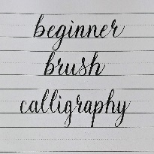
Have you seen fancy calligraphy shared on Pinterest or Instagram and wanted to learn, but didn't know where to start? While there are many styles and tools to create beautiful calligraphy, this class will utilize a beginner friendly brush pen to build skills from basic strokes, to letters, to words. The skills learned in this class will serve as excellent base knowledge for exploring other calligraphy styles to showcase in everything from bullet journals to holiday cards.
- Date: Sunday, November 5
- Time: 1:00 p.m. - 3:00 p.m.
- Fee: $30 payable at time of registration,
- Ages: 10+ (Those under 14 years of age must be accompanied by an adult. The adult need not pay the workshop fee unless they wish to participate.)
- Class size: 18

Fused Glass Small Dish/Votive Cup Artist: Dianne Miller
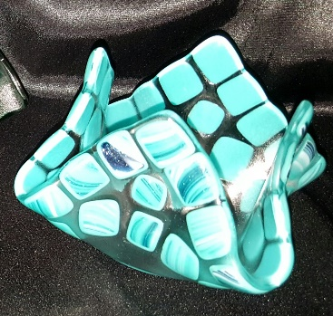
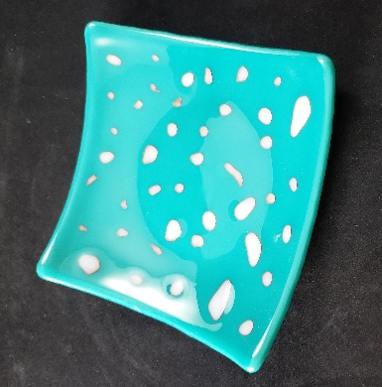
Create a small dish or votive cup to give as gifts this year or keep for yourself in this fused glass workshop. You will learn how to cut glass and arrange on a 5” x 5” clear glass square. Your creations will be fused and ready for the holiday. No experience in glass-cutting is necessary as basic skills will be taught. All tools, glass, and 2 kiln-firings are included in the workshop fee. Please wear close-toed shoes while working with glass.
- Date: Saturday, November 11 | 1:00 p.m. – 4:00 p.m.
- Workshop fee: $35 for one small dish, payable at time of registration
- Class size: 8
- Ages: 12 years and older

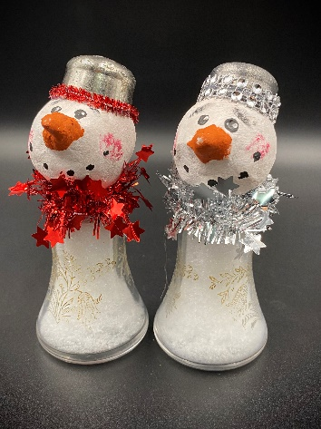
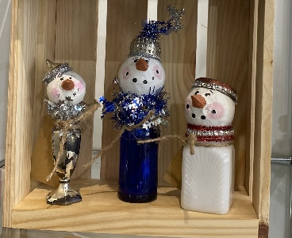
Snowpeople Time! Artist: Brenda Hayes
The upcycled snow people are back! Join Brenda in creating these one-of-a-kind snow people using upcycled materials.
All materials will be provided.

- Date: Sunday, November 12 | 1:00 p.m. – 3:00 p.m.
- Workshop fee: $45 for two snowmen, payable at time of registration
- Class size: 8
- Ages: 12 years and older
Pop Art Poppies Artist: Kathy Allen
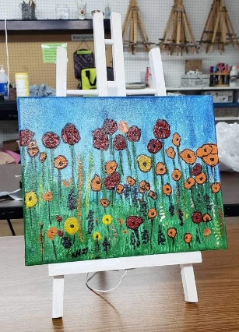
This acrylic painting workshop is designed for those who would like to paint but are hesitant to pick up the brush. The first step is painting the stand and then proceeding with step-by-step instructions to create your poppies. All supplies are provided.
- Date: Saturday, November 18 | 1:00 p.m. –
    - 4:00 p.m.
- Workshop fee: $35, payable at time of registration
- Class size: 8
- Ages: 13 years and older

Ceramic Christmas Trees! Artist: Daria Claiborne

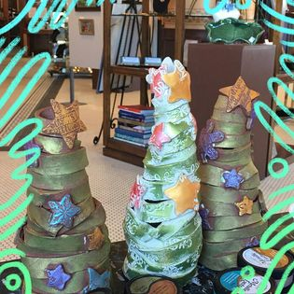
Given a slab of clay, participants will fashion their own ceramic trees, then decorate with clay cut-outs. Glazes and 2 kiln-firings are included in the workshop fee. Bring your creativity and get your hands in the clay!

- Date: Sunday, November 26 | 21:00 p.m. – 4:00 p.m.
- Workshop fee: $50, payable at time of registration
- Class size: 10
- Ages: 12 years and older

Facebook: ArtFormsGallery620/
Website: www.artforms-gallery.com

Do you have a birthday or special occasion to celebrate? Contact the Gallery to book a private party with an ArtForms Gallery artist!
Possibilities include:
- Sip and Paint  - Painting  - Jewelry  - Textiles  - Pour Painting | - Fused Glass/Stained Glass  - Pottery (ceramic birdhouse, windchime, pitchers)  - Fiber  - Glass and Resin
Have a workshop suggestion or special request for us?
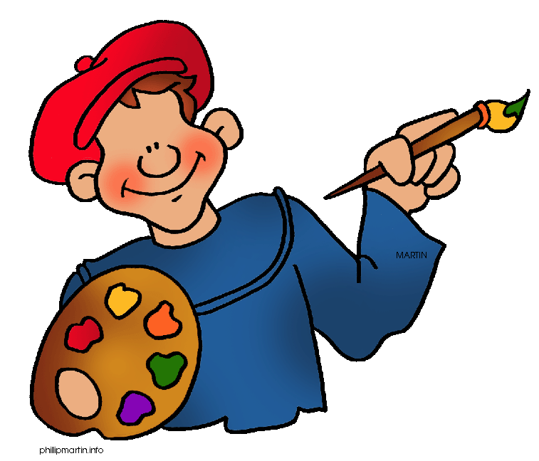
Give us a call!
Become a
Gallery Patron
Save 10% on every workshop you take in a 12-month period!
Only $40.00

ArtForms Gallery artists are planning our annual Holiday Open House! Stay tuned for details in the next month!!

