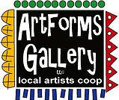
October 2022 Workshops
620 N. Broadway, Pittsburg, KS 620-240-0165

ArtForms Gallery is a co-op of artists offering monthly workshops ranging from acrylic painting, watercolor, glass fusing, pottery, metalsmithing, jewelry, textiles, kids’ art and more! All workshops are held at the Gallery unless otherwise noted. Please call Artforms Gallery to register for any artist’s workshop.
620-240-0165
Refunds/Cancellations—Decisions regarding refunds and cancellations are determined by the artist leading the workshop. You can find individual contact information for each artist on the “Artists” page of our website, or just call the Gallery and we’ll get you in touch.
Website: www.artforms-gallery.com
Facebook: ArtFormsGallery620/
ArtForms Gallery introduces its “Autumn Adventures at ArtForms” this fall! Nicole Meyer-Foresman kicked the season off with a Sip and Paint in September. October presents Getting Wired with Kristin Girard and Dianne Miller’s Flower Power events. November features Debbie Southard and her popular pour painting workshop! Join us!
Each month Gallery artists design and design and stage our front window for your viewing pleasure!
The September window display is courtesy of Sarah Prince and Rolanda Root. We hope you enjoy it!

Give the Gift of Art
- Original Art
- Local Artists
- Gift Cards

Gift cards may be purchased in any amount and do not expire. They may be redeemed for workshops or for original art!

To check the balance of your Gift Card online:
https://squareup.com/gift/46K96BF2TK6W7/check-balance
Meet Our Newest Artists!
Kathy Allen
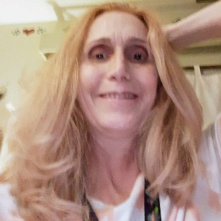
My art seems to just flow out of me. I wake up almost every morning and a new image in my mind and just jump up and put it down on canvas. Art is my therapy. I have had multiple neurosurgeries since I was 19 and many times have come out from surgery with a new ‘gift”. After my last surgery and a little hint from a friend, I found painting. I hope you can find something from my collection that catches your eye. I do special colors by request.

Ginger Copeland
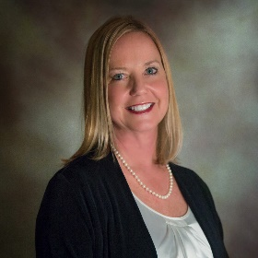
I picked up a paintbrush for the first time in 2018 and have enjoyed experimenting with different media since then. I spent over 40 years as a court reporter and owner of a court reporting firm before retiring in 2020, and art served as a stress reliever for me in the latter part of that time. I mainly work with acrylics and glass and resin; I love seeing how glass and resin can bring a piece to life. More than anything, I like exploring the possibilities of new processes and experiencing results that I never considered at the beginning, and if I create something that makes others happy, that is icing on the cake! Check out Ginger’s workshop this month!

Sarah Prince
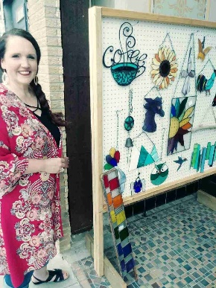
After learning stained glass at ArtForms Gallery, I found something that filled my soul with happiness. I bought my start up tools and materials at an auction and the rest is history.
I enjoy making stained glass artwork because I love seeing the finished panel or suncatcher. I relish how the light shines through and how it explodes with color. I love the wonder I feel, having created something so beautiful.
Working with stained glass is all about the light. The colors and intensity of the glass changes throughout the day. I always look forward to my next project and have 100's of ideas in my head of what I want to make next. It is the perfect creative outlet.

Art Explorations/Painting Intro
Artist: Pat Glick
Are you looking for camaraderie while exploring your artistic side? Join Gallery artists Pat Glick every Tuesday afternoon for a fun time working on your own project or art! Bring your materials and create with us for free!
- Tuesdays, October 4, 11, 18, 25 | 12:30 – 2:30 p.m.
- Art Exploration Workshop Fee: FREE~FREE~FREE!!!
- Beginning Painting Workshop Fee: $15 per session, payable at time of registration each week to reserve a spot
- Ages: Adults only
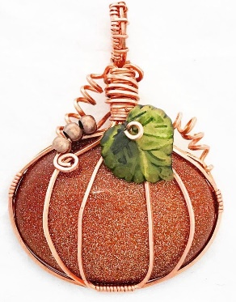
Wire-wrap a Pumpkin! (cabochon)* Artist: Kristin Girard
Get wired with Kristin during this fun jewelry workshop! Learn how to wire-wrap a pumpkin cabochon made of glass. All supplies are provided. You will depart with a classy necklace to wear during the fall holidays!
- Friday, October 7 | 6:30 – 8:30 p.m.
- Workshop Fee: $35, due at time of registration
- Class limit: 8
- Ages: 16 years and older
*This workshop is part of our Autumn Adventures at ArtForms series!

Holiday Ornaments: Resin and Glass Artist: Ginger Copeland
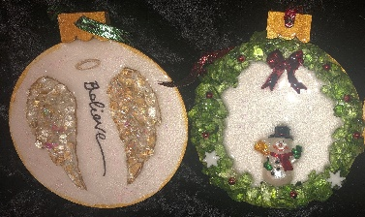
Begin the holiday season with new handmade ornaments! Using resin and glass and other decorative findings, you will create two ornaments of your own design. Simple glass-cutting will be demonstrated and used. Once your design is complete, I will pour resin to finish the design. Items may be picked up beginning Tuesday, October 18, during Gallery hours.
- Saturday, October 15 | 1:00 – 4:00 p.m.
- Workshop Fee: $40, due at time of registration
- Class limit: 10
- Ages: 12 years and older

Ceramic Leaf Plates Artist: Daria Claiborne
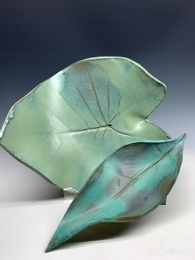
Let’s get creative with actual leaves! We will make plates using REAL leaves as our guide. Choose between elephant ears, cannas or Monstera leaves. All supplies will be provided.
- Sunday, October 16 | 1:00 – 4:00 p.m.
- Workshop Fee: $50, due at time of registration
- Class limit: 10
- Ages: 12 and older

Flower Power! Fused Glass Artist: Dianne Miller
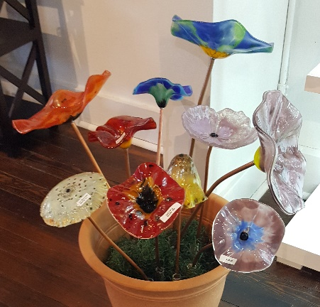
Glass flowers last all year and need no watering or sunlight to maintain their blooms! Attend this workshop and make a fused glass flower that won’t wilt or fade! No glass cutting is required, but you will work with glass powder so a face mask is required. Using glass powders and water, participants will create a slurry in a variety of colors and design a glass flower to be fused on a ceramic mold. After drilling a hole, a copper tube will be inserted to make a free-standing flower for your home or flower bed.
Easy and fun—you don’t need a “green thumb” to “grow” these flowers! Oh, and you don’t have to worry about watering your flower!
- Friday, October 21 | 1:00 -5:00 p.m.
  - Come and go anytime during the afternoon!
- Ages 12 and older
- Workshop Fee: $35; due at time of registration
*This workshop is part of our Autumn Adventures at ArtForms series!

Check out what Debbie and Brenda are doing now!!
Neurographic Art! Artist: Debbie Southard
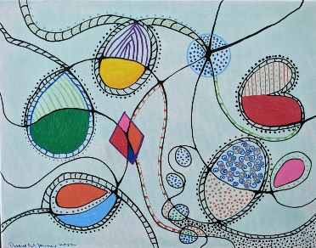
Come, relax, and destress before the holidays with an Art therapy class! Neurographic art is a process used to help make new neural paths in the brain. In brief, a neural pathway is a series of connected neurons that send signals from one part of the brain to another. This is very relaxing and a slow-paced process that anyone, regardless of art experience, is able to do.
- Saturday, October 29 | 2:00 – 4:00 p.m.
- Workshop Fee: $30, due at time of registration
- Class limit: 10
- Ages: 14 and older

Halloween Journal Artist: Brenda Hayes
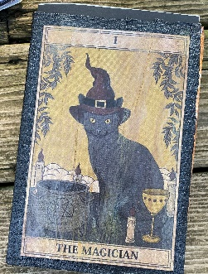
Do you have the Halloween holiday as much as Brenda? Then join her as she leads you in making a Halloween Journal using a Sizzix machine, Gelli plates, paint, and stamps.

- Sunday, October 30 | 1:00 – 4:00 p.m.
- Workshop Fee: $35, due at time of registration
- Class limit: 6
- Ages: 14 and older
Workshops Coming in November!
Ginger: Nov. 6—Resin and Glass Christmas Tree
Debbie: Nov. 12—Autumn Adventures at ArtForms pour painting
Dianne: Nov. 19—Dichroic Pendant Fused Glass
Brenda: Nov. 27—Upcycled Snowmen

Check our Facebook page during the month as artists may offer “popup” workshops!
ArtForms artists also offer pop-up workshops during the month. Follow the Gallery on its Facebook page and/or its website!
- Facebook: ArtFormsGallery620/
- Website: www.artforms-gallery.com
Do you have a birthday or special occasion to celebrate? Contact the Gallery to book a private party with an ArtForms Gallery artist!
Possibilities include:
- Sip and Paint  - Painting  - Jewelry  - Textiles | - Fused Glass/Stained Glass  - Pottery (ceramic birdhouse, windchime, pitchers)  - Fiber
Have a workshop suggestion or special request for us?
Don’t hesitate to give us a call!

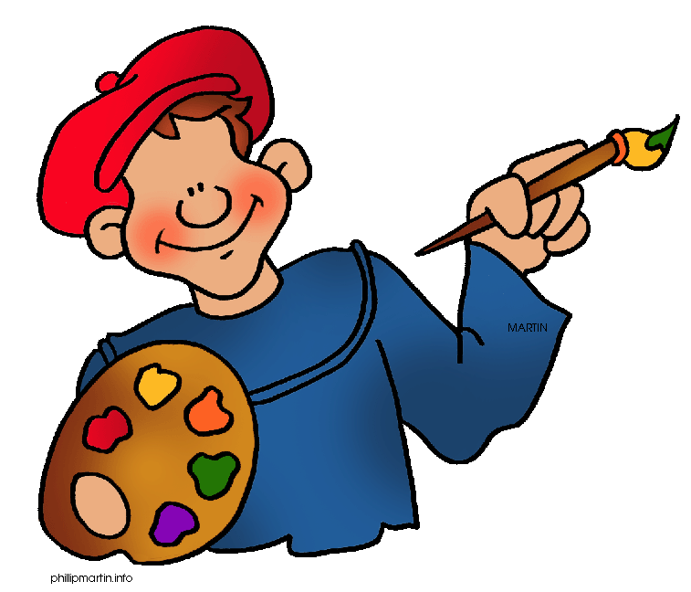
Become a
Gallery Patron
Save 10% on every workshop you take in a 12-month period!!!
Only $40.00

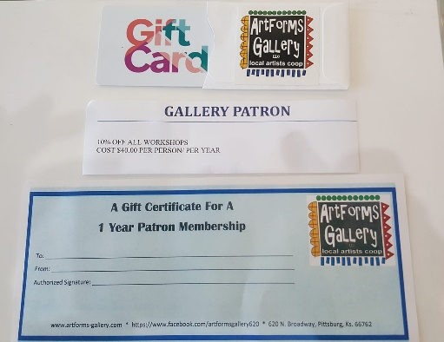
Give the gift of creativity with an
ArtForms Gallery Gift Card or a
Gallery Patron Membership!

