
ArtForms Gallery
October 2020 Workshops
620 N. Broadway, Pittsburg, KS 620-240-0165

ArtForms Gallery artists love when you visit our Gallery in search of the unique, handmade gift or a new art piece for your home or office! However, we also want our customers and artists to remain safe during the changing health conditions in our community. Please maintain appropriate social distancing and wear a mask when visiting. We will do our part in maintaining a clean and safe environment for you to shop or take a workshop. We look forward to seeing you again soon!

ArtForms Gallery is a co-op of 19 different artists offering monthly workshops ranging from oil painting, watercolor, glass fusing, pottery, wood carving, metalsmithing, jewelry, textiles, kids’ art and more! All workshops are held at the Gallery unless otherwise noted. Please call Artforms Gallery to register for any artist’s workshop. 620-240-0165

Refunds/Cancellations—Decisions regarding refunds and cancellations are determined by the artist leading the workshop. You can find individual contact information for each artist on the “Artists” page of our website, or just call the Gallery and we’ll get you in touch.

Art-tober—A Young Artist Series Artists: Laura and Nicole
Every Tuesday in October, young artists, ages 6-12) will participate in a unique and creative art experience. Projects include Paint Party, Face Mask decorating, Spooky Sculptures and Jack-o-lanterns!
- Tuesdays: October 6, 13, 20, 27 4:00—5:30 p.m.
- Class size is limited to 8 young artists.
- $50 for all 4 sessions, or $20 per session, payable at registration
- All supplies are provided.

Whimsical Ceramic Critters Artist: Daria
Create whimsical critters (elephants, little piggies, bunnies, fish, etc.) with ceramic artist Daria! Use your imagination to create your critter!!
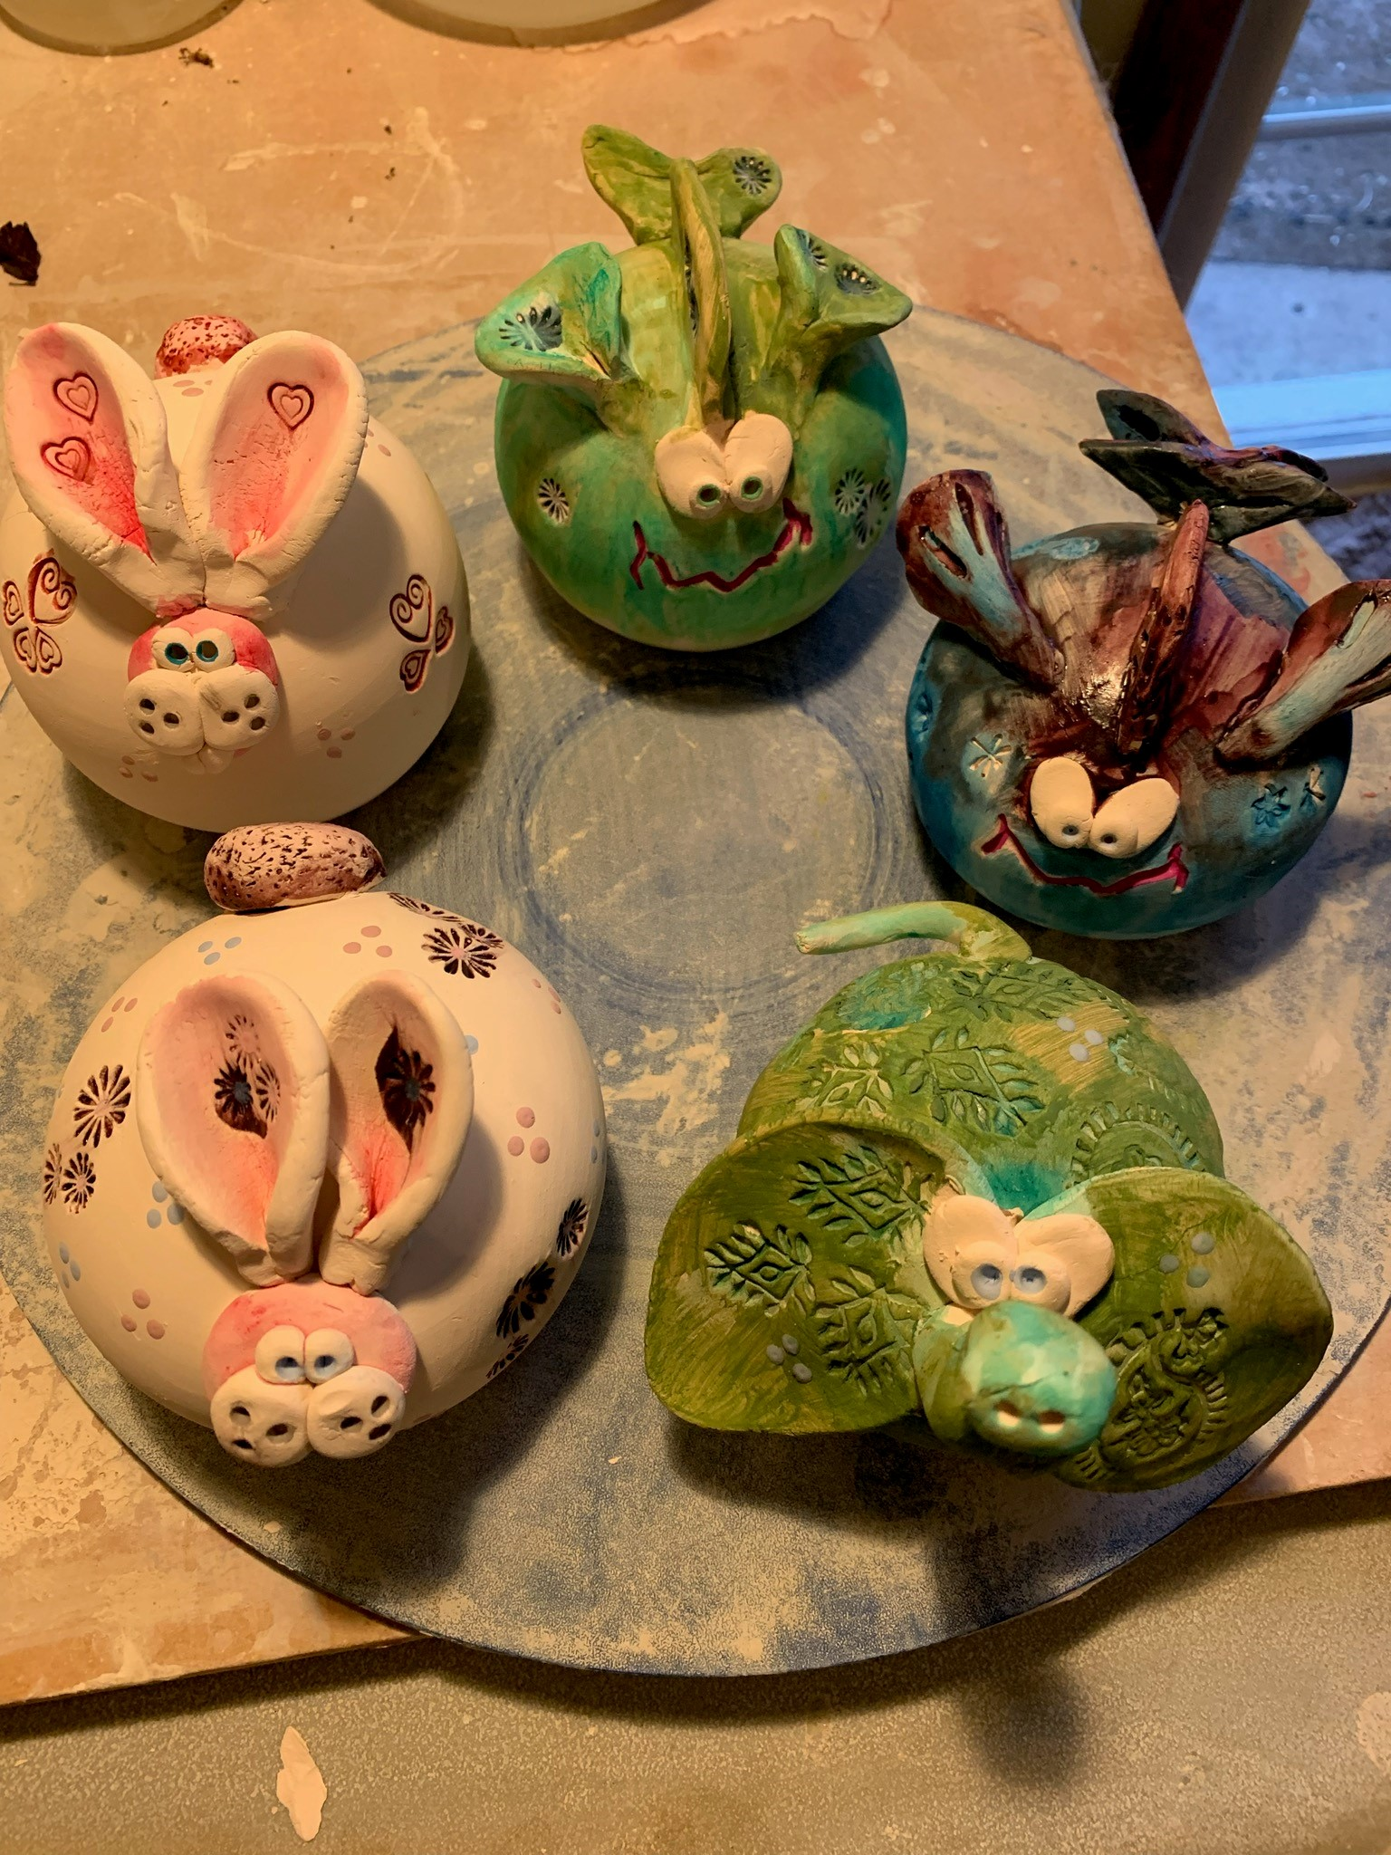
Using a clay slab in this handbuilt ceramic workshop, you will design your critters and select a glaze to enhance them. Projects will be fired and then returned to the Gallery for you to pick up in a couple of weeks.
- Sunday, October 18 2:00 – 4:00 p.m.
- $45 for 2 critters; $15 for each additional critter; payable at time of registration
- Ages 14 and older
- Class Limit: 8

Fused Glass Pendants Artist: Dianne Miller
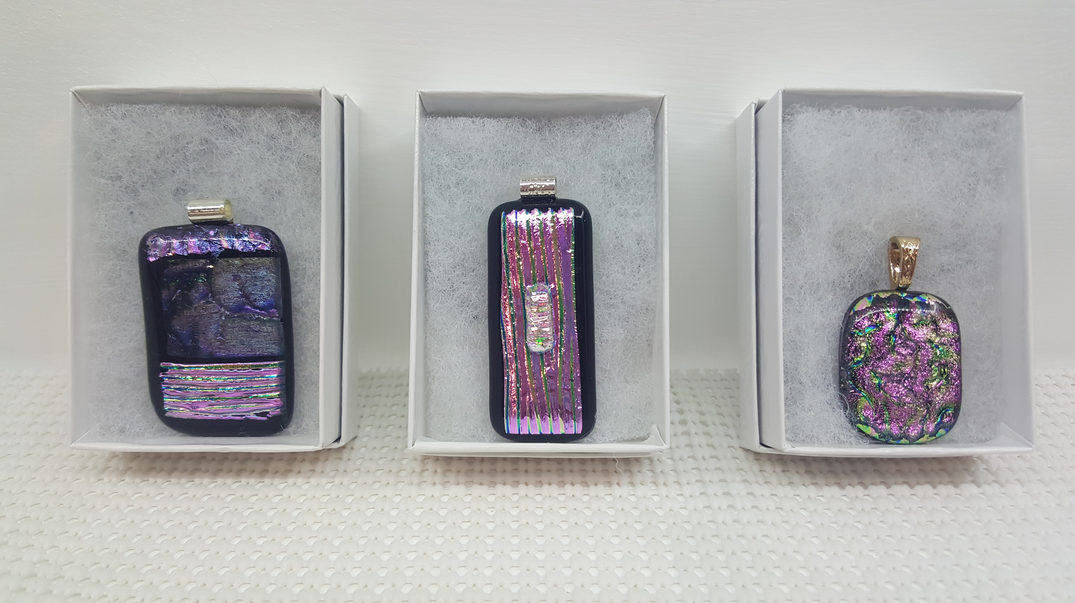
Give your own uniquely handcrafted gifts this season! Join Dianne in this fused glass workshop using dichroic glass to design 4 stunning pendants. Basic glass-cutting skills are demonstrated. Individual instruction is provided along with all glass tools and material. After fusing in my home studio, your exquisite pendants will be returned to the Gallery and ready for you to pickup October 30.
- Sunday, October 25 1:00 p.m. – 3:00 p.m.
- Workshop fee: $40; payable at time of registration
- Ages 14 and older
- Class limit: 8

Kids Halloween Art Party! Artists: Laura and Pat
Register your kids for a fun precursor to the evening’s trick or treating! Gallery artists Laura and Pat will guide the kiddos in creating Halloween-themed crafts, painting, sculpting, drawing, and shadow dancing! All materials and supplies are provided.
- Saturday, October 31 4:30 p.m.— 5:30 p.m.
- Workshop fee: $15; payable at time of registration
- Ages 7-12 years
- Class limit: 8

Halloween Spook, Paint, and Potion Artist: Laura
After the kiddos’ trick-or-treating is finished, join Laura at the Gallery for your own Halloween fun! Paint a fun Halloween design on 12 x 12 black stretched canvas.
- Saturday, October 31 10:00 p.m. to 11:30-12:00
- Workshop fee: $25; payable at time of registration
- Ages 18 and older
- Class limit: 8
- Please bring beverages of your choice.

Check our Facebook page during the month as artists may offer “popup” workshops!

ArtForms artists also offer pop-up workshops during the month. Follow the Gallery on its Facebook page and/or its website!
- Facebook: ArtFormsGallery620/
- Website: www.artforms-gallery.com

Do you have a birthday or special occasion to celebrate? Contact the Gallery to book a private party with an ArtForms Gallery artist!
Possibilities include:
- Sip and Paint  - Painting  - Jewelry  - Textiles | - Fused Glass/Stained Glass  - Pottery (ceramic birdhouse, windchime, pitchers, wheel-throwing)  - Woodcarving
Have a workshop suggestion or special request for us?
Don’t hesitate to give us a call!

Important!!!
Call ArtForms Gallery each Tuesday to confirm Art Exploration is definitely scheduled before coming.
Art Exploration! Free! Free! Free!

Are you looking for camaraderie while exploring your artistic side? Join Gallery artist Pat Glick every Tuesday afternoon, 1 p.m. – 3 p.m. to explore different art techniques. Pat will lead you through a creative art experience every week. Feel free to bring something you are working on also. We will have opportunities to participate in community activities and charities at times.
Art Exploration is free so you just bring your willingness to try something new in art!
- Every Tuesday
- 1:00 p.m. – 3:00 p.m.

Become a
Gallery Patron
Save 10% on every workshop you take in a 12-month period!!!
Only $40.00




Give the gift of creativity with an
ArtForms Gallery Gift Card or a
Gallery Patron Membership!

