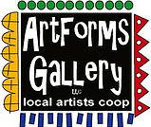
June 2022 Workshops
620 N. Broadway, Pittsburg, KS 620-240-0165

Give the Gift of Art
- Original Art
- Local Artists
- Gift Cards

Gift cards may be purchased in any amount and do not expire. They may be redeemed for workshops or for original art!

To check the balance of your Gift Card online:
https://squareup.com/gift/46K96BF2TK6W7/check-balance
ArtForms Gallery is a co-op of artists offering monthly workshops ranging from acrylic painting, watercolor, glass fusing, pottery, metalsmithing, jewelry, textiles, kids’ art and more! All workshops are held at the Gallery unless otherwise noted. Please call Artforms Gallery to register for any artist’s workshop. 620-240-0165
Refunds/Cancellations—Decisions regarding refunds and cancellations are determined by the artist leading the workshop. You can find individual contact information for each artist on the “Artists” page of our website, or just call the Gallery and we’ll get you in touch.
Website: www.artforms-gallery.com
Facebook: ArtFormsGallery620/
Have you seen our special window that Phil, Kristin, Laura, and Sue created for
The Big Kansas Roadtrip???
Stop by soon and check out the special Kansas-related art inside too!

Save the date!! Thursday, June 16, 2 p.m.
A PSU orchestral ensemble, under the direction of Professor Raul Mungula, will perform at ArtForms Gallery. Please join us for a delightful hour of music.
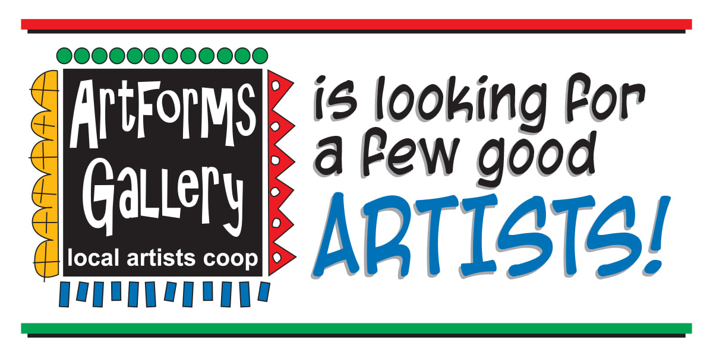
- Constant exposure in the community with minimal time and financial investment.
- Opportunity to be featured in special events and on the ArtForms Gallery website and Facebook page.
- Participate in ArtForms Gallery group shows.
- Be a member of a supportive community of artists.
- Maximize sales with minimal effort. NO commission on sales through the gallery.
- Offer workshops to increase income potential through the gallery.
- Attend monthly meeting to discuss and offer input in gallery operations.
- IT’S FUN!
Email info@ArtForms-Gallery.com for more information
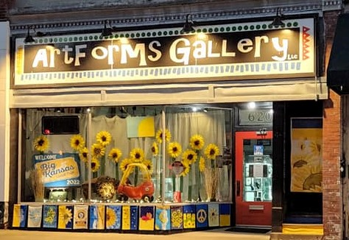
We at ArtForms Gallery are proud of our community for participating with us in the UNICEF USA fundraiser for the children of Ukraine!
The following projects were taken on in support of Ukraine:
• A banner was created expressing our solidarity with Ukraine.
• A fundraiser was started benefitting Ukrainian children through UNICEF.
• Artists painted garden flags in support of Ukraine.
• Artists created Ukrainian-themed works benefitting Ukrainian children through UNICEF.
• Artists donated a portion of their sales benefitting Ukrainian children through UNICEF.
• The Collaborative Joy! community event benefitted Ukrainian children through UNICEF.
• The auction of the paintings, from the Collaborative Joy! community event, will benefit Ukrainian children through UNICEF.
• The Stand Together! painting event benefitted Ukrainian children through UNICEF.
Thank you for supporting us in our endeavor to help the children of Ukraine!

Art Exploration/Weekly Beginning Painting Instruction
Artists: Pat Glick and Laura Wright
Are you looking for camaraderie while exploring your artistic side? Join Gallery artists Pat Glick and Laura Wright every Tuesday afternoon for a fun time working on your own project or art! Bring your materials and create with us for free!
Tuesdays, June 7, 14, 21, 28 | 12:30 – 2:30 p.m.
- Art Exploration Workshop Fee: FREE~FREE~FREE!!!
- Beginning Painting Workshop Fee: $15 per session, payable at time of registration each week to reserve a spot
- Ages: 18 years and older

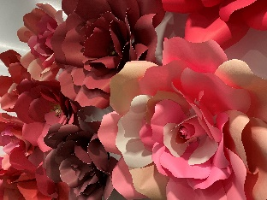
HUGE Paper Flower! Artist: Rebecca Lomshek
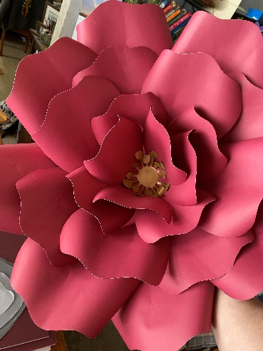
Make your own HUGE paper flower. You will have time to create a paper flower with a diameter of approximately 20”. An amazingly simple process that yields a beautiful outcome. Craft at its finest! Resources you will leave with are the knowledge to make your own flower, templates with which to create and one model flower.
Date: Friday, June 3 | 6:00 p.m. –8:30 p.m.
Workshop Fee: $40, payable at time of registration
Ages: 12 years and older
Class Size: 5

Citra Solv Prints! Artist: Rolanda Root
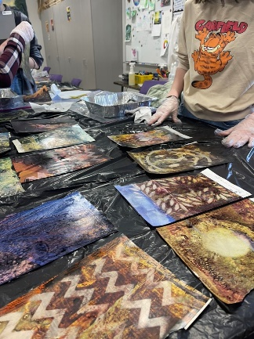
With Citra Solv, participants will create unique prints using magazines, and stencils. Techniques to embellish your prints with ink, stamps, and stencils will be demonstrated. All supplies are provided.
Date: Thursday, June 16 | 5:00 p.m. –7:00 p.m.
Workshop Fee: $35, payable at time of registration
Ages: 14 years and older
Class Size: 6

Acrylic Pour Painting Artist: Debbie Southard
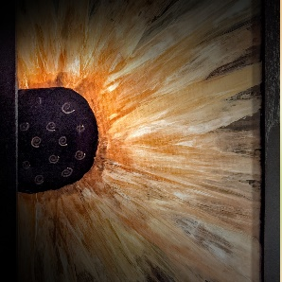
It’s summer in Kansas, and the fields of sunflowers are growing! Join me to create your own sunflower using acrylic paints and the “pour” technique. All materials provided. I offer free varnishing. This class is for those who are inexperienced and experienced with fluid art.
Once varnished, your art is very touchable and can be wiped off easily with a damp cloth to clean.
- Date: Saturday, June 18 | 2:00 p.m. – 4:00 p.m.
- Fee: $35, payable at time of registration
- Class limit: 10
- Age: 14 years and older
Blue for You — A Study in Cyanotype Artist: Michael Cessna
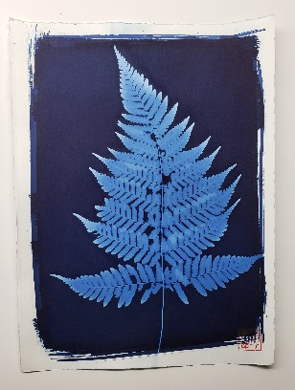
This class will focus on the alternative photographic process known as cyanotype, which was first introduced by John Herschel in 1842. We'll create photograms on three different surfaces: fine art paper, silk, and wood. Please join along as we explore this fascinating and popular alternative photographic process!
- Date: Sunday, June 19 | 2:00 p.m. - 4:30 p.m.
- Fee: $45
- Age Limits: Adult
- Class limit: 6
- Masks: Optional
Fused Glass Votive Cups Artist: Dianne Miller
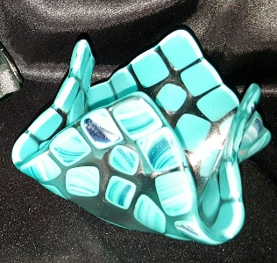
Glass votive cups make great gifts! Votive cups are suitable to be used for jelly/butter dishes or hold candies and nuts. Another use is to burn a small votive candle inside to add a glow to your evenings. Create 2 adorable votive cups by arranging cut pieces of glass on a 6” clear glass base. Basic glass-cutting skills are taught so experience is not required. Just bring your enthusiasm and creativity! All supplies, tools, and instructions are included in the workshop fee. Please wear close-toed shoes when working with glass. Protective eyewear is available if you do not wear glasses or you may bring your own.

- Date: Saturday, June 25 | 1:00 p.m. – 3:00 p.m.
- Fee: $40, payable at time of registration
- Class limit: 10
- Age: 14 years and older

Ceramic Creation Artist: Daria Claiborne
I provide you with a slab of clay, and you make whatever you like with it! Bring your imagination and have fun with this free-for-all clay workshop! All supplies are provided.
- Date: Sunday, June 26 | 2:00 p.m. – 4:00 p.m.
- Fee: $45, payable at time of registration
- Class limit: 10
- Age: 14 years and older
Check out these pictures taken during the Pittsburg ArtWalk!
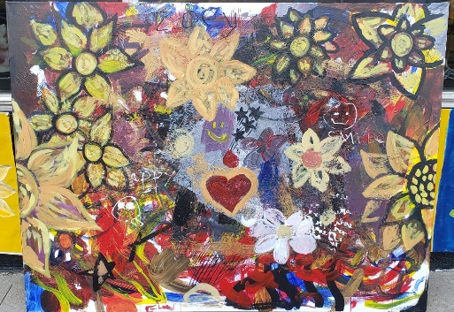
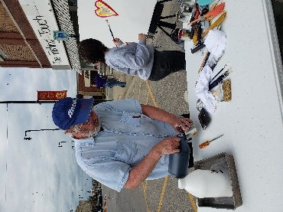
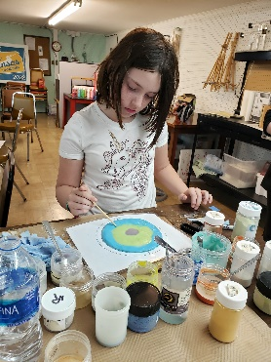
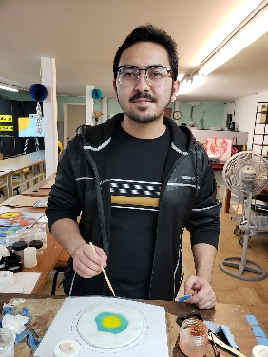

Check our Facebook page during the month as artists may offer “popup” workshops!
ArtForms artists also offer pop-up workshops during the month. Follow the Gallery on its Facebook page and/or its website!
- Facebook: ArtFormsGallery620/
- Website: www.artforms-gallery.com
Do you have a birthday or special occasion to celebrate? Contact the Gallery to book a private party with an ArtForms Gallery artist!
Possibilities include:
- Sip and Paint  - Painting  - Jewelry  - Textiles | - Fused Glass/Stained Glass  - Pottery (ceramic birdhouse, windchime, pitchers)  - Fiber
Have a workshop suggestion or special request for us?
Don’t hesitate to give us a call!

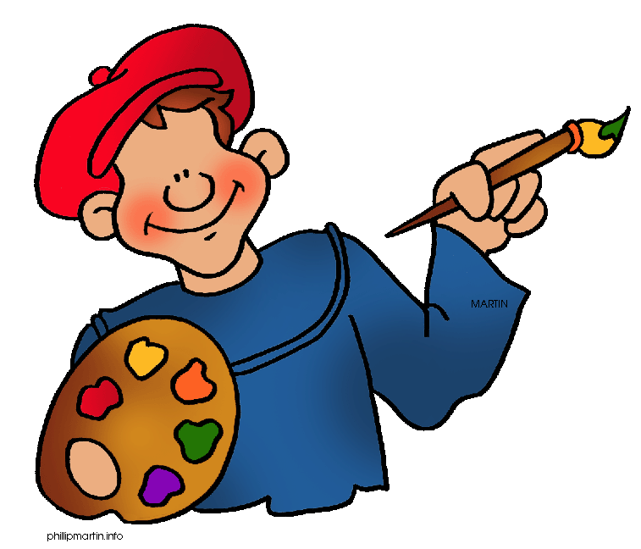
Become a
Gallery Patron
Save 10% on every workshop you take in a 12-month period!!!
Only $40.00

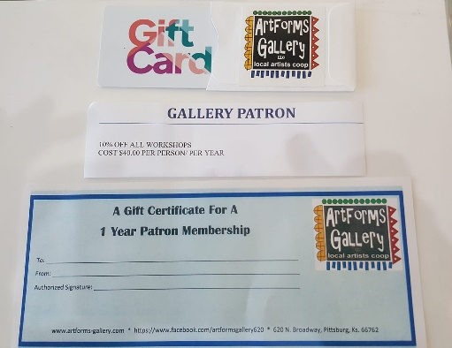
Give the gift of creativity with an
ArtForms Gallery Gift Card or a
Gallery Patron Membership!

