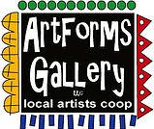
January 2023 Workshops
620 N. Broadway, Pittsburg, KS 620-240-0165

ArtForms Gallery is a co-op of artists offering monthly workshops ranging from acrylic painting, watercolor, glass fusing, pottery, metalsmithing, jewelry, textiles, kids’ art and more! All workshops are held at the Gallery unless otherwise noted. Please call Artforms Gallery to register for any artist’s workshop. 620-240-0165
Refunds/Cancellations—Decisions regarding refunds and cancellations are determined by the artist leading the workshop. You can find individual contact information for each artist on the “Artists” page of our website, or just call the Gallery and we’ll get you in touch.
Give the Gift of Art
- Original Art
- Local Artists
- Gift Cards

Gift cards may be purchased in any amount and do not expire. They may be redeemed for workshops or for original art!

To check the balance of your Gift Card online:
https://squareup.com/gift/46K96BF2TK6W7/check-balance

Website: www.artforms-gallery.com
Facebook: ArtFormsGallery620/
Art Explorations is once again offered every Tuesday beginning January 3!

Check out the exciting workshops offered for the first time in January!!!

Art Exploration! Free! Free! Free!
Are you looking for camaraderie while exploring your artistic side? Join Gallery artists Pat Glick every Tuesday afternoon for a fun time working on your own project or art! Bring your materials and create with us for free!
- Tuesdays, January 3, 10, 17, 24, 31 | 12:30 – 2:30 p.m.
- Workshop Fee: FREE~FREE~FREE!!!
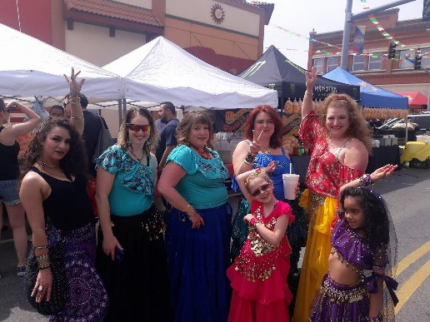
Intro to Bellydance! Yes! Bellydance!!! Artist: Lacy Warfel
No experience necessary! Bellydance is one of the most forgiving forms of dance out there- all shapes, sizes and ages are invited. This will be fun and challenging, but you’ll feel great when you leave. Aaaand- you have the opportunity to learn some “choreos” for the May gallery window event. I’d love to form a small but fierce Artforms Troupe! Wear yoga clothes or sweats, and a hip scarf if you have one. Non-grippy shoes are best.
- Thursdays, January 5, 12, 19 and 26 | 6 p.m. — 7 p.m.
- Workshop fee: $40 for the month—Use it or lose it!
  - Must be paid at signup to guarantee a spot.
- Class Limit: 6
- Ages: 14 and older
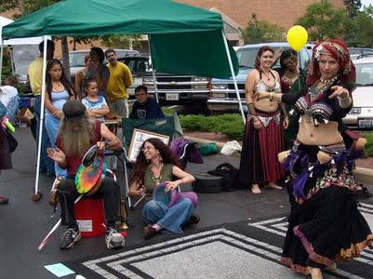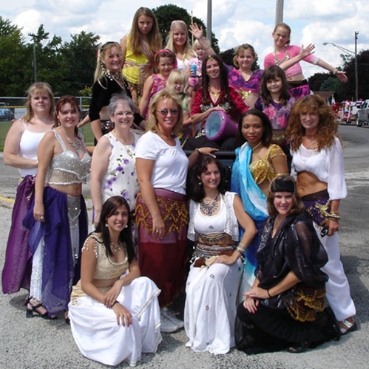

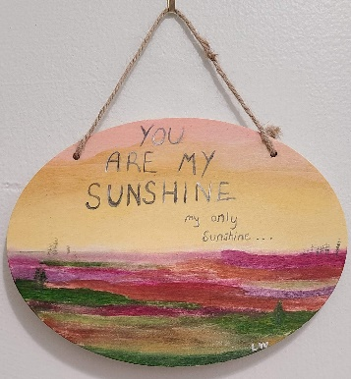
Messages of Love Artist: Lacy Warfel
Do you have plans to propose to someone special? Are you a secret admirer? Maybe you have a loved one or pet you’d like to memorialize. Perhaps someone is your Sunshine, your only Sunshine, and you just want to let them know. Participants can do a make & take sign where we will practice lettering (I know, it can be daunting). Your signs can also be part of our February front window installation!! This workshop repeats as indicated.
- Attend one or all of these sessions! Each session is $25.
  - Friday, Jan 6 | 6:00 – 8:00 p.m.
  - Saturday, Jan 14 | 6:00 – 8:00 p.m.
  - Sunday, Jan 22 | 6:00 – 8:00 p.m.
  - Tuesday, Jan 24 | 4:00 – 6:00 p.m.
- Workshop fee: $25 per session, payable at time of registration
- Class Limit: 15
- Ages: 14 and older

Toothpick Dandelion Painting Artist: Lacy Warfel
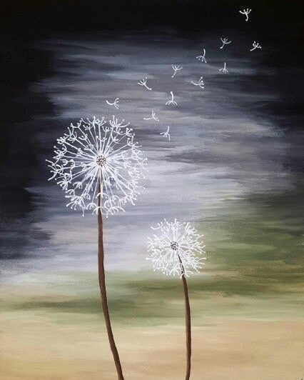
This is an easy, beginner level make-and-take. This will be a smaller sized canvas.
- Thursday January 12 | 4:00 – 6:00 p.m.
- Workshop fee: $30, payable at registration
- Ages: 14 and older
- Class limit: 10

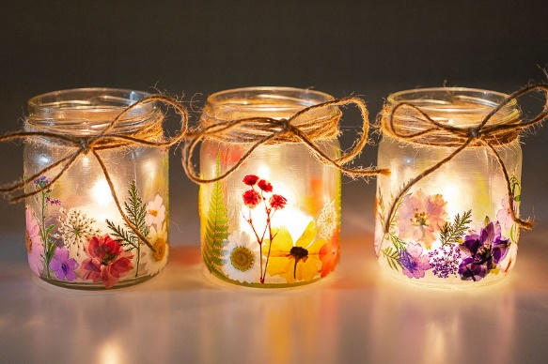
Pressed Flower Lanterns Artist: Sarah Prince
Wanting to add some color into your life during the cold, dark winter? These super cute pressed flower lanterns make great centerpieces, party favors, or gifts. We will be placing dried flowers on jars which will in turn be candle holders. You can stick to one color scheme or add a variety of colors. It's totally up to you. Feel free to bring your own, personal pressed flowers, but a large variety will be offered.
- Date: Saturday, January 14 | 2:00 – 4:00 p.m.
- Workshop Fee: $20 for 1 jar or $35 for two jars
- Ages: 10-100+ years!
- Class limit: 12 people

Sew and Tote! Artist: Daria Claiborne
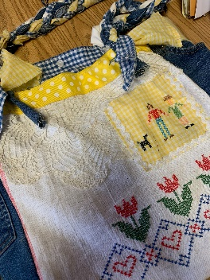
Using vintage materials (quilt parts, doilies, tea towels, jeans, etc.), design your large tote bag. There are two options: If you have a portable sewing machine and want to sew it yourself, bring your machine along with your sewing scissors and pins. Another option is you design your tote, and I sew it for you. Either way, you end up with a great soft tote to take to your local farmer’s market or on a trip.
- Date: Sunday, January 15 | 1:00 – 4:00 p.m.
- Workshop fee: $25 DIY or $35 (I sew your design!)
- Class max: 10
- Ages: 10 years and older

Candy Heart Class Artist: Ginger Copeland

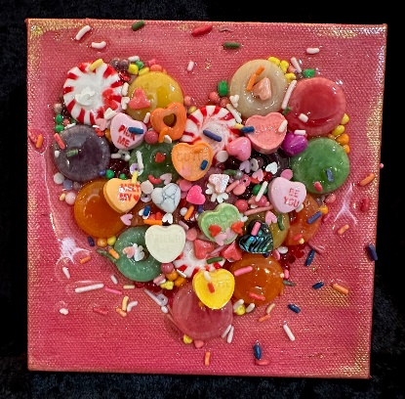
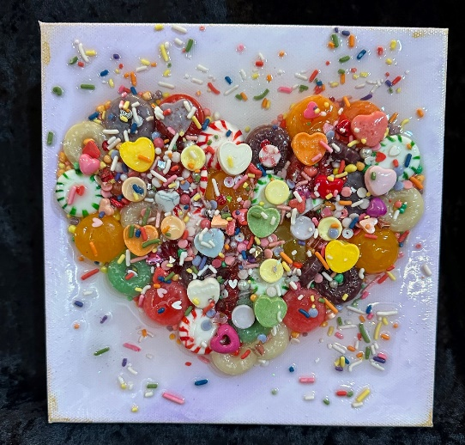
Have some fun and make your very own 6” x 6” candy heart. We will use real candy, plus heart-shaped beads and findings. If you have heart-shaped items you would like to include to make it very personal, please bring them. You will choose what color to paint your background, then create your beautiful heart. I will resin after the class has ended. They will be ready to pick up at the gallery beginning Tuesday, January 24.
Please let me know if you wish to make more than one in order to assure I
have enough canvases available.
- Date: Saturday, January 21 | 1:00 p.m.
- Workshop fee: $50 for 1; $90 for 2 by the same participant
- Class max: 10
- Ages: 11 years and older

Batik Workshop Daria Claiborne
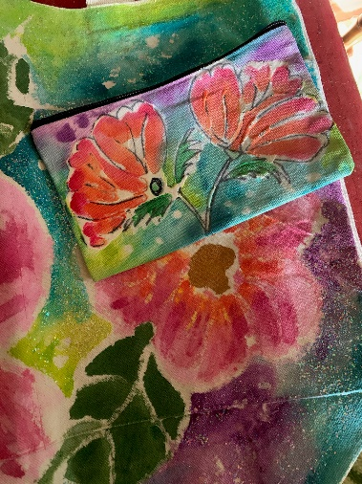
Design and paint your own apron with the Zimbebe batik technique. All supplies will be provided. Bring a hair dryer, please.
- Date: Sunday, January 29 (Kansas Day!)
- Time: 1:00 – 4:00 p.m.
- Workshop fee: $40
- Class max: 10
- Ages: 12 and up.

ArtForms artists also offer pop-up workshops during the month. Follow the Gallery on our Facebook page and/or our website!

Facebook: ArtFormsGallery620/
Website: www.artforms-gallery.com

Do you have a birthday or special occasion to celebrate? Contact the Gallery to book a private party with an ArtForms Gallery artist!
Possibilities include:
- Sip and Paint  - Painting  - Jewelry  - Textiles  - Pour Painting | - Fused Glass/Stained Glass  - Pottery (ceramic birdhouse, windchime, pitchers)  - Fiber  - Glass and Resin
Have a workshop suggestion or special request for us?
Don’t hesitate to give us a call!

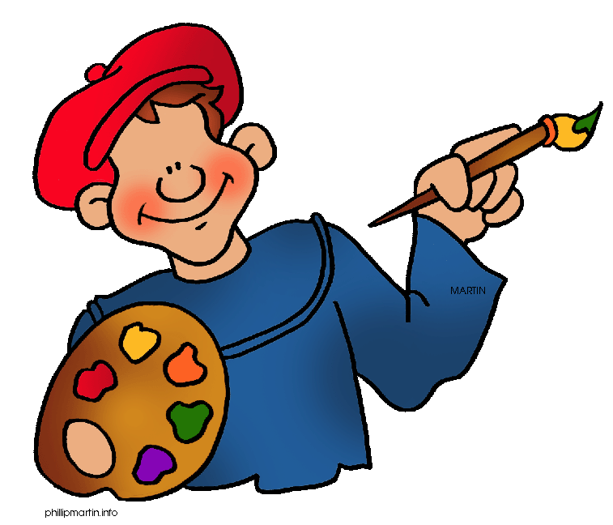
Become a
Gallery Patron
Save 10% on every workshop you take in a 12-month period!!!
Only $40.00

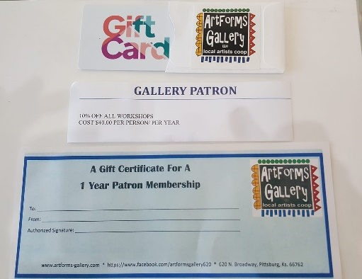
ArtForms Gallery has the perfect gift for any occasion! Our gift cards may be purchased in any amount.

