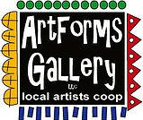
April 2023 Workshops
620 N. Broadway, Pittsburg, KS 620-240-0165
ArtForms Gallery is a co-op of artists offering monthly workshops ranging from acrylic painting, watercolor, oil pastels, glass fusing, pottery, metalsmithing, jewelry, textiles, kids’ art and more! All workshops are held at the Gallery unless otherwise noted. Please call Artforms Gallery to register for any artist’s workshop.

Refunds/Cancellations—Decisions regarding refunds and cancellations are determined by the artist leading the workshop. You can find individual contact information for each artist on the “Artists” page of our website, or just call the Gallery and we’ll get you in touch. Facebook:ArtFormsGallery620/
Art Explorations!
Are you looking for camaraderie while exploring your artistic side? Join Gallery artists Pat Glick every Tuesday afternoon for a fun time working on your own project or art! Bring your materials and create with us for free!
Every Tuesday
April 4, 11, 18, 25
12:30 – 2:30 p.m.
FREE~FREE~FREE!!!
Give the Gift of Art
- Original Art
- Local Artists
- Gift Cards

Gift cards may be purchased in any amount and do not expire. They may be redeemed for workshops or for original art!

To check the balance of your Gift Card online:
https://squareup.com/gift/46K96BF2TK6W7/check-balance
Website:www.artforms-gallery.com

It’s not too late to pick up your Mini Art Kit at the Gallery!
Join us in a fundraiser for our Gallery! Our Mini Art contest began February 21 and will wrap up on Pittsburg Artwalk Day, April 21.
- Purchase a Mini Art Kit from ArtForms Gallery for $20. Instructions, 4 acrylic paint colors, a 4” x 4” canvas, and two brushes are included in the kit.
- Paint your 4” x 4” masterpiece.
- Return it to the Gallery by April 7 for a chance to win a People's Choice Award. Voting takes place April 8—21 and is by cash donations in a container with your name on it.
  - Age Groups
    - Elementary School
    - Middle School
    - High School
    - 18 years and over crowd.
- Round up your family and friends to vote for you!
Prizes are gift baskets filled with art-related supplies. Winners will be notified Saturday, April 22.

All funds raised from the Mini Art Contest will go toward upgrading ArtForms Gallery from our front window to our classroom.

Bring your Mini-Art kit or purchase one ($20) and sit a spell
with Nicole Meyer-Foresman in a relaxing environment
to create your own little masterpiece for the Gallery’s fundraising event.
Saturday, March 25, 6 p.m. to 8 p.m.
This is a free event if you have already purchased your kit.

Pisces Zodiac Painting Artist: Lacy Warfel
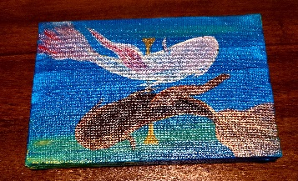
This is a small acrylic make and take. March includes the “last” sign in the zodiac, Pisces. Acrylic paint, canvas, and brushes are supplied. Pisces are known for their imagination…
- Date: Thursday, April 6 | 6:00 – 8:00 p.m.
- Workshop fee: $25, due at time of registration
- Class Limit: 10 max
- Ages: 14 and older

Neurographic Art! Artist: Debbie Southard
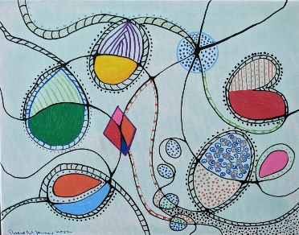
This class helps you to work through different areas of life that you may be wanting to change or are struggling in. Neurographic art helps to form new neural paths in the brain. This is a relatively new technique and has been used about 5 years. It was developed by a Russian psychologist to help his patients work through different areas of life. When you are finished with the process you can use markers, crayolas, or pencils to color in the areas. You are then left with your own unique piece of art.
- Saturday, April 8 | 2:00 – 4:00 p.m.
- Workshop Fee: $30, due at time of registration
- Class limit: 10
- Ages: 18 and older

Taurus Zodiac Painting Artist: Lacy Warfel
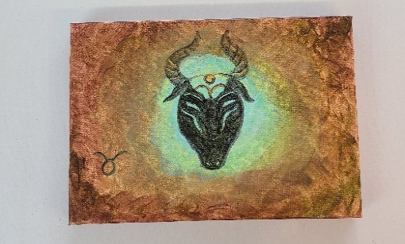
This is a small acrylic make and take. Represented by the bull, Taurus is the first Earth sign in our Zodiac series. They are known for loyalty and enjoying the good things in life. Acrylic paint, canvas, and brushes are supplied.
- Date: Tuesday April 11 | 6:00 – 8:00 p.m.
- Workshop fee: $25, payable at registration
- Ages: 14 and older
- Class limit: 10 max
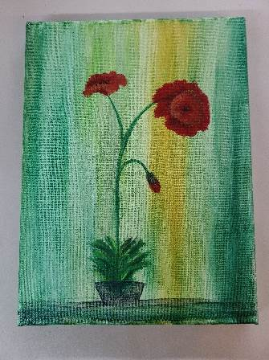
Happy Flowers: An Acrylic Painting Artist: Lacy Warfel
This is a small acrylic make and take. I’m so excited for the flowers to start blooming! Just in time for Mother’s Day, you can learn to paint sweet flowers. We are not limited to Poppies… Acrylic paint, canvas, and brushes are supplied.
- Date: Thursday April 13 | 6:00 – 8:00 p.m.
- Workshop fee: $25, payable at registration
- Ages: 14 and older
- Class limit: 10 max
Pressed Flower Lantern Workshop Artist: Sarah Prince
Back by Popular Demand! Are you excited to start seeing those spring flowers? Let’s press fast-forward and bring out our own flowers. These super cute, pressed flower lanterns make great centerpieces, party favors, or gifts. We will be placing dried flowers on jars which will, in turn, be candle holders. You can stick to one color scheme or add a variety of colors. It's totally up to you. Feel free to bring your own personal pressed flowers, but a large variety of flowers and all materials will be available.
- Date: Saturday, April 15 | 2:00 – 4:00 p.m.
- Workshop Fee: $25 for 1 jar or $40 for 2 jars, payable at time of registration
- Ages: 10-100+ years!
- Class limit: 12 max
From Junk Mail to Junk Journal! Artist: Brenda Hayes
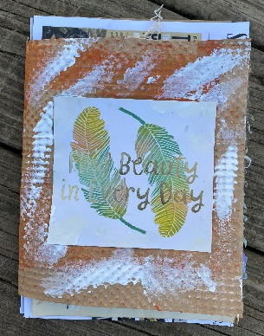
Turn your junk mail into an art journal! With paint, stencils, stamps, marking tools, and tapes, we will make an artsy journal with very affordable materials.

All materials will be provided, including some of my own junk mail. You are welcome to bring your own junk mail, envelopes, flyers, etc. to class to use.

- Date: Sunday, April 16 | 1:00 p.m. – 3:00 p.m.
- Workshop fee: $35.00, due at time of registration
- Ages: 13 and older
- Class size: Max 6

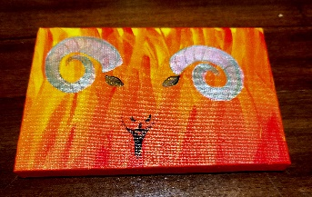
Aries Zodiac Painting Artist: Lacy Warfel
This is a small acrylic make and take. Aries is now the 2nd astrological sun sign. Aries are known for being relentless and fearless… Acrylic paint, canvas, and brushes are supplied.
- Date: Tuesday, April 18 | 6:00 – 8:00 p.m.
- Workshop fee: $25, due at time of registration
- Class Limit: 10 max
- Ages: 14 and older

Join the ArtForms Gallery Artists
during the Pittsburg ArtWalk!!!
Friday, April 21 | 5:00 – 9:00 p.m.
Artists will be inside ArtForms and on the street.
- Sarah Prince, stained glass, Fox Theater
- Lacy Warfel, belly dancing troupe, near Eclectic Soul
- Rebecca Lomshek and the PHS Art Club
- Dianne Miller, ArtForms Gallery classroom

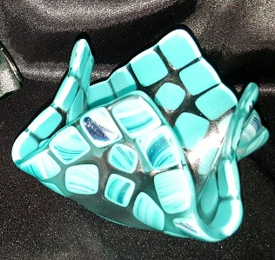
Fused Glass Votive Cups Artist: Dianne Miller
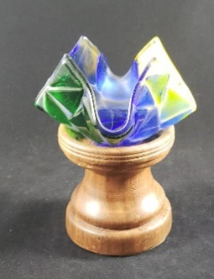
Fused Glass votive cups make great gifts! Votive cups are suitable to be used for jelly/butter dishes or hold candies and nuts. Another use is to burn a small votive candle inside to add a glow to your evenings. Create an adorable votive cup by arranging cut pieces of glass on a 6” clear glass base. Basic glass-cutting skills are taught so experience is not required. Just bring your enthusiasm and creativity! All supplies, tools, and instructions are included in the workshop fee. Please wear close-toed shoes when working with glass. Protective eyewear is available if you do not wear glasses or bring your own.
- Date: Saturday, April 22 | 1:00 - 4:00 p.m.
- Workshop Fee: $50—Please pay at time of registration payable at time of registration
- Class limit: 10 max
- Ages: 14 and older

Ceramic Coil Pots Artist: Daria Claiborne
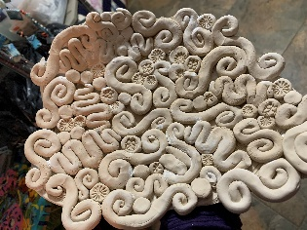
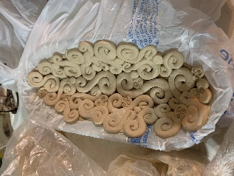
Let's play with coils to make awesome ceramic vessels. All supplies will be included as well as all the firing for a finished product.
- Date: Sunday, April 23 | 1:00 p.m. – 3:00 p.m.
    - Workshop fee: $45.00, due at time of registration
    - Ages: 12 years and older
    - Class size: 10

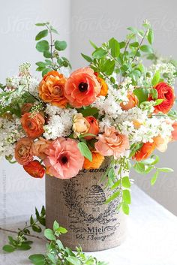
Spring Floral Table Arrangement
Artists: Sarah Prince and Rilie Creollo
Grab a friend and come spend a fun afternoon learning how to build a beautiful fresh spring flower table arrangement. Our special guest, Rilie Creollo, professional florist, will be giving step-by-step instructions. You choose your own color palette and flowers. We provide everything you need…container, tools, flowers, etc. Yummy snacks and beverages will be provided. It will be an afternoon to remember. Spaces will fill quickly.
- Date: Saturday, April 29 | 2:00 – 4:00 p.m.
- Workshop Fee: $50 per person—Please pay at time of registration
- Ages: 10-100
- Class limit: 14 max

ArtForms artists also offer pop-up workshops during the month. Follow the Gallery on our Facebook page and/or our website!
Facebook: ArtFormsGallery620/
Website: www.artforms-gallery.com
Do you have a birthday or special occasion to celebrate? Contact the Gallery to book a private party with an ArtForms Gallery artist!
Possibilities include:
- Sip and Paint  - Painting  - Jewelry  - Textiles  - Pour Painting | - Fused Glass/Stained Glass  - Pottery (ceramic birdhouse, windchime, pitchers)  - Fiber
Have a workshop suggestion or special request for us?
Don’t hesitate to give us a call!
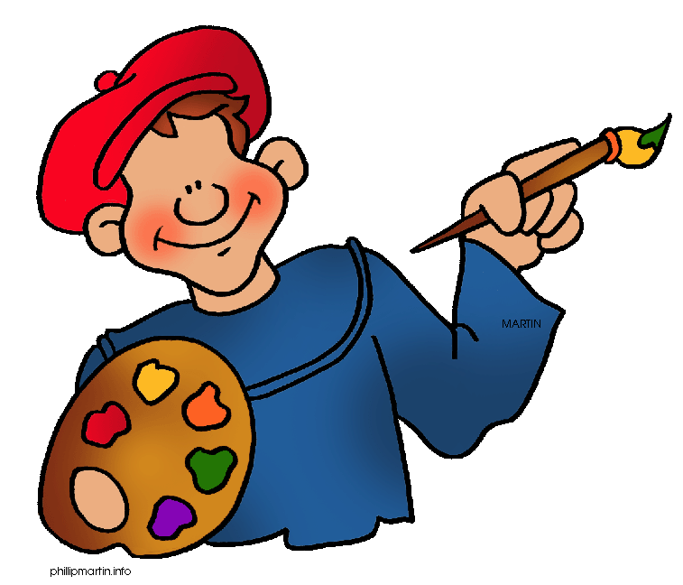
Become a
Gallery Patron
Save 10% on every workshop you take in a 12-month period!!!
Only $40.00

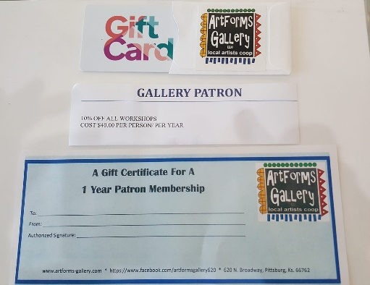
An ArtForms Gallery gift card makes the perfect gift for any occasion! Our gift cards may be purchased in any amount and they never expire.

