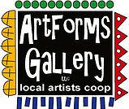**July 2022 Workshops**

**620 N. Broadway, Pittsburg, KS 620-240-0165**

ArtForms Gallery is a co-op of artists offering monthly workshops ranging from acrylic painting, watercolor, glass fusing, pottery, metalsmithing, jewelry, textiles, kids’ art and more! All workshops are held at the Gallery unless otherwise noted. Please call Artforms Gallery to register for any artist’s workshop. **620-240-0165**

Refunds/Cancellations—Decisions regarding refunds and cancellations are determined by the artist leading the workshop. You can find individual contact information for each artist on the “Artists” page of our website, or just call the Gallery and we’ll get you in touch.

**Give the Gift of Art**

* Original Art
* Local Artists
* Gift Cards

Gift cards may be purchased in any amount and do not expire. They may be redeemed for workshops or for original art!

To check the balance of your Gift Card online:

[https://squareup.com/gift/46K96BF2TK6W7/check-balance](https://squareup.com/gift/46K96BF2TK6W7/check-balance?fbclid=IwAR1iEqUd4ASMldq6Fm8eoysfMKfOYcFHXH1Rb1SFKIGHspD2yyCQCQInoJ8)

Website: [www.artforms-gallery.com](http://www.artforms-gallery.com)

Facebook: [ArtFormsGallery620/](https://www.facebook.com/ArtFormsGallery620/)

Each month Gallery artists design and stage our front window for your viewing pleasure!

May: Sue Horner, Kristin Girard and Phil Delasega staged the special Big Kansas Road Trip window.

June: Mona Jurshak and Ruth Miller

July: Michael Cessna and Dianne Miller are planning an Americana/patriotic theme so drop by to check it out!

.

**Art Exploration/Weekly Beginning Painting Instruction**

**Artist: Pat Glick**

Are you looking for camaraderie while exploring your artistic side? Join Gallery artists Pat Glick **every** Tuesday afternoon for a fun time working on your own project or art! Bring your materials and create with us for free!

* Date: Tuesdays, July 5, 12, 19 | 12:30 – 2:30 p.m.
* **Due to Kids’ Camp the last week of July, there will be no Art Exploration July 26.**
* Art Exploration Workshop Fee: FREE~FREE~FREE!!!
* Beginning Painting Workshop Fee: $15 per session, payable at time of registration each week to reserve a spot
* Ages: **Adults only**

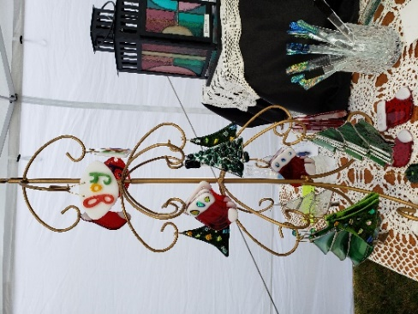**Stained Glass Christmas in July** Artist: Dianne

Get a jump on your holiday gift-giving while learning a new art! For three Wednesdays in July, join Dianne at the Gallery to learn **basic stained glass** as you create small holiday ornaments. This workshop is for the beginner as well as those who have previously attended a stained glass workshop. This is a drop-in and work for 2-3 hours as fits your schedule, but you **MUST** register and pay in advance to ensure enough glass is on hand to accommodate you. Tools, glass, supplies and instruction are included. Please do not wear open-toed shoes when working with glass.

* Date: Wednesdays, July 6, 13, 20 | 1:00 p.m. – 5:00 p.m.
* Fee: $60 for beginning instruction, approximately 3 hours
* Fee: $15 per ornament for those who have taken Stained Glass bootcamp at the Gallery
* Ages: 14 years and older

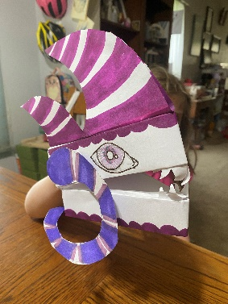**Dragon Puppet for Kids! Artist:** Rebecca Lomshek

Make your own dragon puppet out of supplies found in your home. They are fun to make and access your creativity. Each puppet can be individualized to suit the maker and the beast.

* Date: Wednesday, July 6 | 9:00 a.m. -- 10:30 a.m.
* Ages: 8-13 years
* Fee: $20, payable at registration
* Class limit: 10

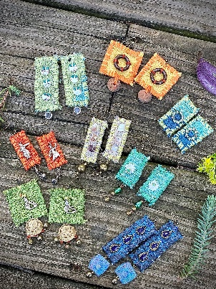**Fiber Earrings** Artist: Brenda Hayes

We will hand-stitch various fibers into one-of-a-kind fabric earrings. Adding beads and baubles. All materials will be provided.

* Date: Saturday, July 9 | 1:00 – 3:00 p.m.
* Fee: $30, payable at registration
* Ages: 14 and older
* Class limit: 6

**Beginner Mandala** Artist: Rebecca Lomshek

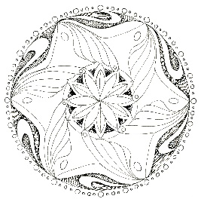Drawing a mandala by hand is great way to improve your drawing skills. Using repeating patterns and concentric circles, let structure build a beautiful drawing that you can share proudly with friends and family. There will be time to not only draw your mandala, but to also add a bit of color. Whether you like to draw or would like a stepping stone into the world of drawing, this is a great class for you!

All materials will be supplied.

* Date: Monday, July 11 | 6:00 p.m. – 8:00 p.m.
* Fee: $25, payable at registration
* Ages: 12 years and above
* Class size: 10

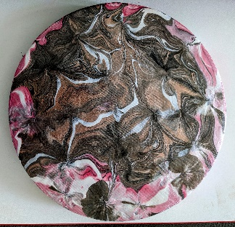**Fluid Art Painting** **A**rtist: Debbie Southard

What can you do with a bottle bottom and a napkin? FLUID ART!  Join our class and let's paint together. Once varnished, your art is very touchable and can be wiped off easily with a damp cloth to clean.

* Date: Saturday, July 16 | 2:00 p.m. – 4:00 p.m.
* Fee: $35, payable at time of registration
* Class limit: 10
* Age: 14 years and older

**Fused Glass Pocket Vase** Artist: Dianne Miller

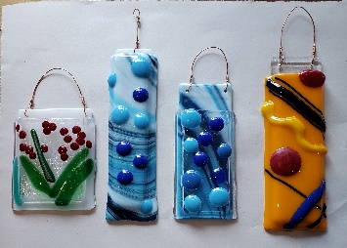Create 3 pocket vases to keep or give as gifts! You will create a design by arranging cut pieces of glass and adorable embellishments on a white glass base. Special ceramic paper will be sandwiched between your glass design layer and a clear base ready to fire in the kiln. The result is a pocket vase that actually holds water! Basic glass-cutting skills are taught so experience is not required. Just bring your enthusiasm and creativity! All supplies, tools, instructions, and kiln-firing are included in the workshop fee. Please wear close-toed shoes when working with glass. Protective eyewear is available if you do not wear glasses or you may bring your own.

* Date: Saturday, July 23 | 1:00 p.m. – 3:00 p.m.
* Fee: $45, payable at time of registration
* Class limit: 10
* Age: 14 years and older

Young Artist Camp! Round II

**Yes! You read that right! ArtForms Gallery artists are offering another exciting week of art for your kiddos!!**

Artists are volunteering their time, their talents, and their materials in a fundraiser for the Gallery.Your young artist will be led by different ArtForms Gallery artists each day! They will demonstrate techniques they use, followed by time for the young artists to create their own projects. Each day the young artists will go home with a finished project.

* Mon July 25 Demo airbrush painting followed by project
* Tues July 26 Demo throwing clay on the pottery wheel and

handbuilding pinch pots

* Wed July 27 Geeometric drawings/paintings and mandalas.

Participants will learn how to use protractor and compass as part of the drawings.

* Thurs July 28 Demo ofAcrylic Pour Painting followed by

individual acrylic pour projects

* Fri July 29 Demo Loom weaving and students’ weaving projects

|  |  |
| --- | --- |
| **Ages** | **Time** |
| **6-9** | **9:00 – 10:00 a.m.** |
| **10-12** | **11:00 – 12:30 p.m.** |
| **13-18** | **1:30 – 3:00 p.m.** |

* **Workshop fee: $100, payable at registration**
* **Class size: 10 per session**

**Watercolor Sunflower Cards** Artist: Daria Claliborne

Paint your own sunflower cards. All supplies included.

* Date: Sunday, July 31 | 2:00 p.m. – 4:00 p.m.
* Fee: $35
* Class limit: 10
* Age: 12 years and up

**Check our Facebook page during the month as artists may offer “popup” workshops!**

ArtForms artists also offer pop-up workshops during the month. Follow the Gallery on its Facebook page and/or its website!

* Facebook: [ArtFormsGallery620/](https://www.facebook.com/ArtFormsGallery620/)
* Website: [www.artforms-gallery.com](http://www.artforms-gallery.com)

Do you have a birthday or special occasion to celebrate? Contact the Gallery to book a private party with an ArtForms Gallery artist! Private workshops are perfect for team-building, bridal parties, kids’ birthdays!

Possibilities include:

|  |  |
| --- | --- |
| * Sip and Paint * Painting * Jewelry * Textiles | * Fused Glass/Stained Glass * Pottery (ceramic birdhouse, windchime, pitchers) * Fiber |
| **Have a workshop suggestion or special request for us?**  **Don’t hesitate to give us a call!**  See the source image  **Become a**  **Gallery Patron**  Save 10% on **every** workshop you take in a 12-month period!!!  Only $40.00 | |

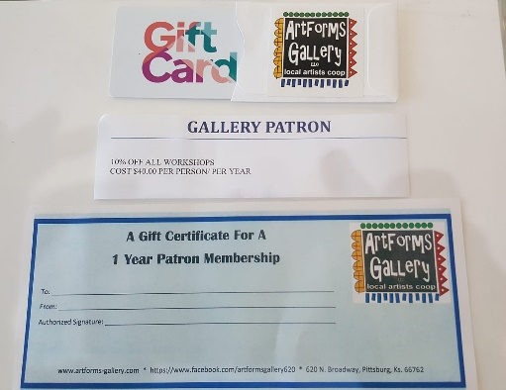

Give the gift of creativity with an

ArtForms Gallery Gift Card or a

Gallery Patron Membership!

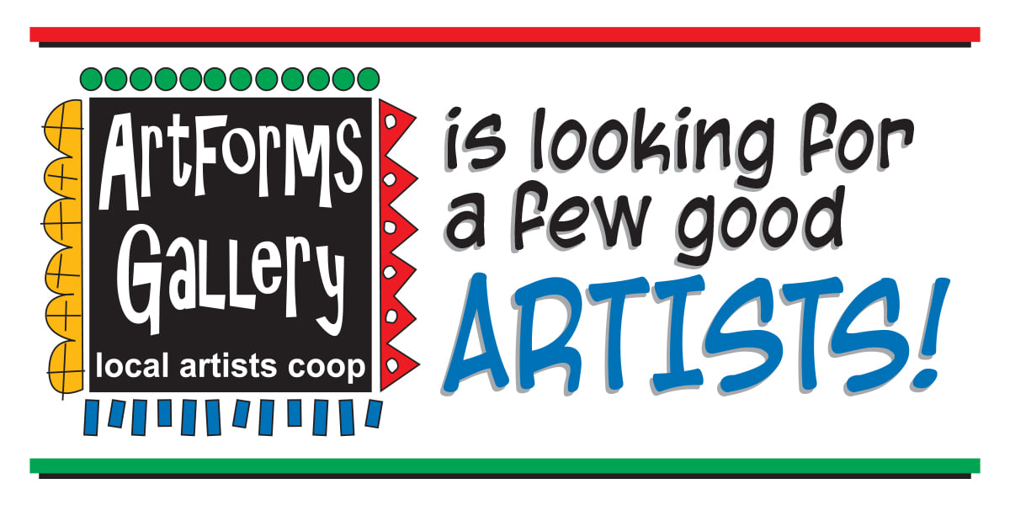

* Constant exposure in the community with minimal time and financial investment.
* Opportunity to be featured in special events and on the ArtForms Gallery website and Facebook page.
* Participate in ArtForms Gallery group shows.
* Be a member of a supportive community of artists.
* Maximize sales with minimal effort. NO commission on sales through the gallery.
* Offer workshops to increase income potential through the gallery.
* Attend monthly meeting to discuss and offer input in gallery operations.
* IT’S FUN!

**Email info@ArtForms-Gallery.com for more information**