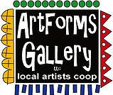
October 2023 Workshops
620 N. Broadway, Pittsburg, KS 620-240-0165
ArtForms Gallery is a co-op of artists offering monthly workshops ranging from acrylic painting, watercolor, oil pastels, glass fusing, pottery, metalsmithing, jewelry, textiles, kids’ art and more! All workshops are held at the Gallery unless otherwise noted. Please call Artforms Gallery to register for any artist’s workshop. 620-240-0165
Refunds/Cancellations—Decisions regarding refunds and cancellations are determined by the artist leading the workshop. You can find individual contact information for each artist on the “Artists” page of our website, or just call the Gallery and we’ll get you in touch. Facebook:ArtFormsGallery620/
Art Explorations!
Are you looking for camaraderie while exploring your artistic side? Join Gallery artists Pat Glick every Tuesday afternoon for a fun time working on your own project or art! Bring your materials and create with us for free!
Every Tuesday
Oct. 3, 10, 17, 24, 31
12:30 – 2:30 p.m.
FREE~FREE~FREE!!!
Give the Gift of Art
- Original Art
- Local Artists
- Gift Cards

Gift cards may be purchased in any amount and do not expire. They may be redeemed for workshops or for original art!

To check the balance of your Gift Card online:
https://squareup.com/gift/46K96BF2TK6W7/check-balance
Website:www.artforms-gallery.com

Give the gift of your own handmade art by enrolling in a workshop!
Congratulations to the winners of “The 7th Wonder of Pittsburg” Art Scavenger Hunt in honor of our 7th anniversary!
Misty Gorman Finn Gorman
Sherri Lindsay Amy Mason
Myriam Krepps Diana Viets
Robin Carson Devin Gorman
Carolyn Ahring Belinda Skiles
Rilynn Deringer Will Bennetts
Mary Lakey Lindsay Deringer
Adreana Michand
Thank you to everyone who participated. Pittsburg has great art!

Pittsburg Fall ArtWalk!!!
Friday, September 29
5 p.m. – 9 p.m.
ArtForms Gallery artists will be on the street
and INSIDE the Gallery!
Plan now to attend!

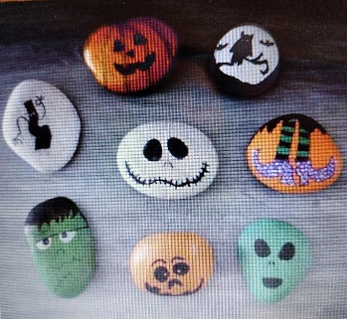
Halloween Rock Painting for Kids/Adults Artist: Sarah Prince
Let's get spooky by painting some super fun Halloween rocks. Sarah will give a tutorial and then it's up to you to add your own pizazz to each rock. Several examples will be available. We will listen to some mysterious music and have some eerie snacks too. This workshop is great for a parent/child date day, friends who like to get together, or anyone who loves the spooky season.
- Date: Saturday, October 14 | 2:00 - 4:00 p.m.
- Workshop fee: $30, payable at time of registration
- Ages: 7 years and older
- Class limit: 14 people

Fused Glass! Holiday Ornaments Artist: Dianne Miller
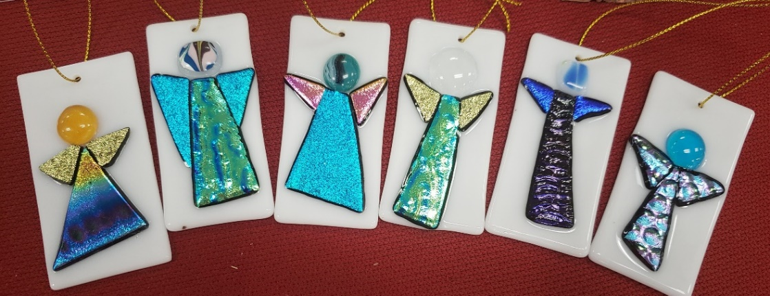
Angels! Snowmen! Santas! Snow Globes! Decorated Trees! And More!

Get a jump on gift-giving by creating your own fused glass holiday ornaments. These will be perfect to hang on a tree, in the window or adorn a package. In the workshop, you will learn how to cut and arrange the glass pieces for fusing in a glass kiln. Glass-cutting techniques will be taught so experience is not necessary. You should be able to create 4-5 small ornaments in the time allowed. All supplies and tools are provided. Please wear close-toed shoes when working with glass.
- Date: Saturday, October 21 | 1:00 p.m. – 4:00 p.m.
- Workshop fee: $50, payable at time of registration
- Class size: 8
- Ages: 12 years and older

Watercolor Pumpkin Cards Artist: Daria Claiborne
Give your friends and family unique holiday greeting cards that you created!! Using watercolors, we will create 4 different greeting cards. (I'm working on a surprise!) All supplies and instruction are included.
- Date: Sunday, October 22 | 2:00 p.m. – 4:00 p.m.
- Workshop fee: $40, payable at time of registration
- Ages: 12 and up
- Class size: 12

Get your Halloween VooDoo On! Artist: Brenda Hayes
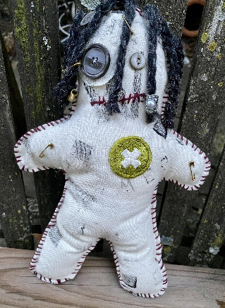
Who or what do you want to cast a spell on? That cute UPS driver? The friendly girl that works at Taco Bell? Do you want to VooDoo cancer to be forever gone or end world hunger? You can custom make your doll to fit your aspirations. All supplies will be provided.
- Date: Sunday, October 29 | 10:00 a.m. – 12:00 p.m.
- Workshop fee: $35, payable at time of registration
- Ages: 12 and older
- Class limit: 8

Ceramic Leaf Platters Artist: Daria Claiborne
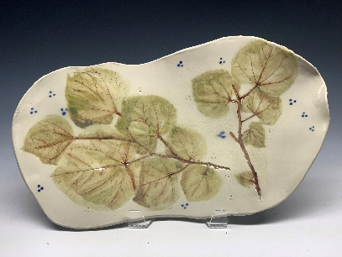
Beginning with a prepared clay slab, we will create hand-built platters by impressing real leaves into the clay, then adding colorants and feet for a statement piece. Your finished beauty can also hang from the wall.
- Date: Sunday, October 29 | 1:00 p.m. – 4:00 p.m.
- Workshop fee: $50, payable at time of registration
- Ages: 12 and older
- Class limit: 10

Upcoming Workshops and Possibilities!!!
- Fused Glass Cabochons by Dianne (November)
- Upcycled Snowmen by Brenda (November)
- Fall Scented Candles or Fall Scented Steam Pots by Sarah (November)
- Fused Glass Small Dishes by Dianne (December)

Will you have family home for the holidays? Now is the time to schedule a family-bonding and creative private art workshop with one of our talented artists! Just call us: 620-240-0165.

Facebook: ArtFormsGallery620/
Website: www.artforms-gallery.com

Do you have a birthday or special occasion to celebrate? Contact the Gallery to book a private party with an ArtForms Gallery artist!
Possibilities include:
- Sip and Paint  - Painting  - Jewelry  - Textiles  - Pour Painting | - Fused Glass/Stained Glass  - Hand-built Pottery (ceramic birdhouse, windchimes, toad houses, pitchers)  - Fiber
Have a workshop suggestion or special request for us?
Give us a call!

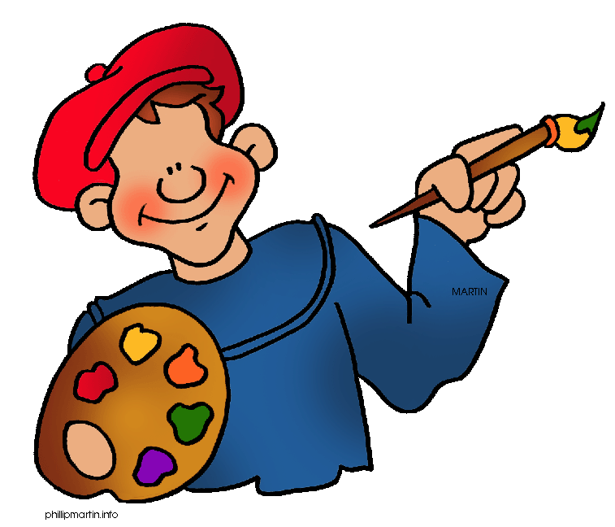
Become a
Gallery Patron
Save 10% on every workshop you take in a 12-month period!
Only $40.00

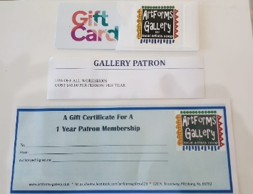
An ArtForms Gallery gift card makes the perfect gift for any occasion! Our gift cards may be purchased in any amount and they never expire.

