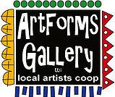**November 2022 Workshops**

**620 N. Broadway, Pittsburg, KS 620-240-0165**

**Holiday Open House**

**Saturday, December 3**

ArtForms Gallery is a co-op of artists offering monthly workshops ranging from acrylic painting, watercolor, glass fusing, pottery, metalsmithing, jewelry, textiles, kids’ art and more! All workshops are held at the Gallery unless otherwise noted. Please call Artforms Gallery to register for any artist’s workshop. **620-240-0165**

**Refunds/Cancellations—Decisions regarding refunds and cancellations are determined by the artist leading the workshop.** You can find individual contact information for each artist on the “Artists” page of our website, or just call the Gallery and we’ll get you in touch.

**Give the Gift of Art**

* Original Art
* Local Artists
* Gift Cards

Gift cards may be purchased in any amount and do not expire. They may be redeemed for workshops or for original art!

To check the balance of your Gift Card online:

[https://squareup.com/gift/46K96BF2TK6W7/check-balance](https://squareup.com/gift/46K96BF2TK6W7/check-balance?fbclid=IwAR1iEqUd4ASMldq6Fm8eoysfMKfOYcFHXH1Rb1SFKIGHspD2yyCQCQInoJ8)

Website: [www.artforms-gallery.com](http://www.artforms-gallery.com)

Facebook: [ArtFormsGallery620/](https://www.facebook.com/ArtFormsGallery620/)

ArtForms Gallery introduced its **“Autumn Adventures at ArtForms”** fundraising workshops this fall!

November features **Debbie Southard** and her popular pour painting workshop November! Join us!

Each month Gallery artists design and design and stage our front window for your viewing pleasure!

The October window display is courtesy of Nicole Meyer-Foresman. We hope you enjoy it!

**Art Explorations**

Are you looking for camaraderie while exploring your artistic side? Join Gallery artists Tuesday afternoon for a fun time working on your own project or art! Bring your materials and create with us for free!

* Tuesdays, November 1, 8, 15, 22, 29 | 12:30 – 2:30 p.m.
* Art Exploration Workshop Fee: FREE~FREE~FREE!!!

**O Christmas Tree: Resin and Glass Artist: Ginger Copeland**

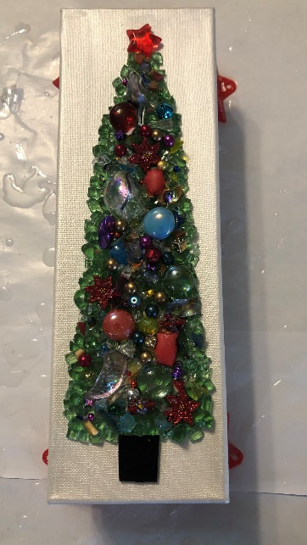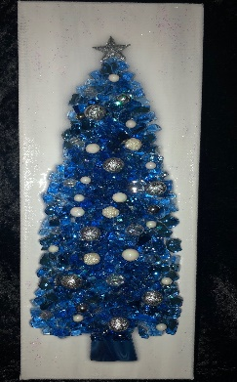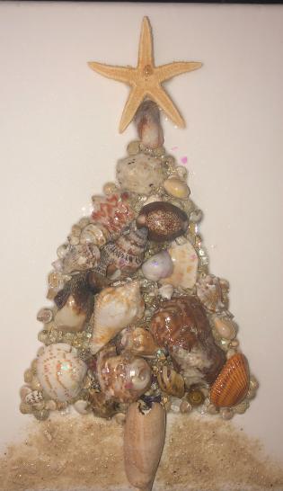Come make your own Christmas tree.   Choose between a 4” x 12” shattered glass tree or an 8” x 10” shell tree.  I will have lots of doodads to use for ornamentation and different colors of shattered glass to choose.  However, if you have something you would like to incorporate, feel free to bring it.  For instance, old jewelry makes great tree toppers.   If you have shells from a vacation you would like to use, do bring those.  I will have lots of shells to choose from, but you are welcome to use yours.    I will resin your finished piece after the class, and you can pick up in the gallery Thursday, November 10 or after.

**Please indicate which size tree(s) you want to make when you register.**

* Sunday, November 6 | 1:00 – 4:00 p.m.
* Workshop fee: $50 for 1 tree or $90 for 2 trees (by the same student)
* Ages: 12 and up
* Class limit: 10

**Dutch Pour Painting** **Artist: Debbie Southard**

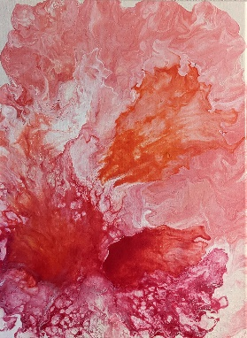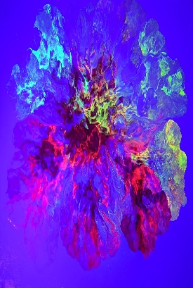Come learn a Dutch pour technique with Debbie's Art Journey at ArtForms Gallery.

We will use a hair dryer to manipulate the paint on the canvas. These pours typically look floral while some may look like the cosmos. I will also have some neon paints that can be added to your pour. Let’s have fun and help me raise some money for our Gallery!

* Saturday, November 12 | 2:00 – 4:00 p.m.
* Workshop Fee: $30, due at time of registration
* Class limit: 10
* Ages: 14 and older

**\*This workshop is part of our Autumn Adventures at ArtForms fundraising series!**

**Holiday Ornaments! Fused Glass** Artist: Dianne Miller

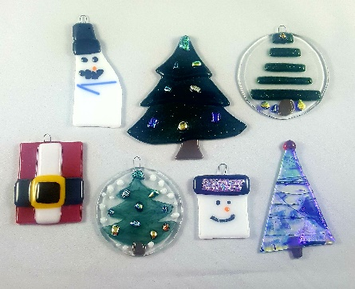Give your own uniquely handcrafted gifts this season! Join Dianne in this fused glass workshop creating your own glass ornaments! Ornaments make great stocking stuffers or may be used as part of the gift’s packaging. Participants should be able to make 4-5 small ornaments. Basic glass-cutting skills are demonstrated. Individual instruction is provided along with all glass tools and material. After fusing in my home studio, your ornaments will be returned to the Gallery and ready for you to pick up November 23 at the Gallery!

* Saturday, November 19 | 1:00 -4:00 p.m.
* Ages: 14 and older
* Workshop Fee: $40 for 4-5 small ornaments; due at time of registration
* Class limit: 10

**Ceramic Pumpkins Artist: Daria Claiborne**

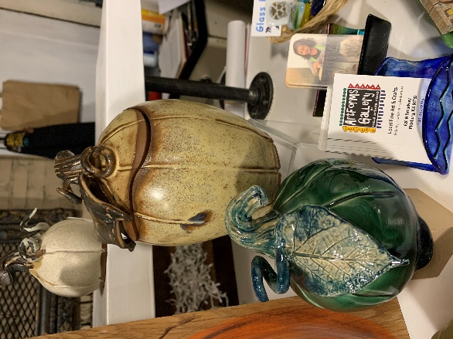Let’s decorate pumpkins for your fall display!!  You will be given 2 enclosed clay forms to decorate however you wish!  Make it scary or cute.  Let your imagination go. As always, all supplies are included as well as the two firings necessary to make your creation durable.

* Sunday, November 20 | 1:00 – 4:00 p.m.
* Workshop Fee: $50, due at time of registration
* Class limit: 8
* Ages: 14 and older

**Upcycled Snowmen**  **Artist: Brenda Hayes**

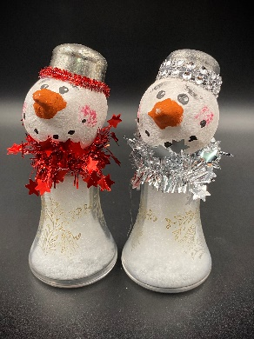We’ve endured the oppressive heat and drought, so let’s get ready for snowman season! Take pieces of old and new to create these one of a kind upcycled snowpeople. These are great to add to your collection or give as gifts.

* Sunday, November 27 | 1:00 – 4:00 p.m.
* Workshop Fee: $40, due at time of registration
* Class limit: 6
* Ages: 13 and older

**Check our Facebook page during the month as artists may offer “popup” workshops!**

ArtForms artists also offer pop-up workshops during the month. Follow the Gallery on its Facebook page and/or its website!

* Facebook: [ArtFormsGallery620/](https://www.facebook.com/ArtFormsGallery620/)
* Website: [www.artforms-gallery.com](http://www.artforms-gallery.com)

  
Do you have a birthday or special occasion to celebrate? Contact the Gallery to book a private party with an ArtForms Gallery artist!

Possibilities include:

|  |  |
| --- | --- |
| * Sip and Paint * Painting * Jewelry * Textiles | * Fused Glass/Stained Glass * Pottery (ceramic birdhouse, windchime, pitchers) * Fiber |
| **Have a workshop suggestion or special request for us?**  **Don’t hesitate to give us a call!**  Give the gift of creativity with an ArtForms Gallery Gift Card or a Gallery Patron Membership! | |

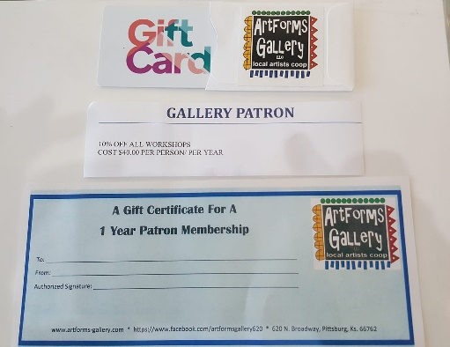

**Become a**

**Gallery Patron**

Save 10% on **every** workshop you take in a 12-month period!!!

Only $40.00