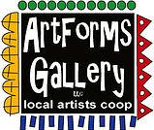**February 2023 Workshops**

**620 N. Broadway, Pittsburg, KS 620-240-0165**

ArtForms Gallery is a co-op of artists offering monthly workshops ranging from acrylic painting, watercolor, oil pastels, glass fusing, pottery, metalsmithing, jewelry, textiles, kids’ art and more! All workshops are held at the Gallery unless otherwise noted. Please call Artforms Gallery to register for any artist’s workshop. **620-240-0165**

**Refunds/Cancellations—Decisions regarding refunds and cancellations are determined by the artist leading the workshop.** You can find individual contact information for each artist on the “Artists” page of our website, or just call the Gallery and we’ll get you in touch. Facebook:[ArtFormsGallery620/](https://www.facebook.com/ArtFormsGallery620/)

**Art Explorations!**

Are you looking for camaraderie while exploring your artistic side? Join Gallery artists Pat Glick **every** Tuesday afternoon for a fun time working on your own project or art! Bring your materials and create with us for free!

Every Tuesday

February 7, 14, 21, 28

12:30 – 2:30 p.m.

FREE~FREE~FREE!!!

**Give the Gift of Art**

* Original Art
* Local Artists
* Gift Cards

Gift cards may be purchased in any amount and do not expire. They may be redeemed for workshops or for original art!

To check the balance of your Gift Card online:

[https://squareup.com/gift/46K96BF2TK6W7/check-balance](https://squareup.com/gift/46K96BF2TK6W7/check-balance?fbclid=IwAR1iEqUd4ASMldq6Fm8eoysfMKfOYcFHXH1Rb1SFKIGHspD2yyCQCQInoJ8)

Website:[www.artforms-gallery.com](http://www.artforms-gallery.com)

**January Popup Workshops!**

**There is still time to register for these late January workshops by Kristin and Dianne!**

Learn how to make these chandelier heart earrings on January 22 from 2:00-4:00. These earrings are made with copper and sterling silver wire and all tools and materials will be included in the $40 price for the class. These earrings would be perfect to give as a gift or wear for yourself for Valentine’s Day. 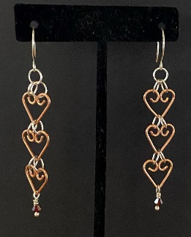

* Sunday, January 22 | 2:00 – 4:00 p.m.
* Workshop fee: $40, due at time of registration
* Ages: 16 years and older
* Class size: 8

**Fused Glass Valentine Heart** Artist: Dianne Miller

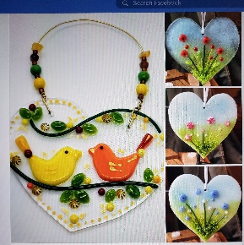 Give your heart away this Valentine's Day! Choose glass embellishments to layer on a precut clear glass heart (approximately 5") that will be fused in a glass kiln to permanently signify your love for someone special--spouse, child, parent, dear friend, or even yourself!

A wide assortment of compatible glass shapes will be available from which you may choose. No glass-cutting is required! Bring your creativity and a N95 mask (in case you use glass powder), and please wear close-toed shoes. Your glass heart will be available for pickup by Thursday, February 2, at the Gallery. Join me in my first workshop in 2023!

* Saturday, January 28 | 1:00 – 3:00 p.m.
* Workshop fee: $40; due at time of registration
* Class size: 10
* Ages: 12 and older
* Photo example is courtesy of another glass artist.

**Valentine Gnomes!** Artist: Ginger Copeland

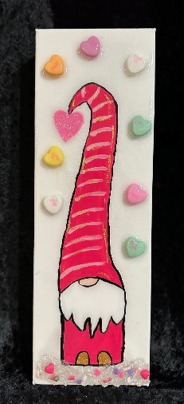Bring a friend and come paint a Valentine’s gnome.  If you wish, we can also add glass or other goodies and resin to really dress him up.

* Date: Saturday, February 4 | 1:00 — 4 p.m.
* Workshop fee: $40 painted gnome; $45 painted gnome

with glass and resin; due at time of registration

* Class max: 10
* Ages: 12 years and older

**Valentine Paper Wreath** Artist: Sarah Prince

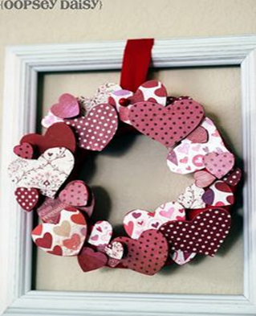Whether you're planning a romantic date night or you just want to stay in to watch rom/com movies on the couch, you'll need some Valentine's Day decorations to set the mood for all of February. During this dark and dreary time of year, a pretty new wreath can add a pop of fresh color to your winter home decor.

In this workshop, we will make a rosy, cheery, and elegant paper heart Valentine's Day wreath. All of the supplies will be available.

* Date: Sunday, February 5 | 2:00 — 4 p.m.
* Workshop fee: $25 for one wreath; $45 for two wreaths
* Class max: 12
* Ages: 7 years and older

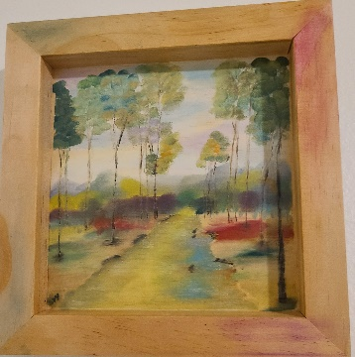**Oil Pastel Landscape** Artist: Lacy Warfel

We will be doing a small landscape on a wood board using a different technique for oil pastels. If you have favorite supplies you want to use then bring them- or I will have everything you need. This is a make and take workshop.

* Tuesday, Feb 7 | 6:00 p.m. – 8:00 p.m.
* Workshop fee: $35, due at time of registration
* Class Limit: 6
* Ages: 14 and older

**Swipe and Spin Heart** Artist: Debbie Southard

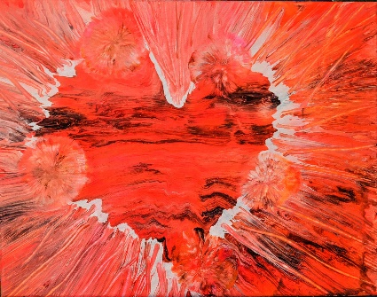In this fluid art workshop, we will be swiping and spinning our canvas to create a heart.

* Saturday, Feb 11 | 2:00 – 4:00 p.m.
* Workshop fee: $35, due at time of registration
* Ages: 14 and older
* Class size: 10 participants

Don’t spend Valentine’s evening watching television this year! Spend it with Lacy Warfel at ArtForms Gallery!



**Textured Abstract Landscape Painting** Artist: Lacy Warfel

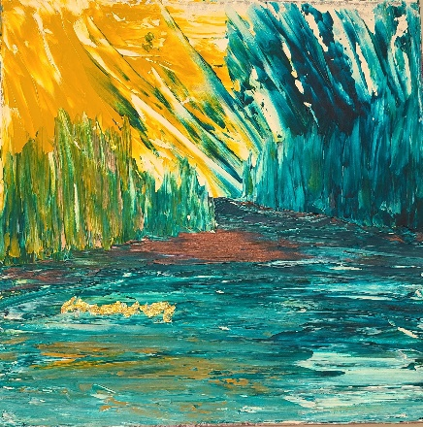This is a fun palette knife, acrylic and finger painting (?) landscape. We will use drywall putty for texture and copper leaf to give it some sparkle. This can be a make and take, but you may want to leave it for a day to dry well. Bring your own tools if you have favorites—but I will have everything you need.

* Tuesday, February 14 | 6:00 – 8:00 p.m.
* Workshop fee: $35
* Ages: 14 and older
* Class limit: 6

**Fused Glass Suncatchers** Artist: Dianne Miller

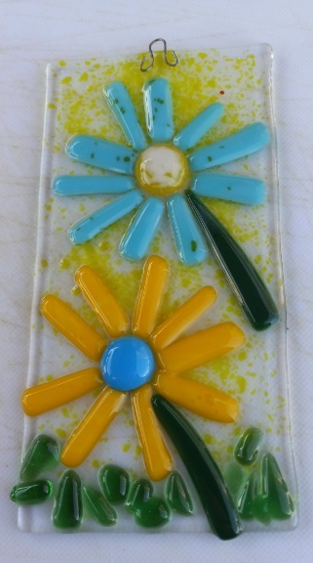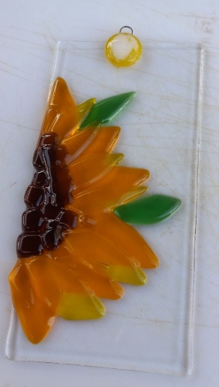Come fuse with me! First time offered—design a fused glass suncatcher that will grace your window or someone else’s. You will begin with a clear 4” x 8” base glass and use basic glass-cutting skills to decorate. Instruction is provided if you have not cut glass before, so don’t worry! All glass, tools, and kiln-firing are included in the workshop fee. Let your imagination be your guide!

* Saturday, Feb 25 | 1:00 – 3:30 p.m.
* Workshop fee: $35, due at time of registration
* Ages: 14 and older
* Class size: 10 participants

**Coming in March!!!**

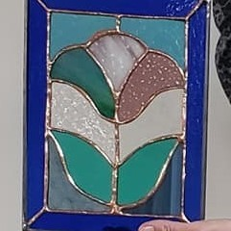**Beginning Stained Glass** Artist: Dianne Miller

This 12-15 hour course is for the beginning stained glass art student or for someone who wishes to improve stained glass skills. You will learn to score, break, groze, grind, copper foil and solder your creation. You will take home a completed stained glass panel (approximately 8” x 10”) that you will be proud to display! An emphasis will be placed on glass considerations for different patterns, glass-cutting techniques and the steps to assemble a Tiffany-style glass panel. (Sample picture is representative of a project. You will have a choice of 6 patterns.)

In a fun and relaxed atmosphere for learning, there will be demos, handouts, skills practice and plenty of time for questions. No experience is necessary. All tools, glass, and supplies will be provided by the instructor.

**Protective eyewear is required**. Regular eyeglasses are sufficient. Please do not wear open-toed shoes when working with glass! Class is limited to the first 8 participants who pay.

* Sundays, March 5, 12, 19, 26, April 2 (if needed)
* 1:30 p.m. to 4:30 p.m.
* $150, **payable at time of registration to guarantee a seat**
* Ages 16 and older
* 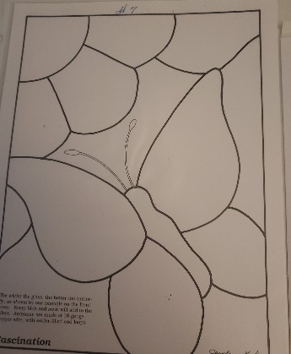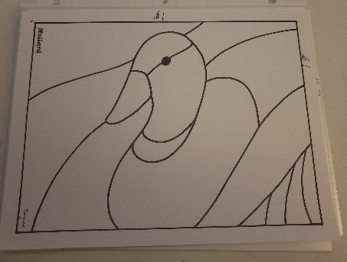Minimum of 4 students required to hold the workshop; maximum 8 students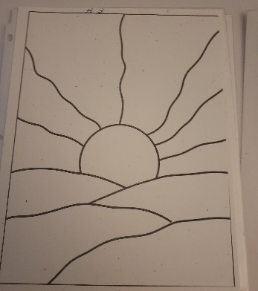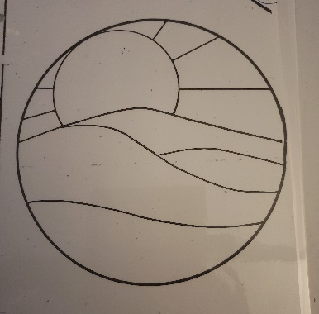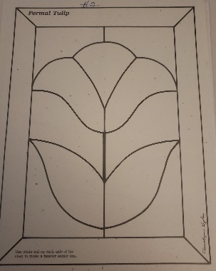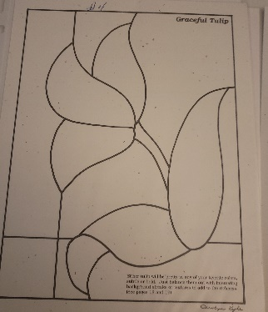

ArtForms artists also offer pop-up workshops during the month. Follow the Gallery on our Facebook page and/or our website!

Facebook: [ArtFormsGallery620/](https://www.facebook.com/ArtFormsGallery620/)

Website: [www.artforms-gallery.com](http://www.artforms-gallery.com)

Do you have a birthday or special occasion to celebrate? Contact the Gallery to book a private party with an ArtForms Gallery artist!

Possibilities include:

|  |  |
| --- | --- |
| * Sip and Paint * Painting * Jewelry * Textiles * Pour Painting | * Fused Glass/Stained Glass * Pottery (ceramic birdhouse, windchime, pitchers) * Fiber * Glass and Resin |
| **Have a workshop suggestion or special request for us?**  **Don’t hesitate to give us a call!**  See the source image  **Become a**  **Gallery Patron**  Save 10% on **every** workshop you take in a 12-month period!!!  Only $40.00 | |

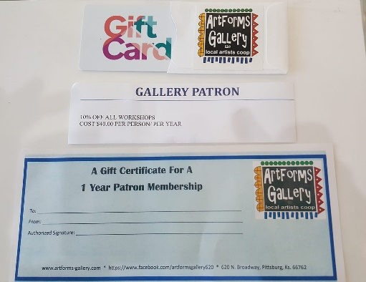

ArtForms Gallery has the perfect gift for any occasion! Our gift cards may be purchased in any amount.